Year 10 |  | Non Linear Relations | Non Calculator
Skills and Knowledge Assessed:  - Graph simple non­linear relations with and without the use of digital technologies and solve simple related equations (ACMNA296)  - Explore the connection between algebraic and graphical representations of relations such as simple quadratics, circles and exponentials using digital technology as appropriate (ACMNA239)  - 10A Describe, interpret and sketch parabolas, hyperbolas, circles and exponential functions and their transformations (ACMNA267) |  |  | Name_________________
Section 1 Short Answer Section
Write all working and answers in the spaces provided on this test paper.

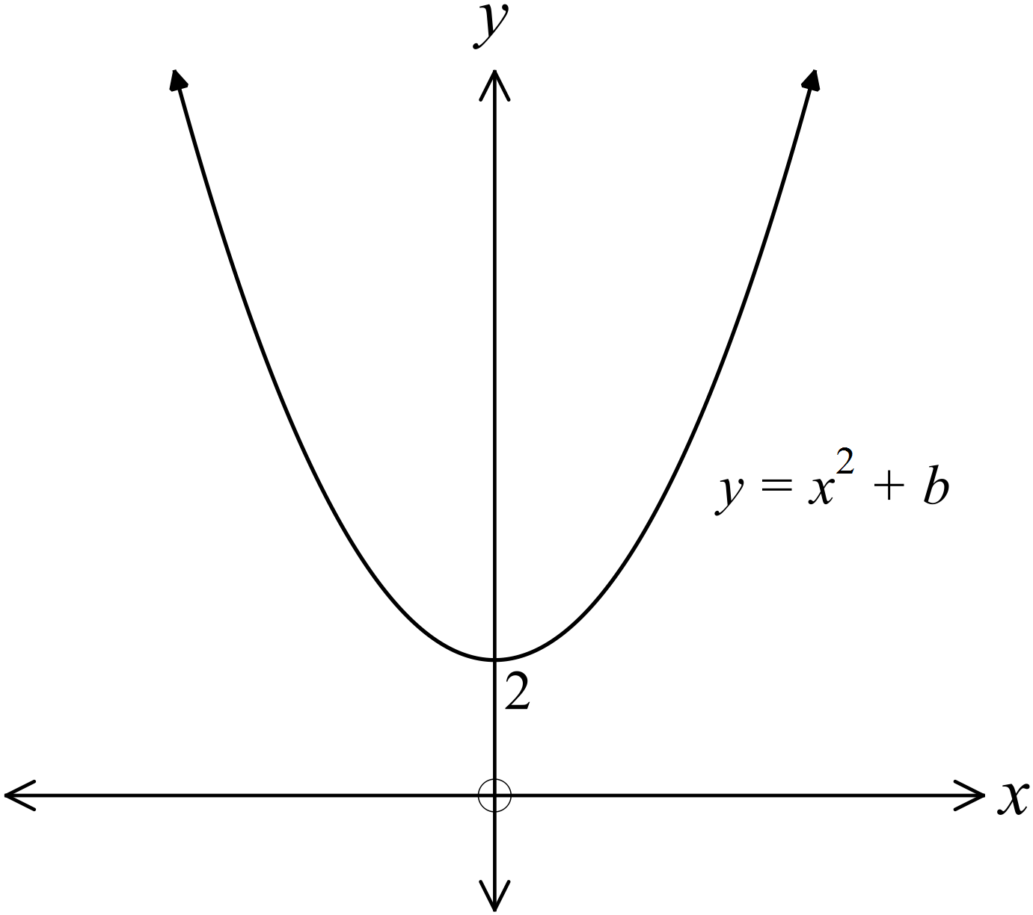The graph of 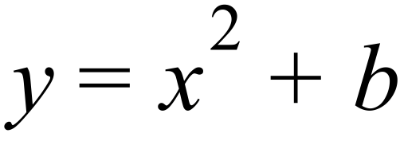 is shown.

What is the value of b?

……………………………………………

…………………………………………….

……………………………………………

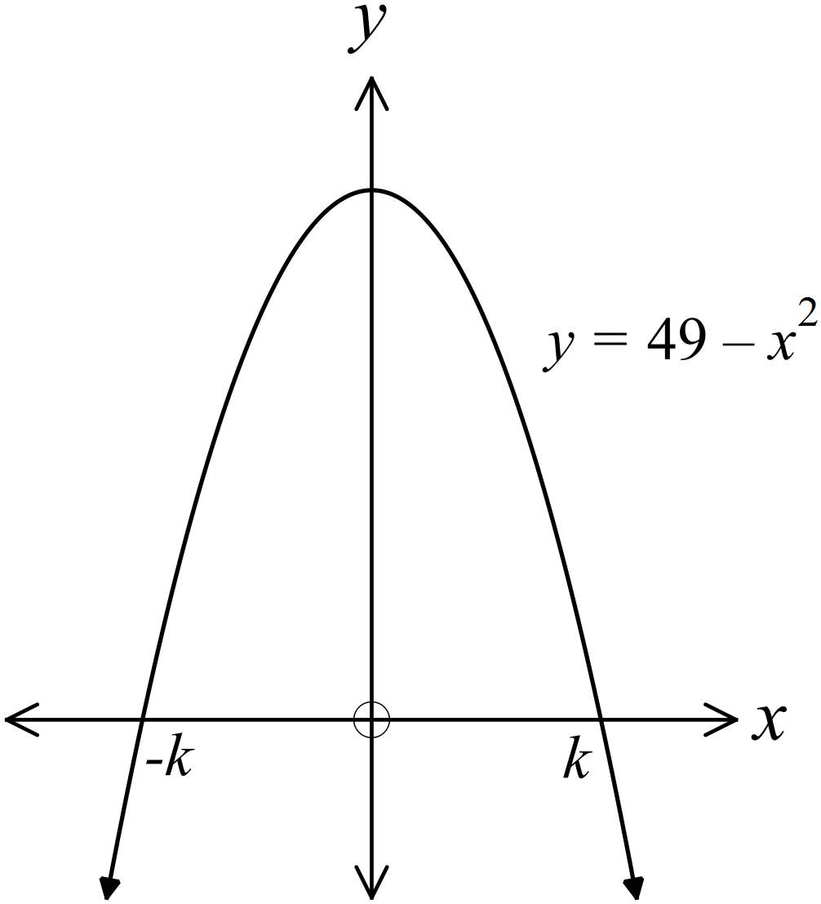The equation of the graph shown is 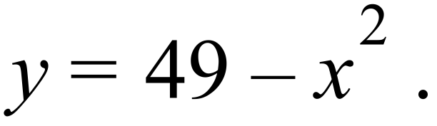
What is the value of k ?

………………………………………………

……………………………………………….

………………………………………………

……………………………………………….

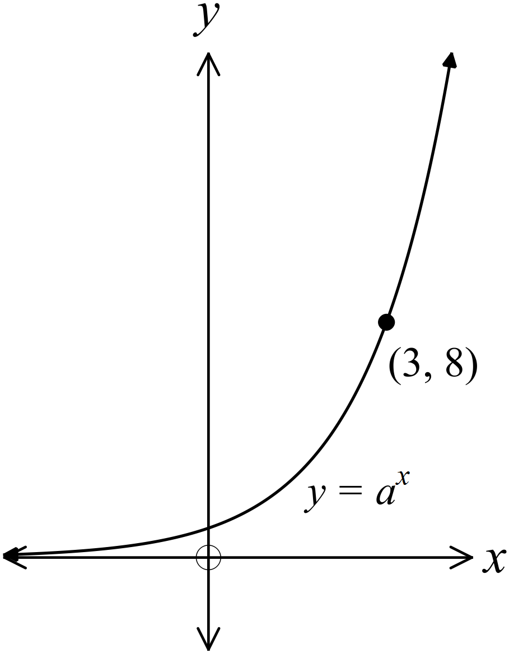The equation of the graph shown is 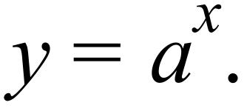
The graph passes through the point 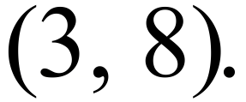

What is the value of a?

………………………………………………

……………………………………………….

………………………………………………

……………………………………………….

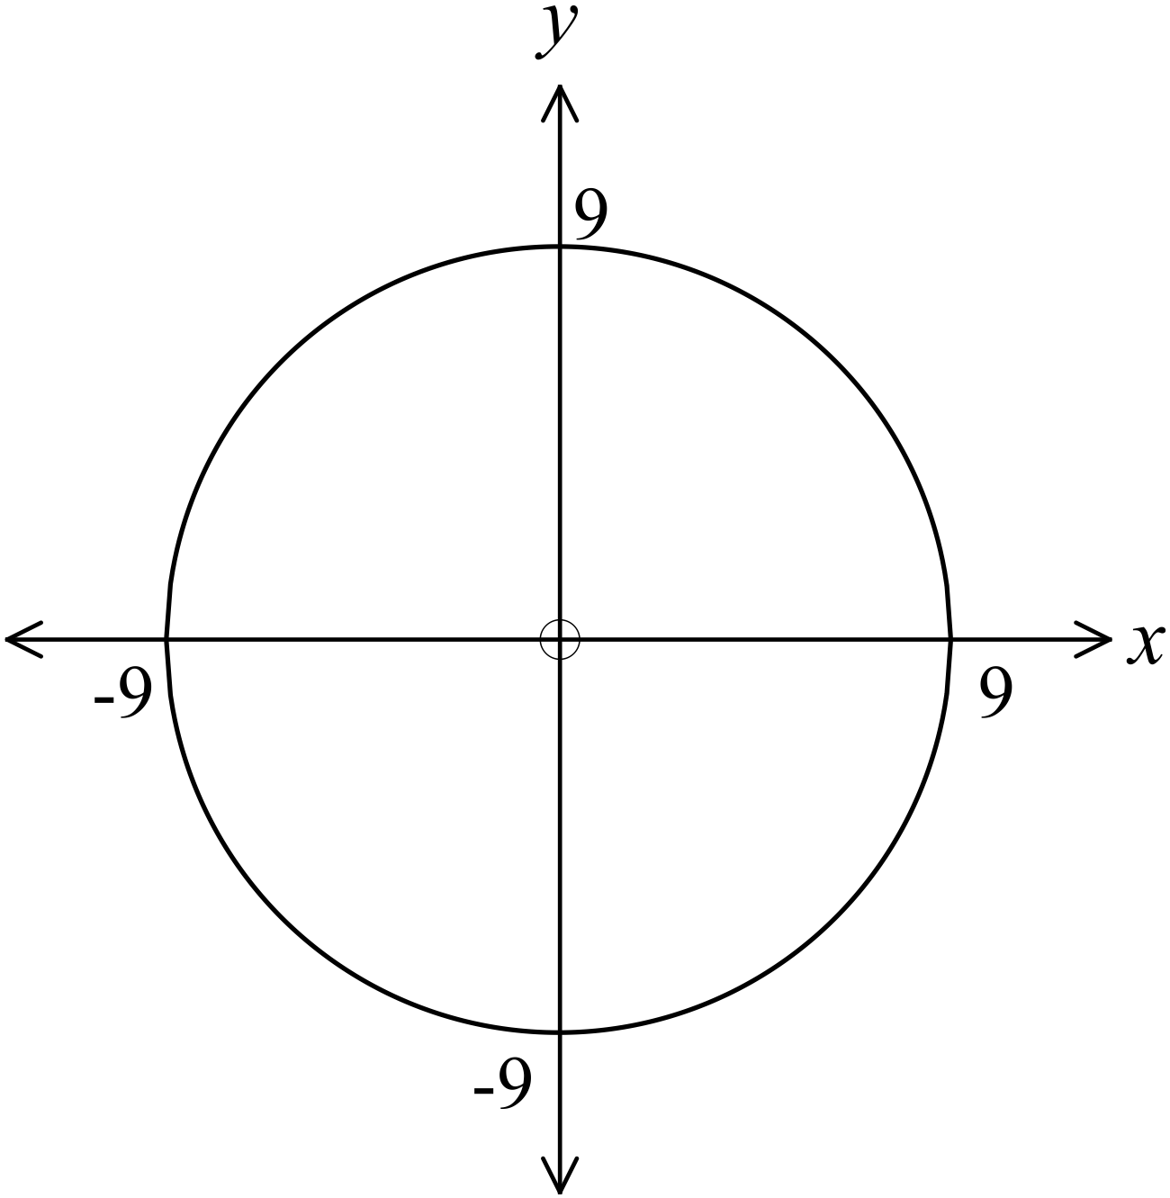The graph shown is a circle with its centre at the origin.

What is the equation of the graph?

………………………………………………

……………………………………………….

………………………………………………

……………………………………………….

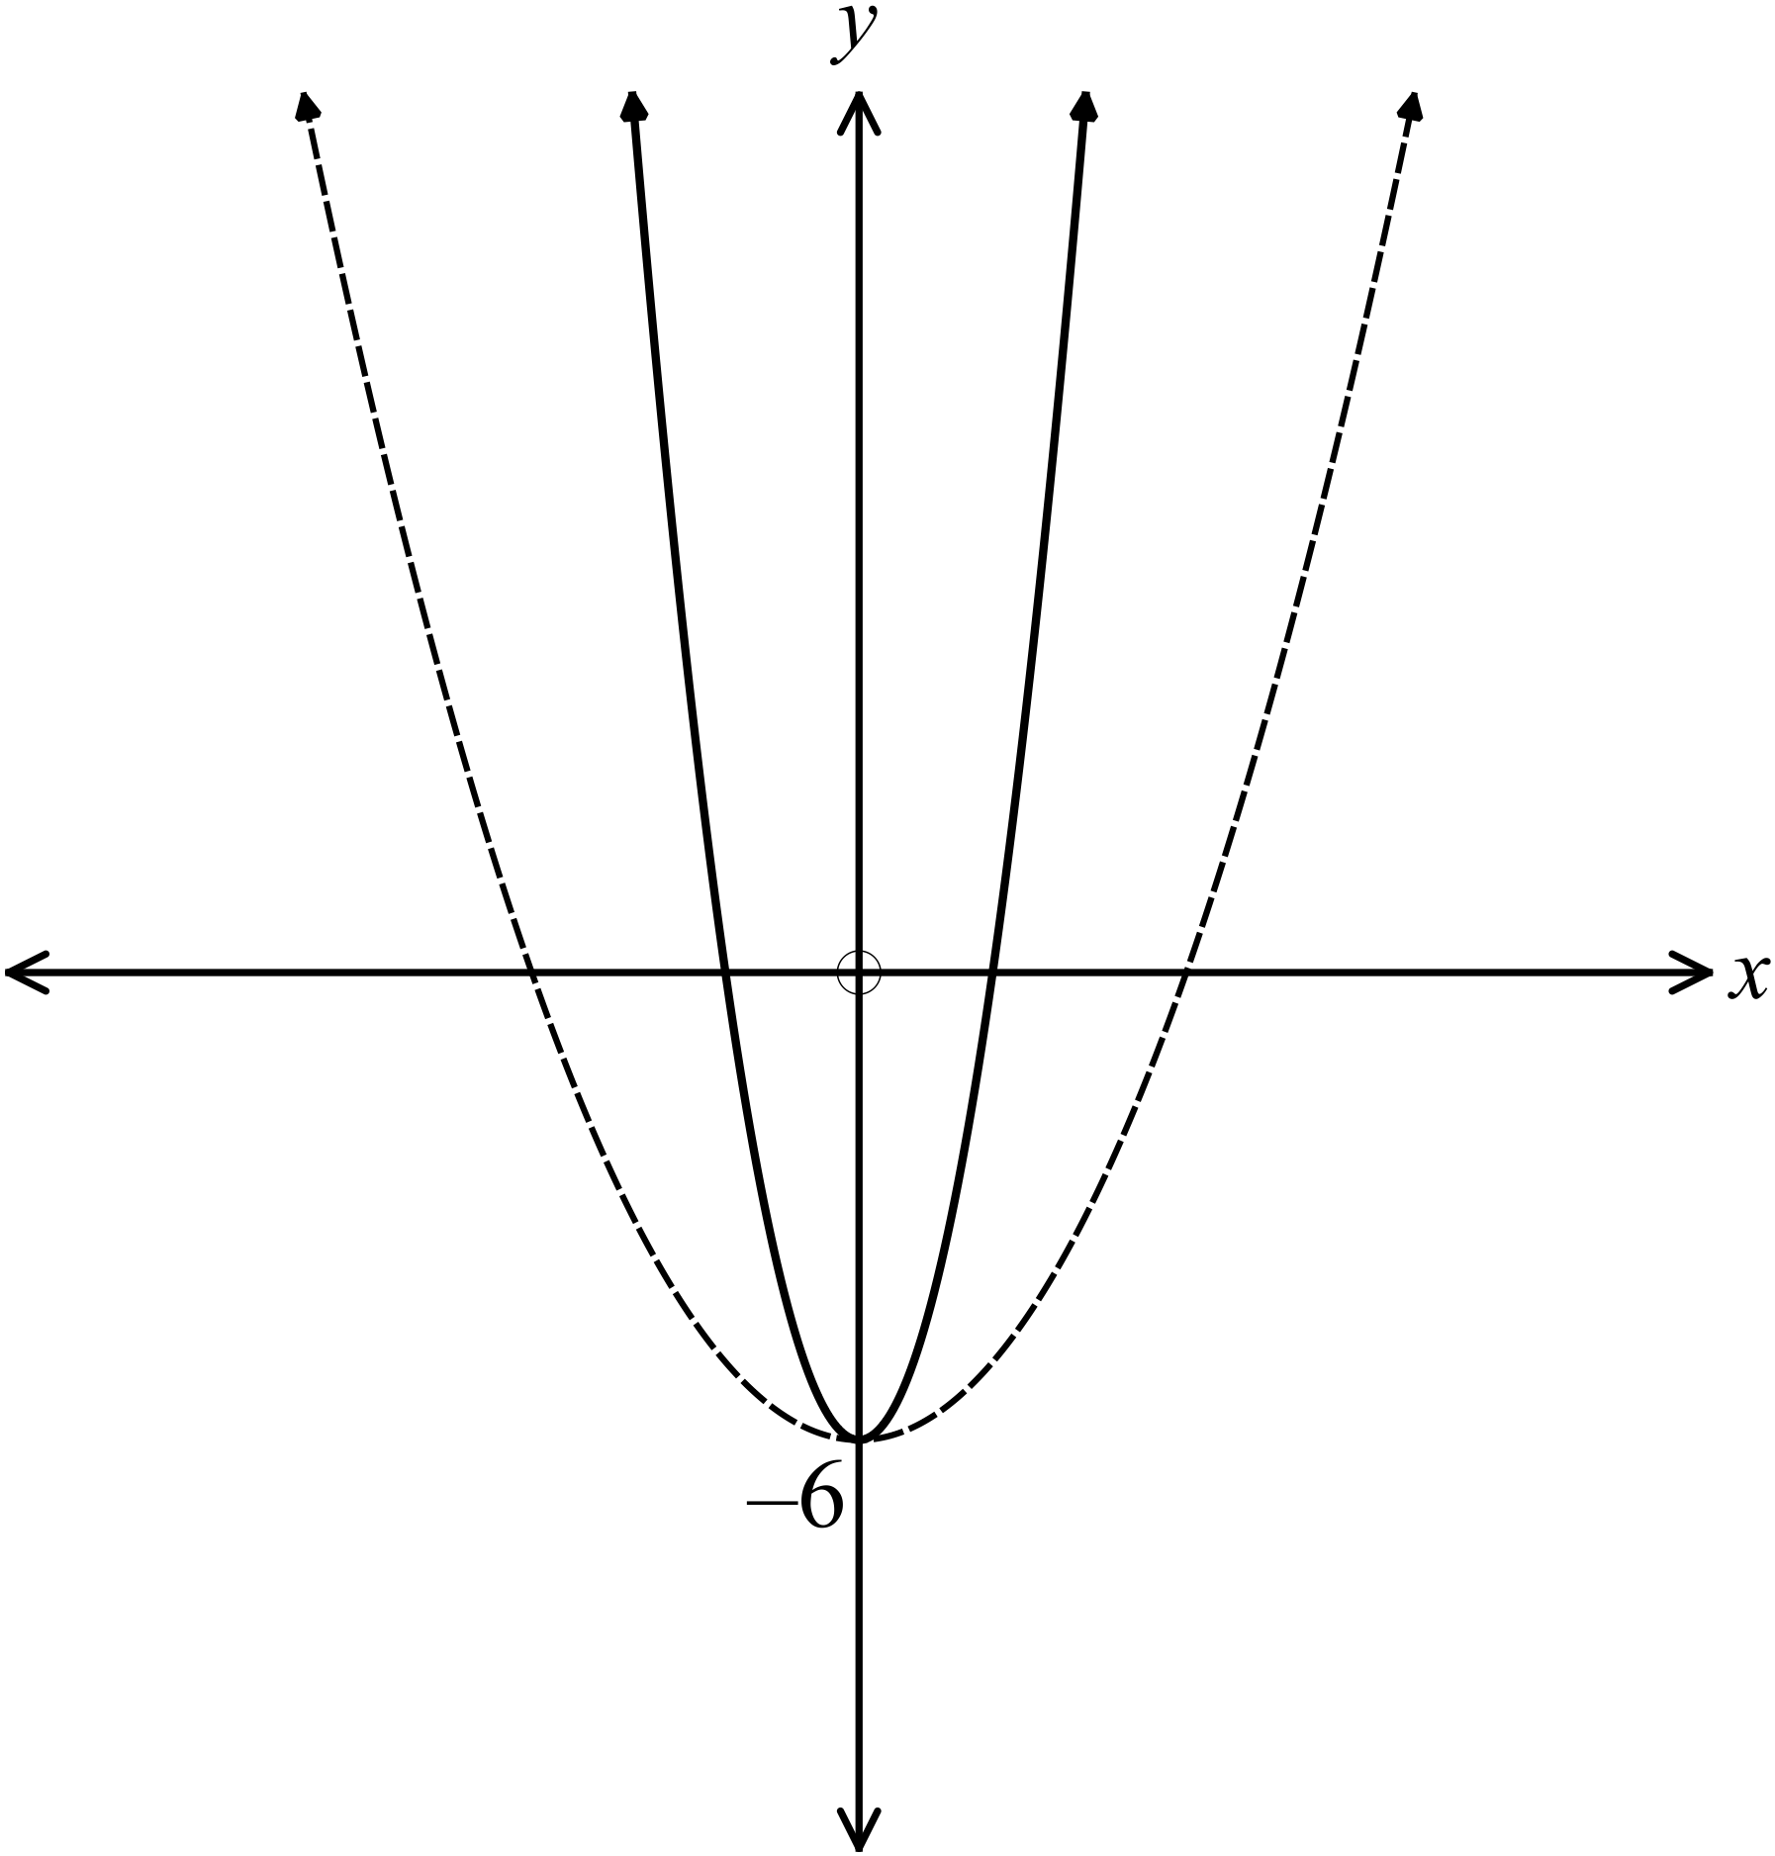The graphs of 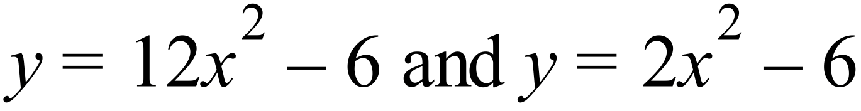 are shown.
One is drawn with a broken line and one with an unbroken line.
Describe which graph is which and explain why you made this decision.

…………………………………………………..

…………………………………………………..

………………………………………………….

………………………………………………….

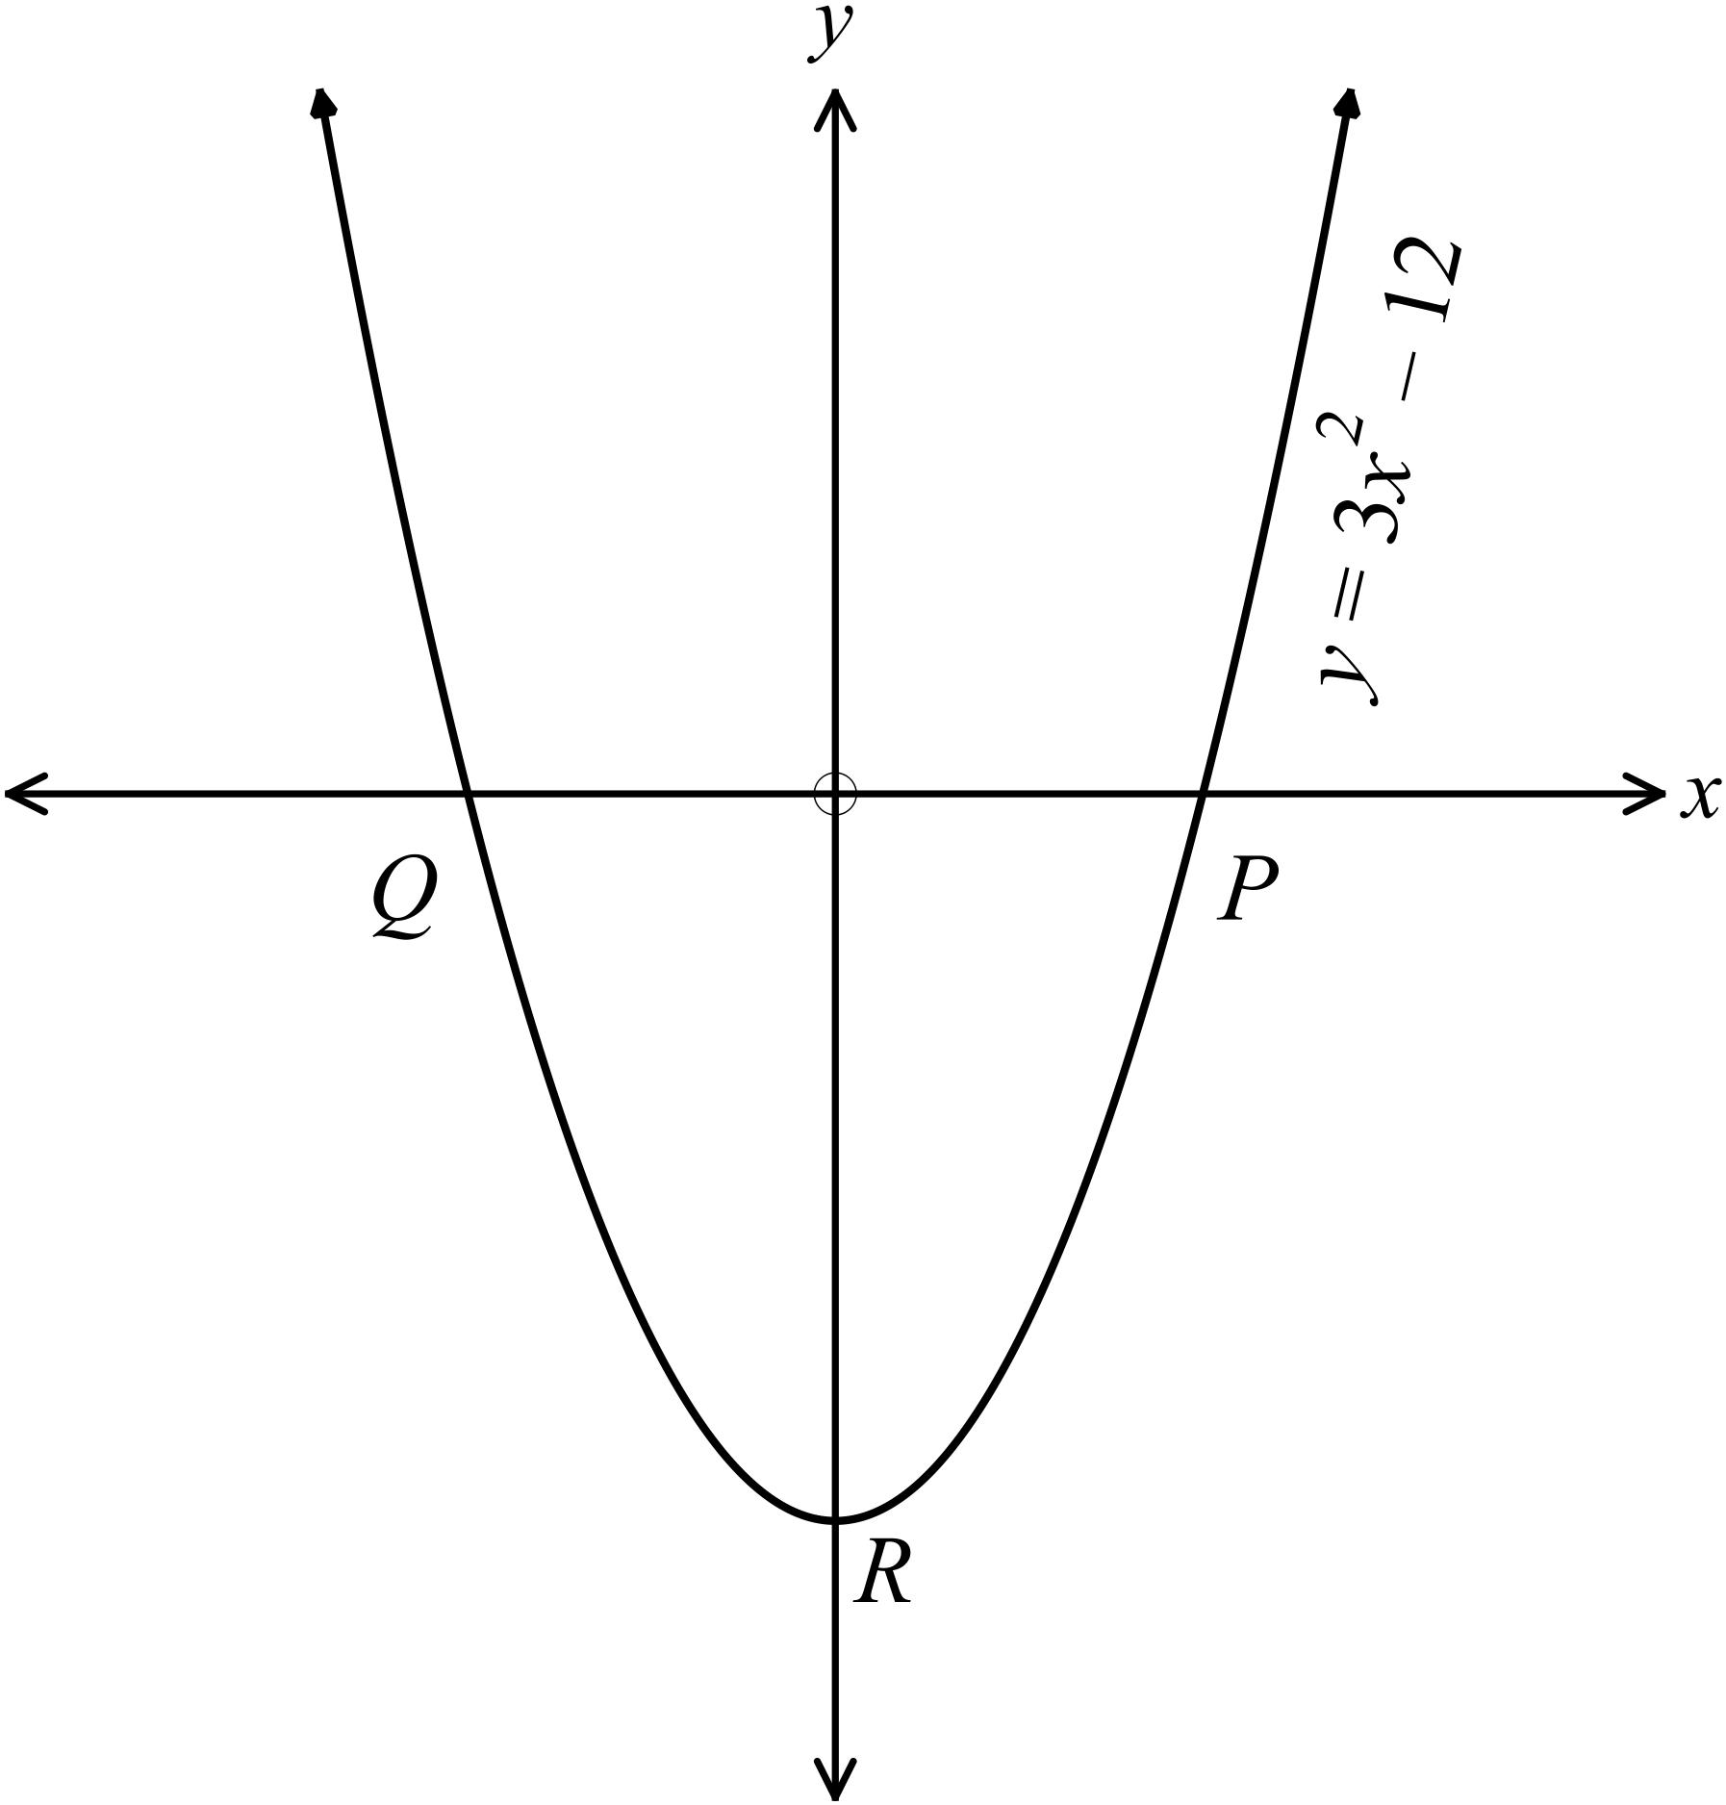The graph of 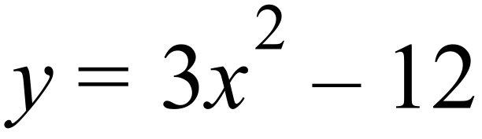 is shown.
What are the coordinates of the y intercept R?

…………………………………………

………………………………………….

………………………………………….

What are the coordinates of the x intercepts P and Q in the curve in Question 6?

…………………………………………………………………………………….

………………………………………….………………………………………….
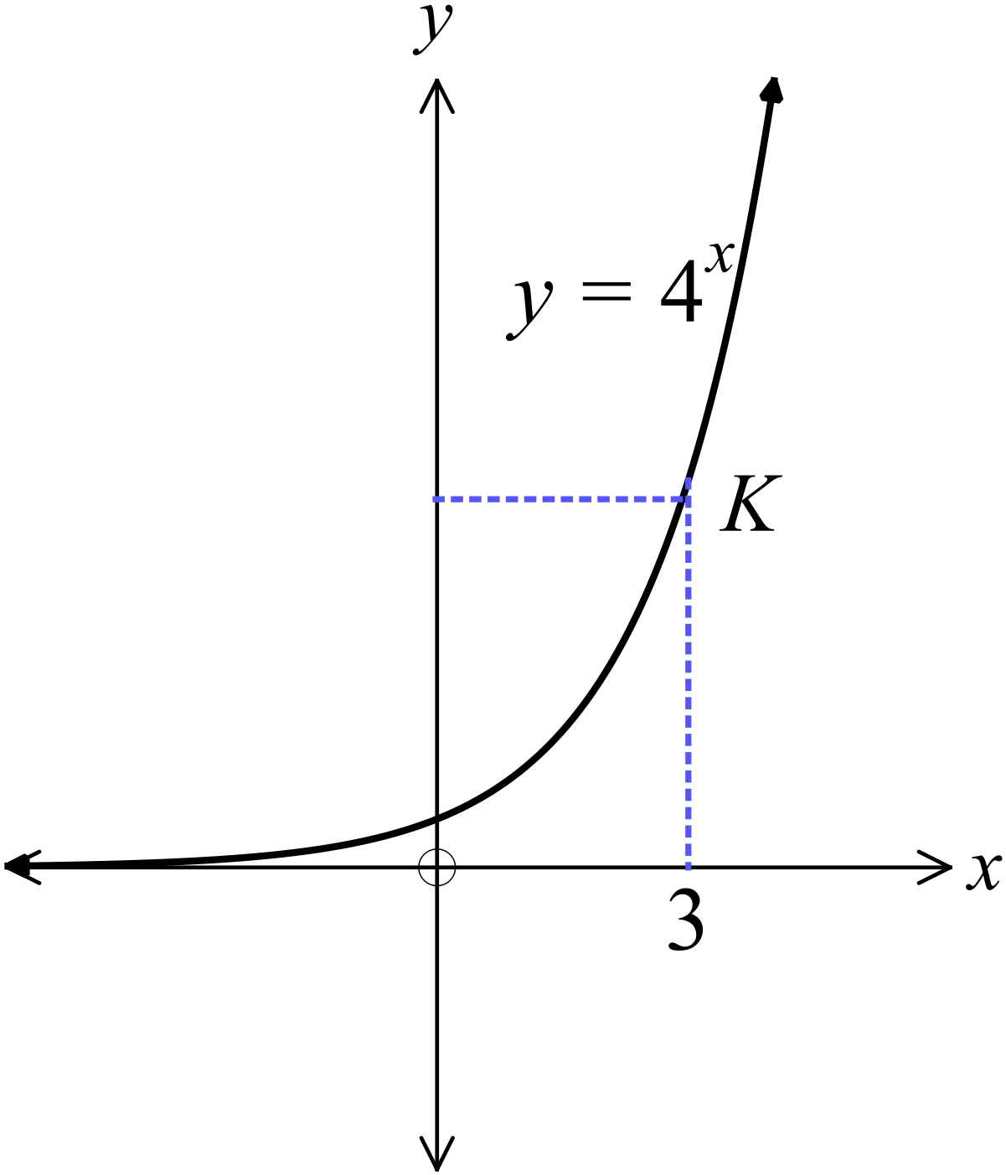The graph of 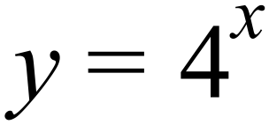 is shown.
What are the coordinates of the point K?

………………………………………………

……………………………………………….

………………………………………………

……………………………………………….

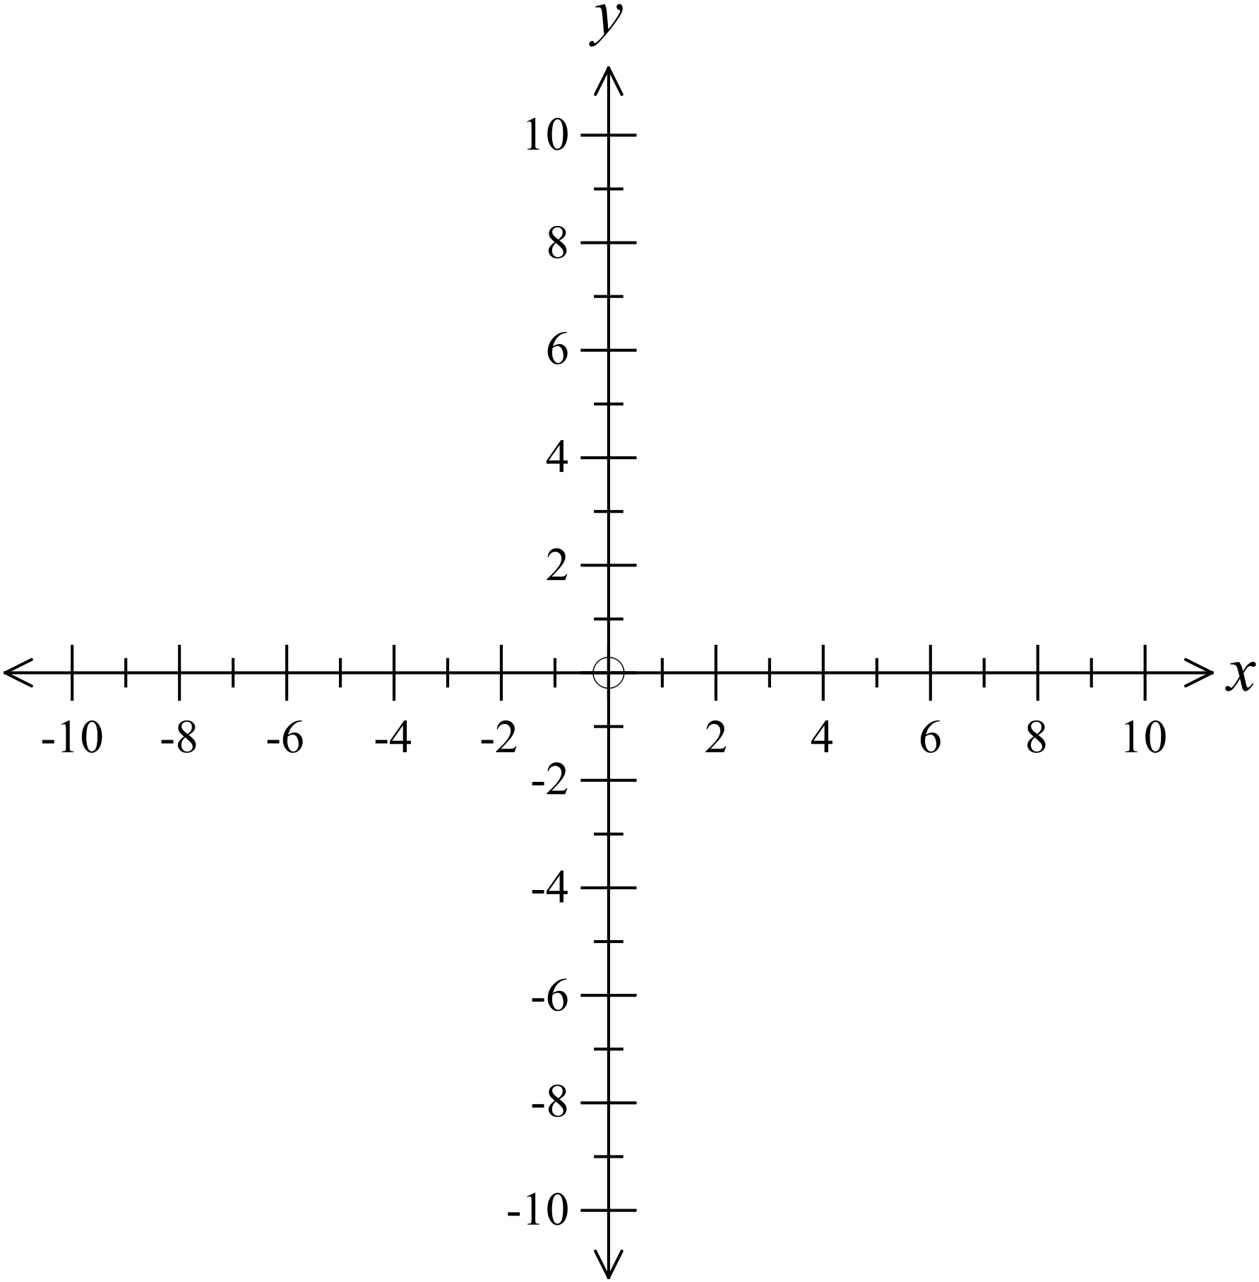Sketch the circle which has an equation 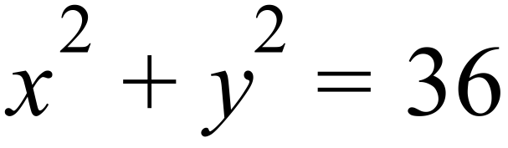

………………………………………………

……………………………………………….

………………………………………………

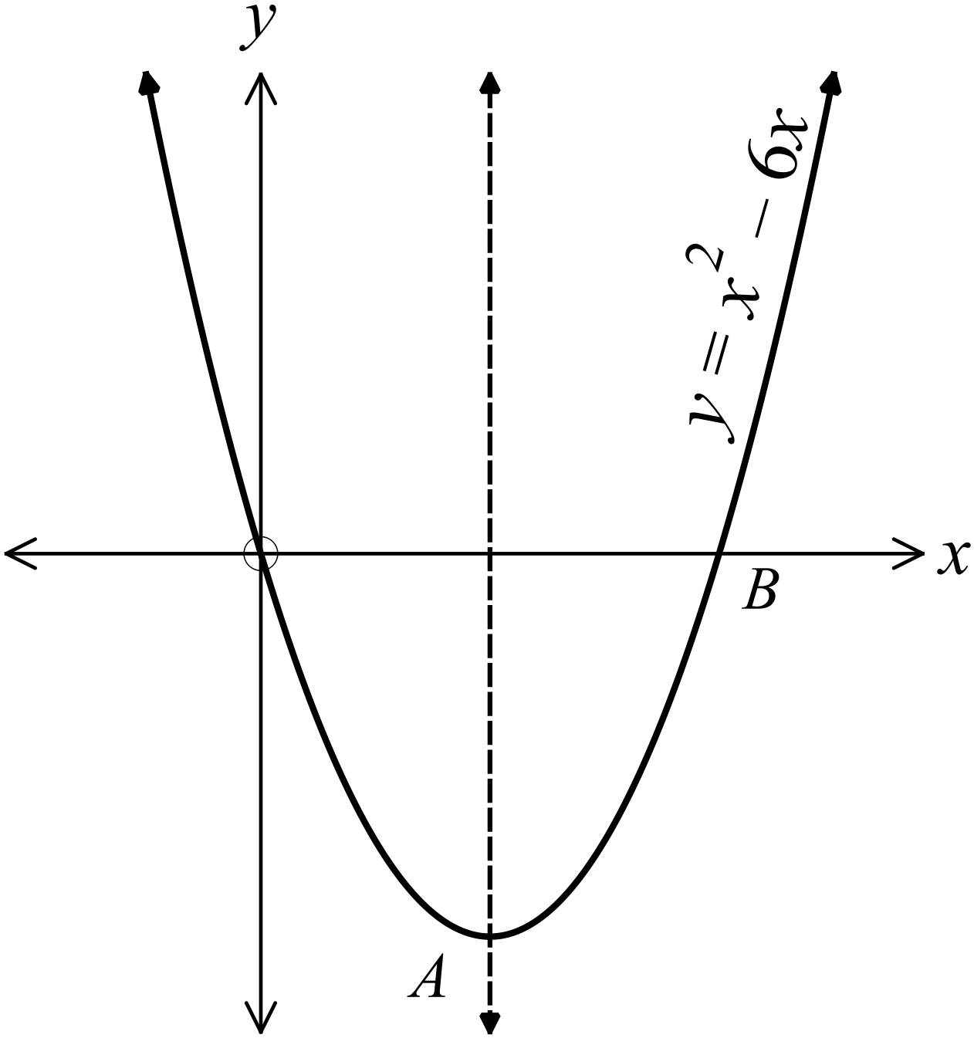The graph of 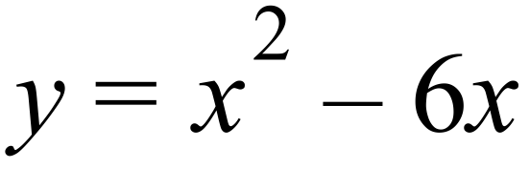 is shown.
The dotted line is its axis of symmetry.

What are coordinates of the x intercept B?

…………………………………………

………………………………………….

………………………………………….

In the graph in question 10, what are coordinates of the vertex A?

……………………………………………………………………………………

………………………………………….…………………………………………

………………………………………….…………………………………………
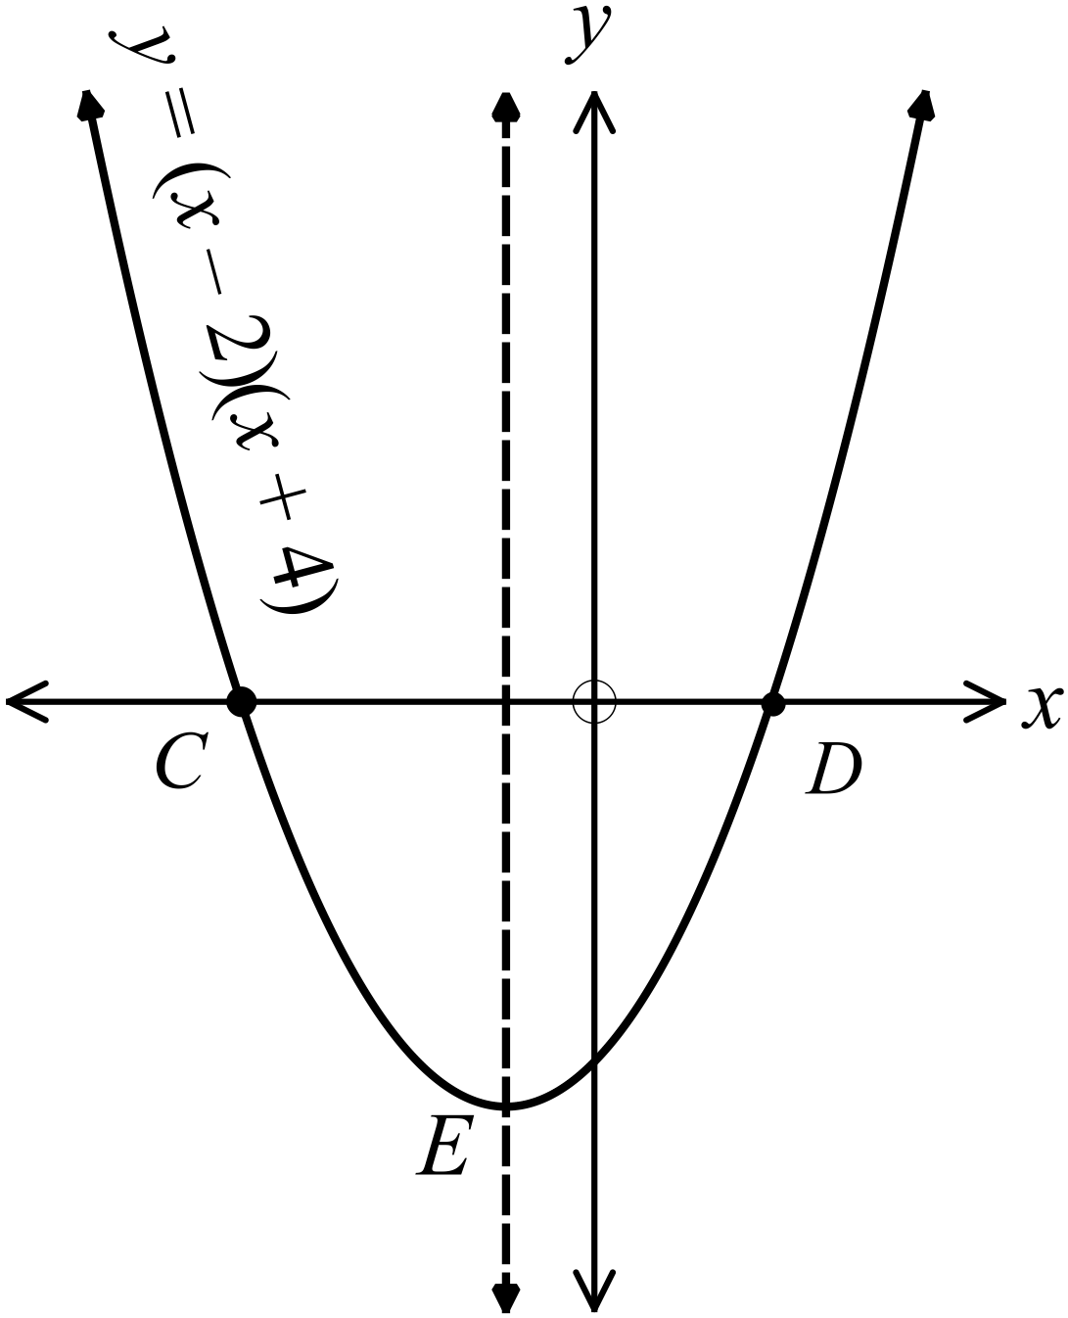The curve below has equation 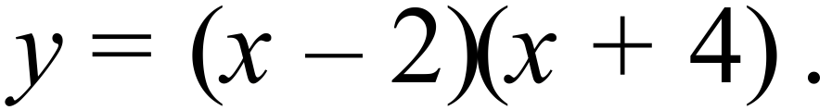
The axis of symmetry is shown by the broken line.
What are the coordinates of the points C and D ?

………………………………………………

……………………………………………….

………………………………………………

In the graph in question 12, what are coordinates of the vertex E?

……………………………………………………………………………………

………………………………………….…………………………………………

………………………………………….…………………………………………
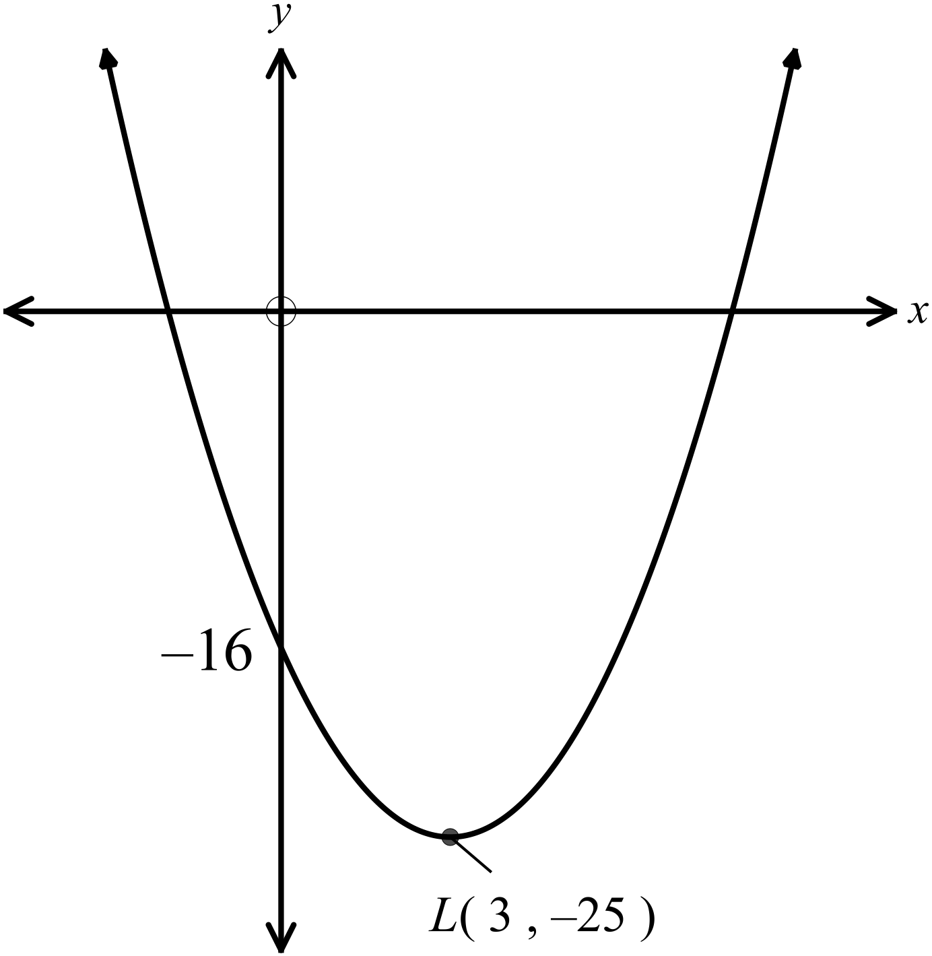The equation of the parabola shown is
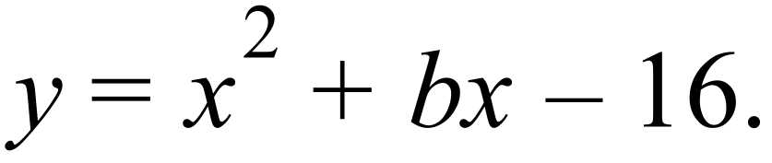

What is the value of b?

………………………………………………

……………………………………………….

………………………………………………

……………………………………………….

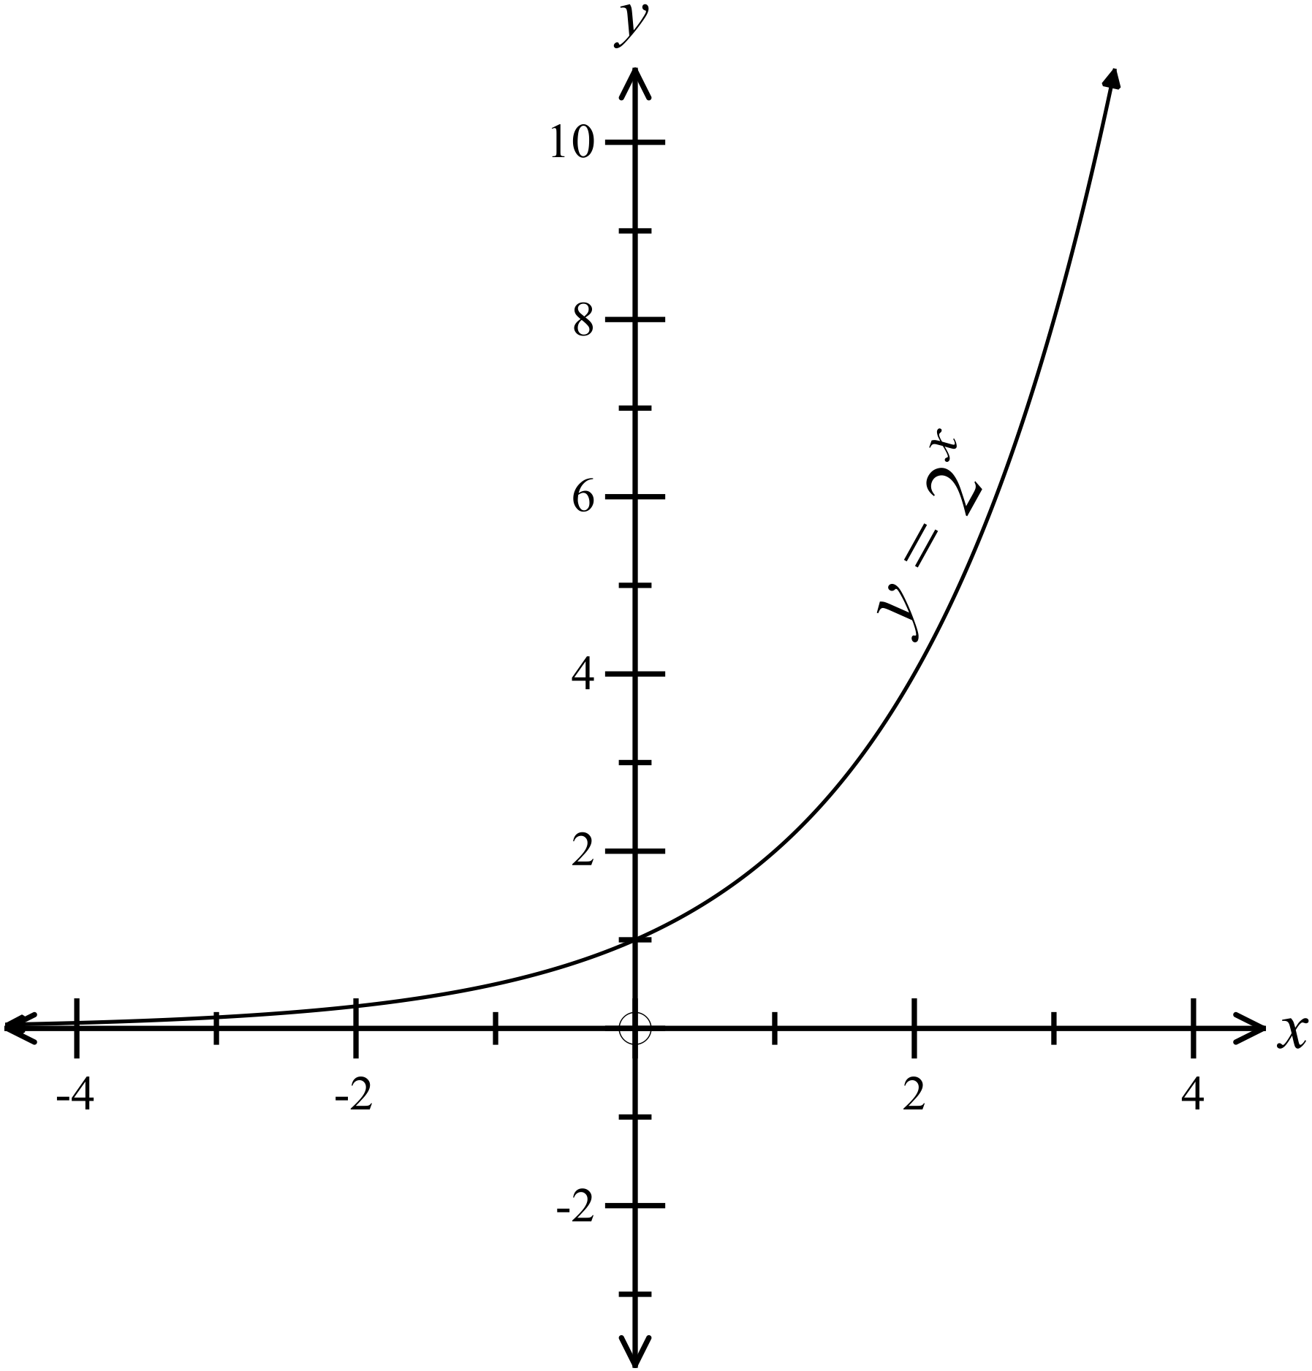The graph of 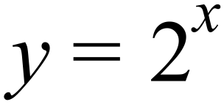 is shown.
Draw a quick sketch, on the same set of axes, of 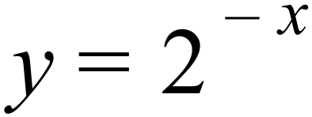

……………………………………………

…………………………………………….

………………………………………………

What is the centre and radius of the circle which has an equation of 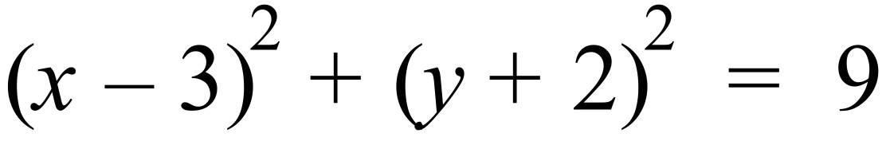

……………………………………………………………………………………………….

……………………………………………………………………………………………….

Year 10 |  | Non Linear Relations | Calculator Allowed
 |  | Non Linear Relations | Name_________________
Section 2 Multiple Choice Section
Mark all your answers on the accompanying multiple choice answer sheet, not on this test paper. You may do any working out on this test paper. Calculators are allowed for this section.

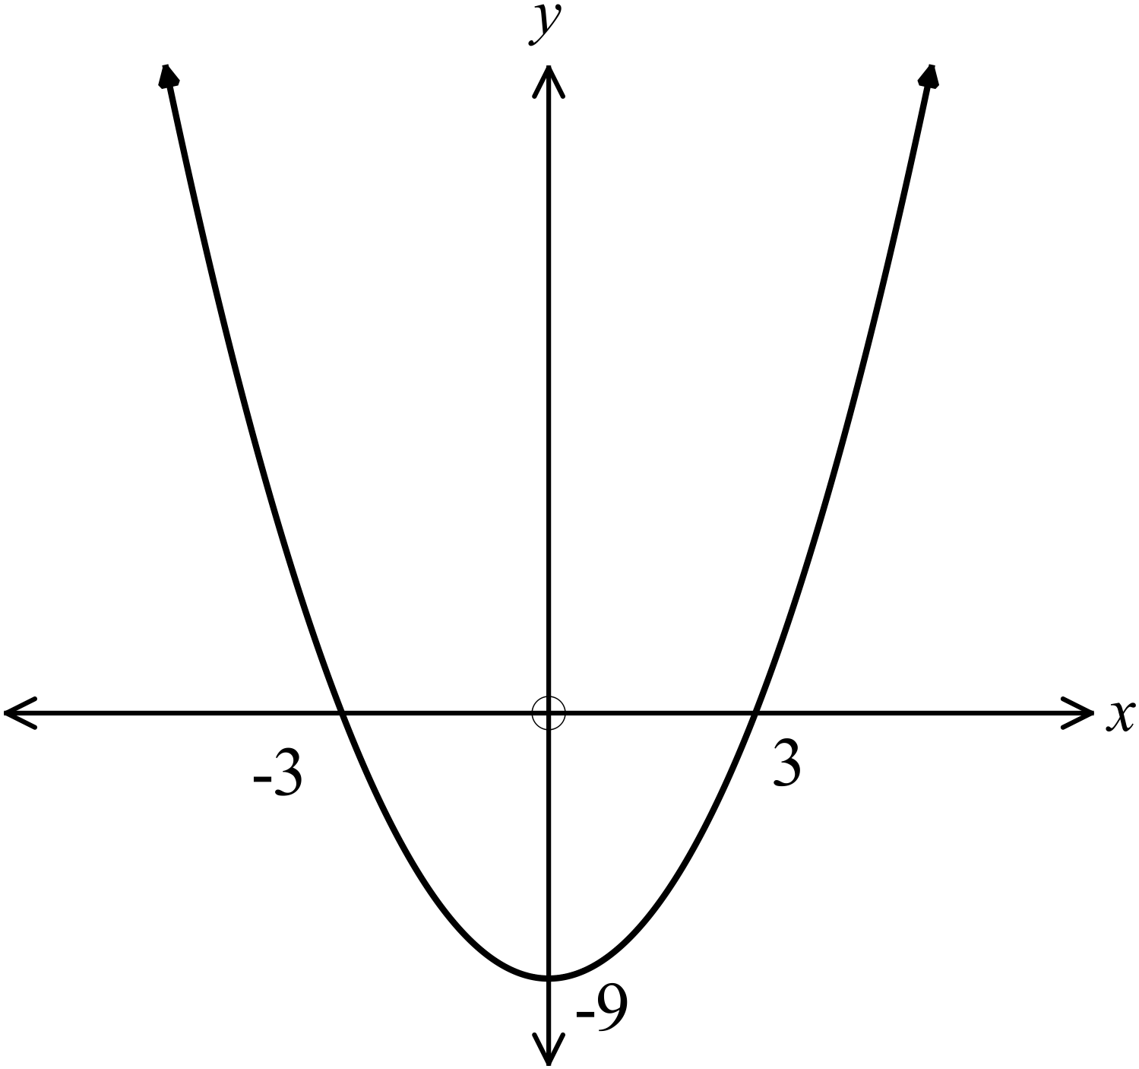Which equation could describe the graph shown?

A. 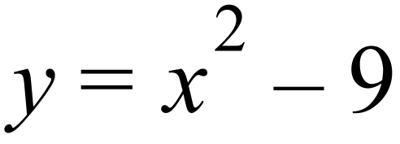
B. 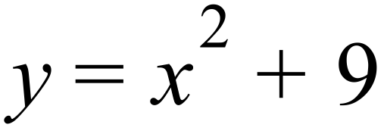
C. 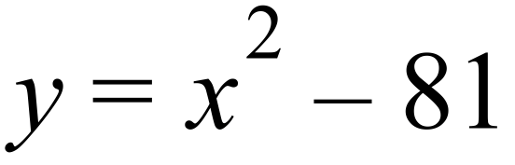
D. 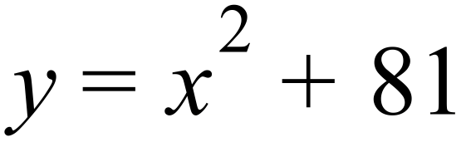

Which graph below could have an equation of 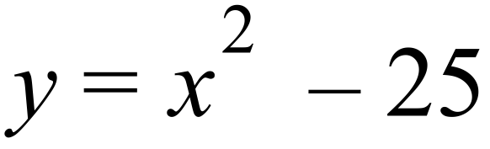 ?
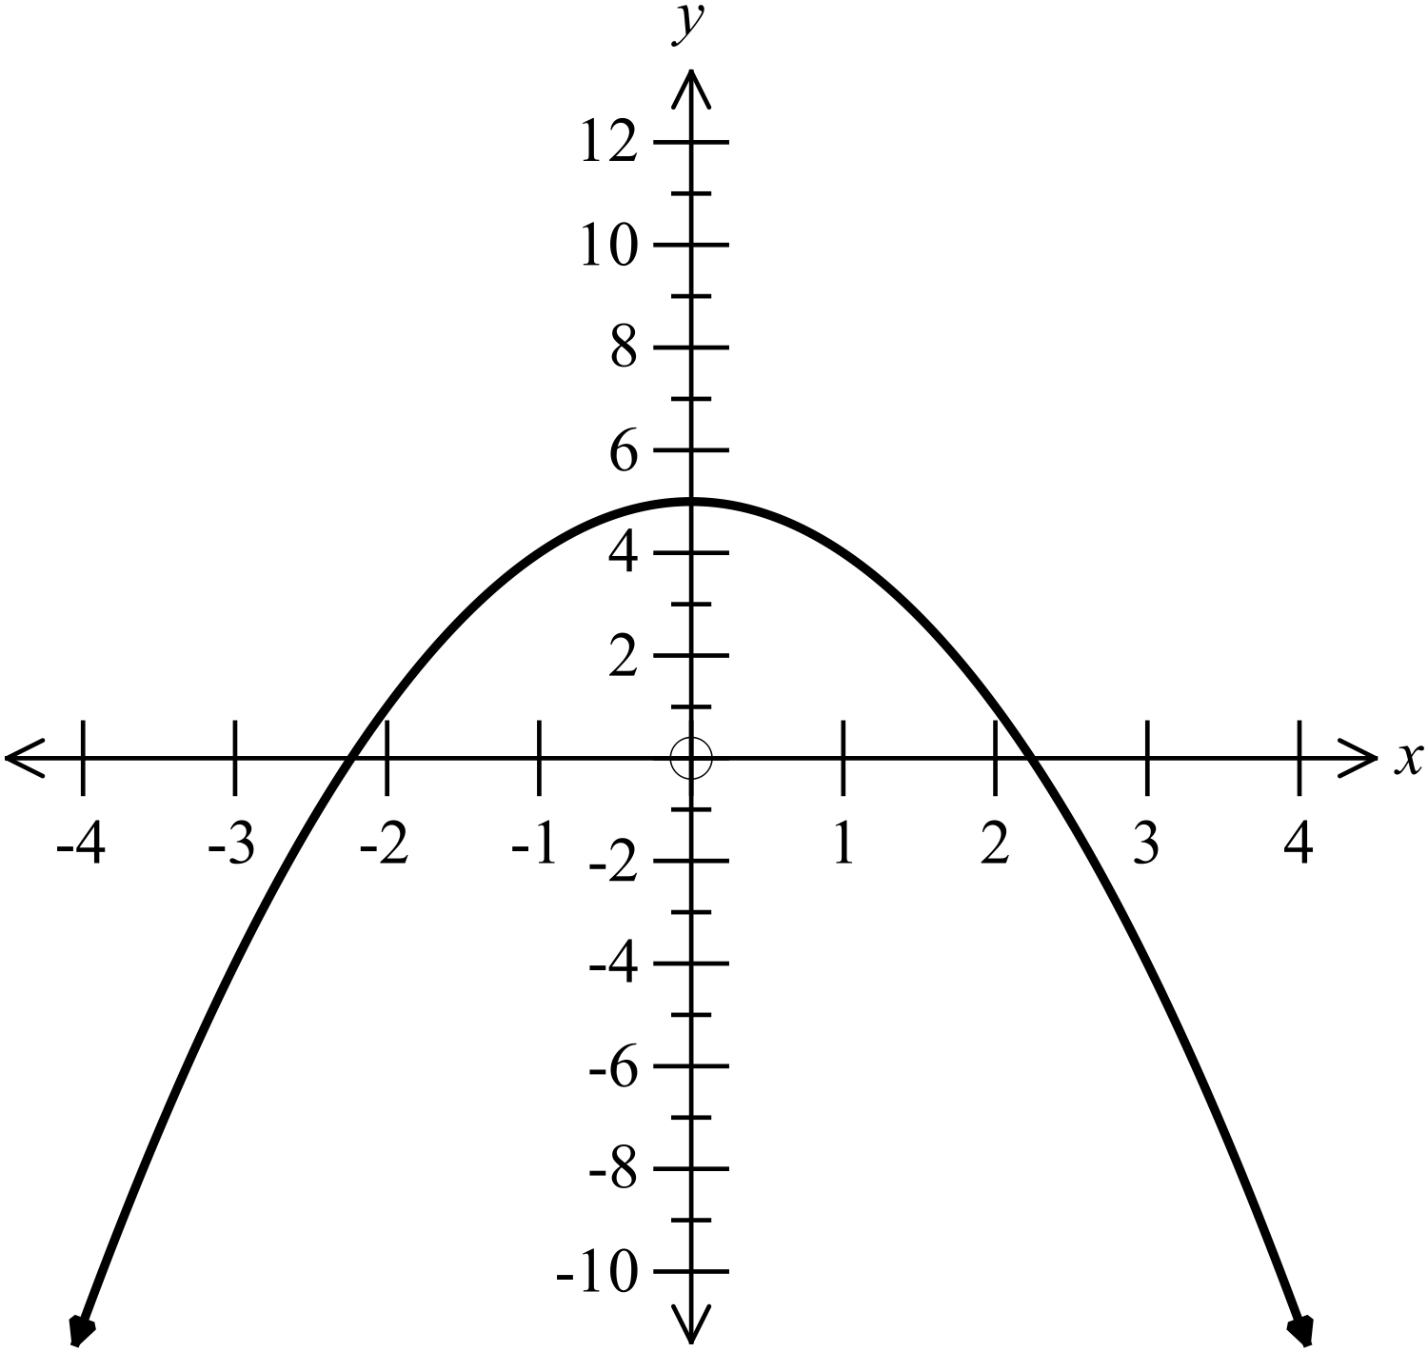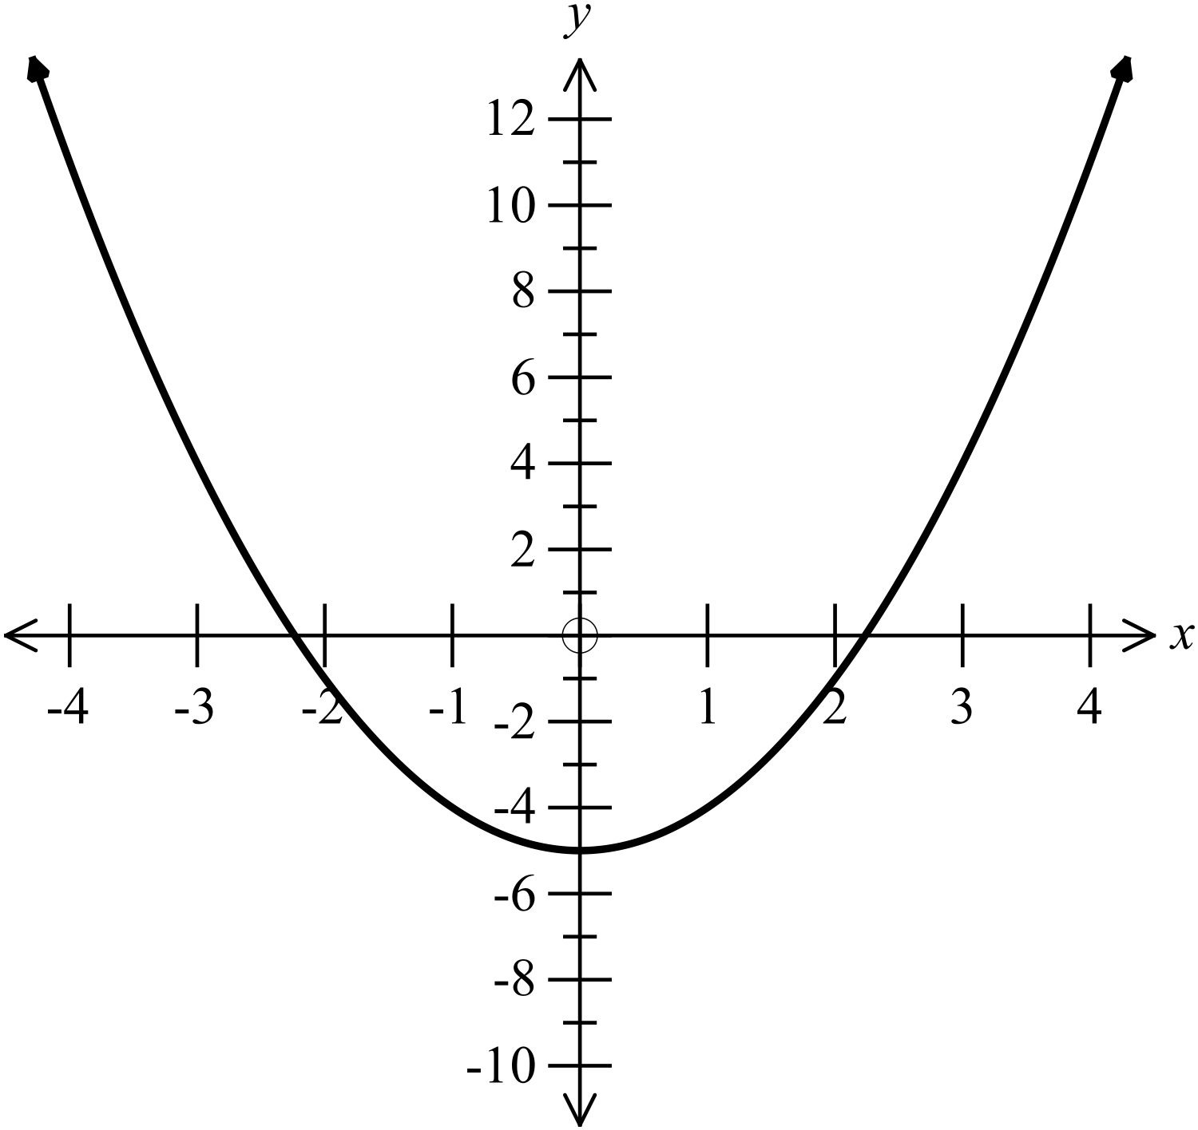A. B.

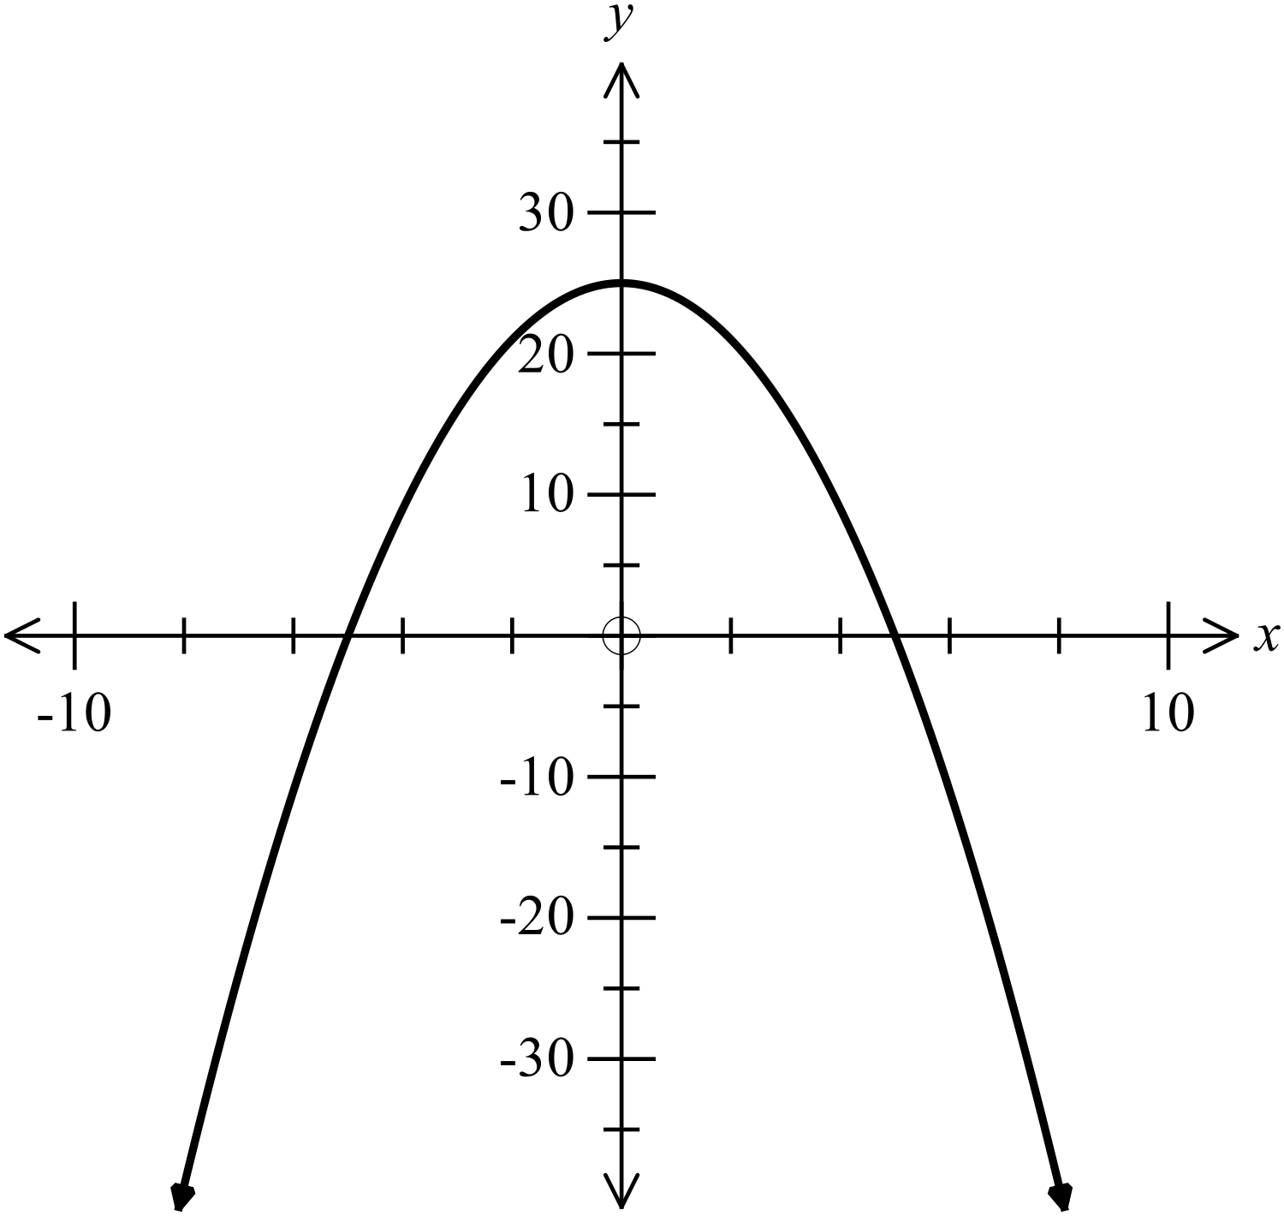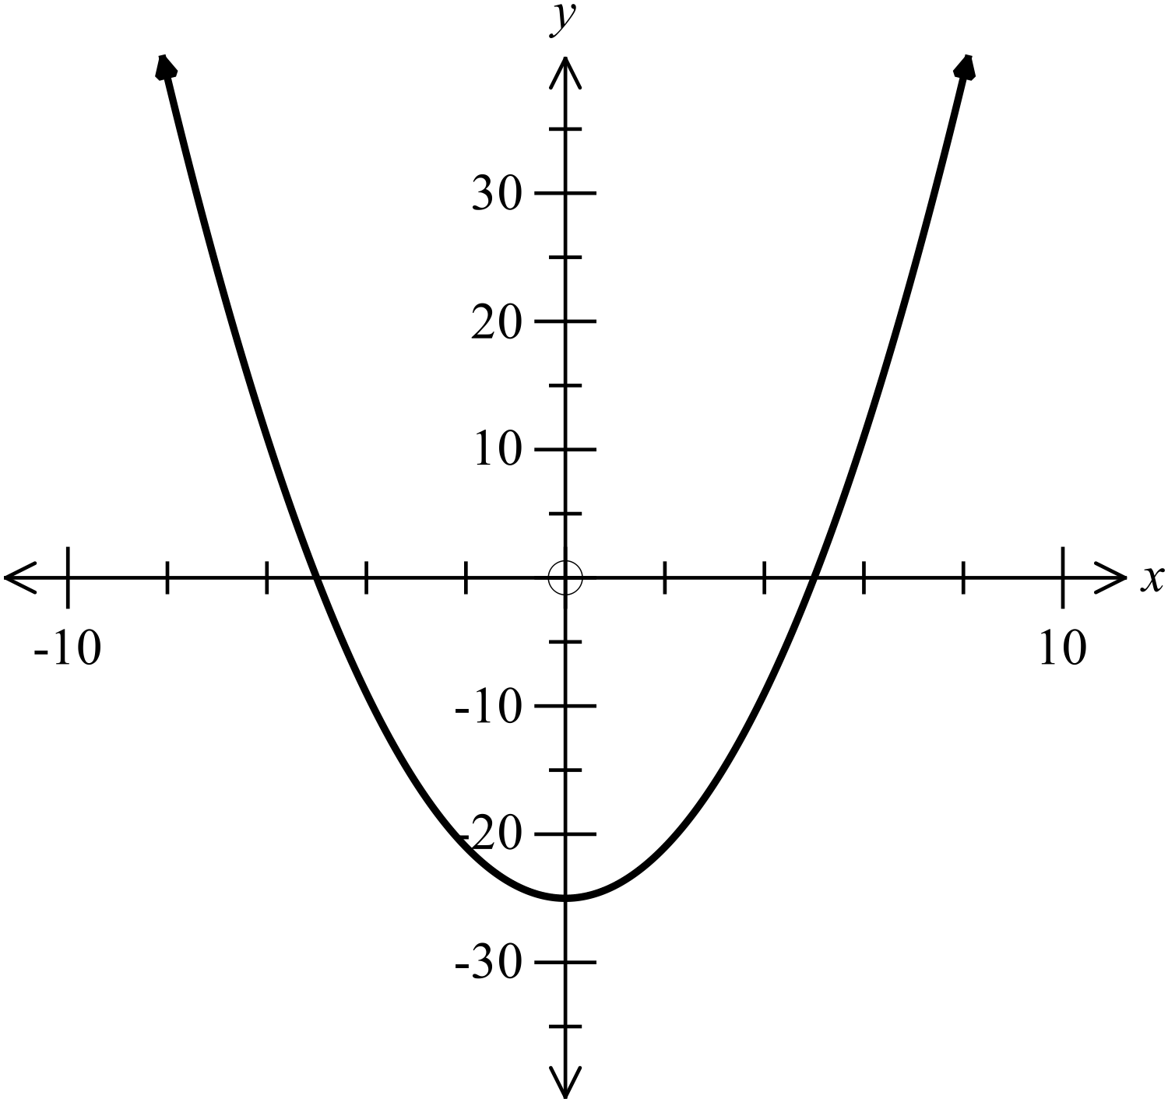C . D.

Which equation would not represent a parabola?

A. 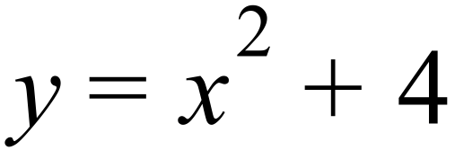 B. 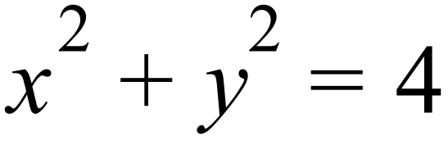 C. 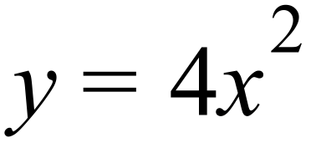 D. 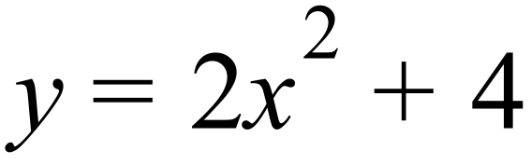
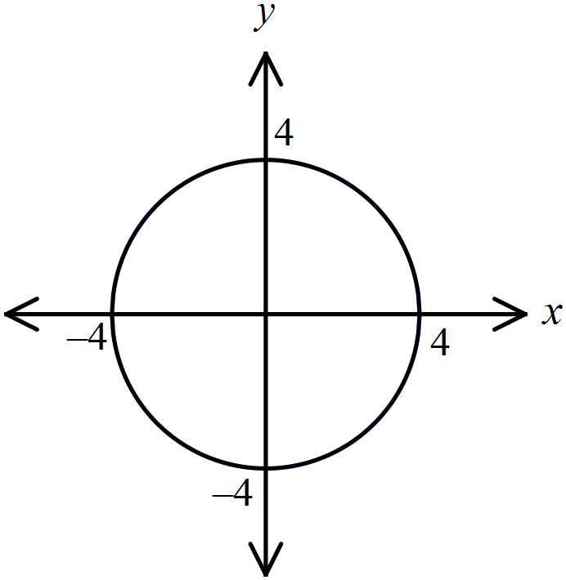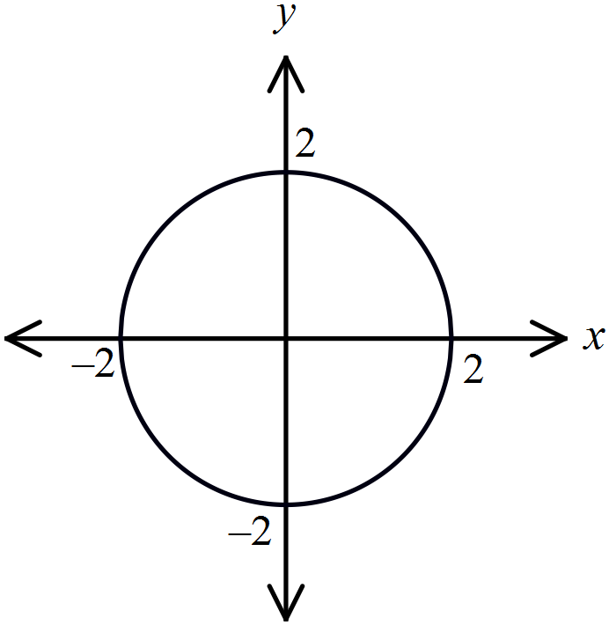
A. B.

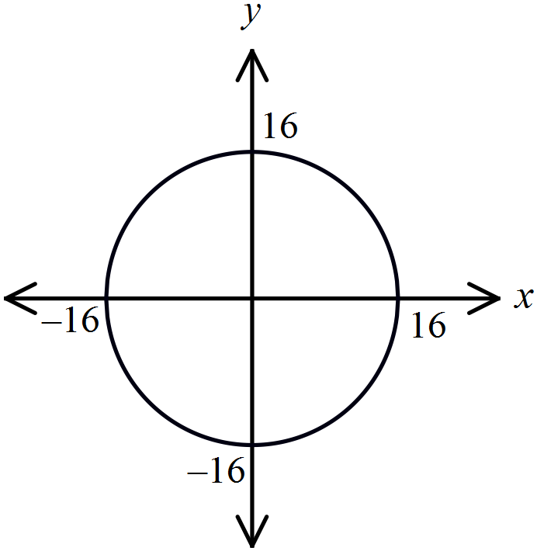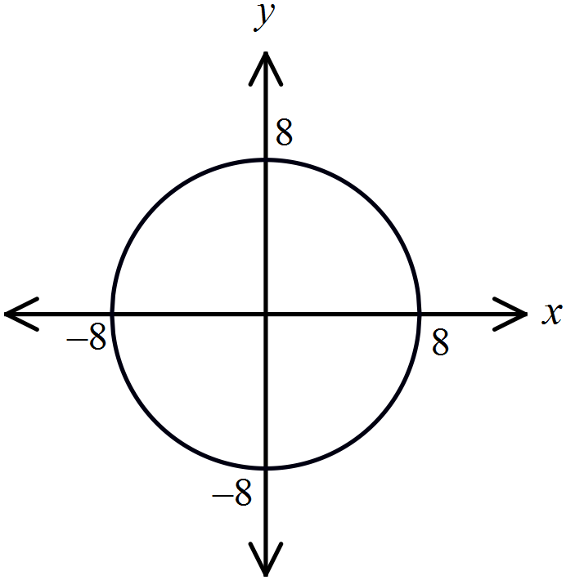
C. D.

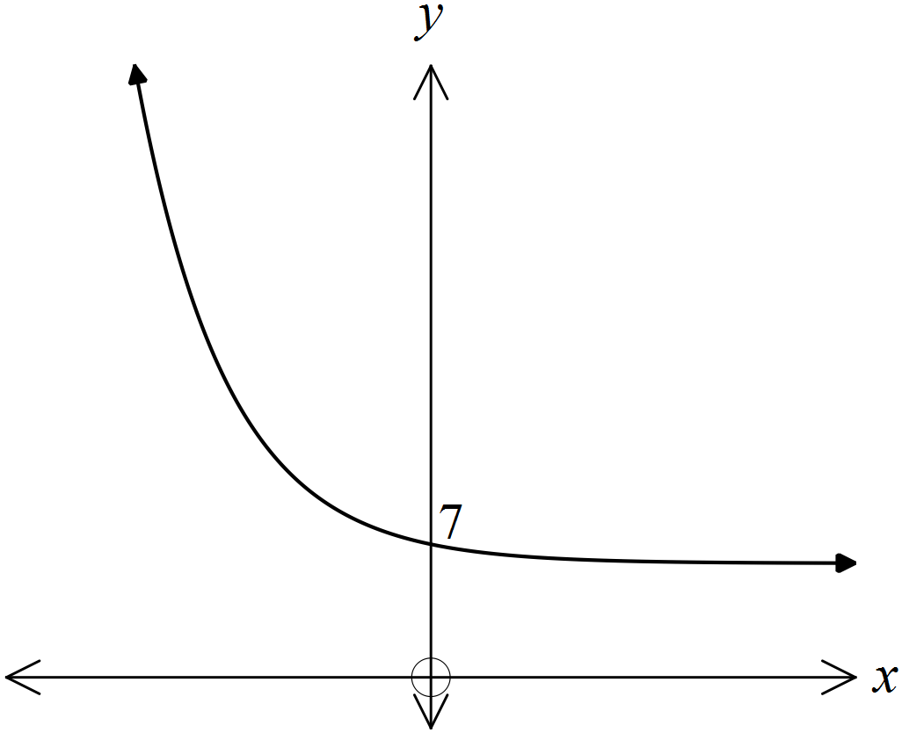Which equation could describe the graph shown?

A. 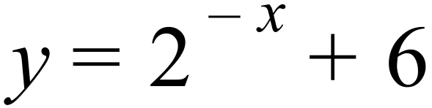

B. 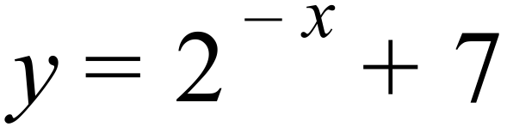

C. 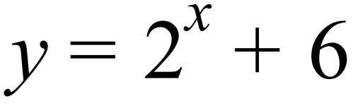

D. 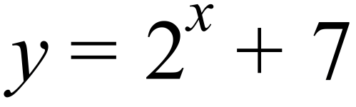

Which curve has a vertex at 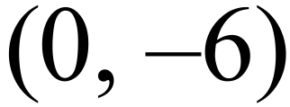?

A. 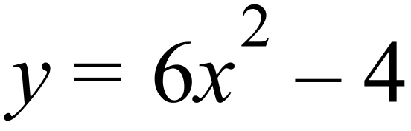 B. 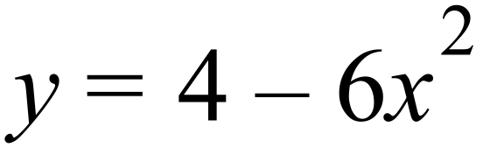 C. 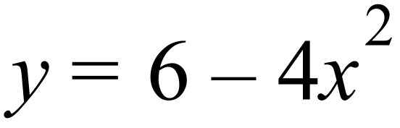 D. 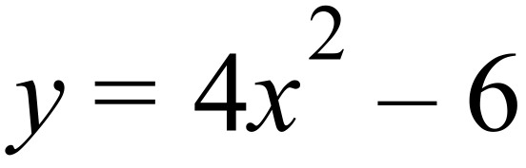

Which diagram below could be the graph of 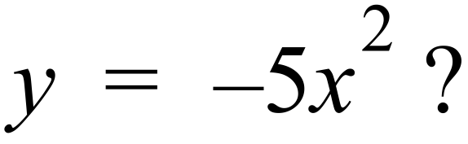

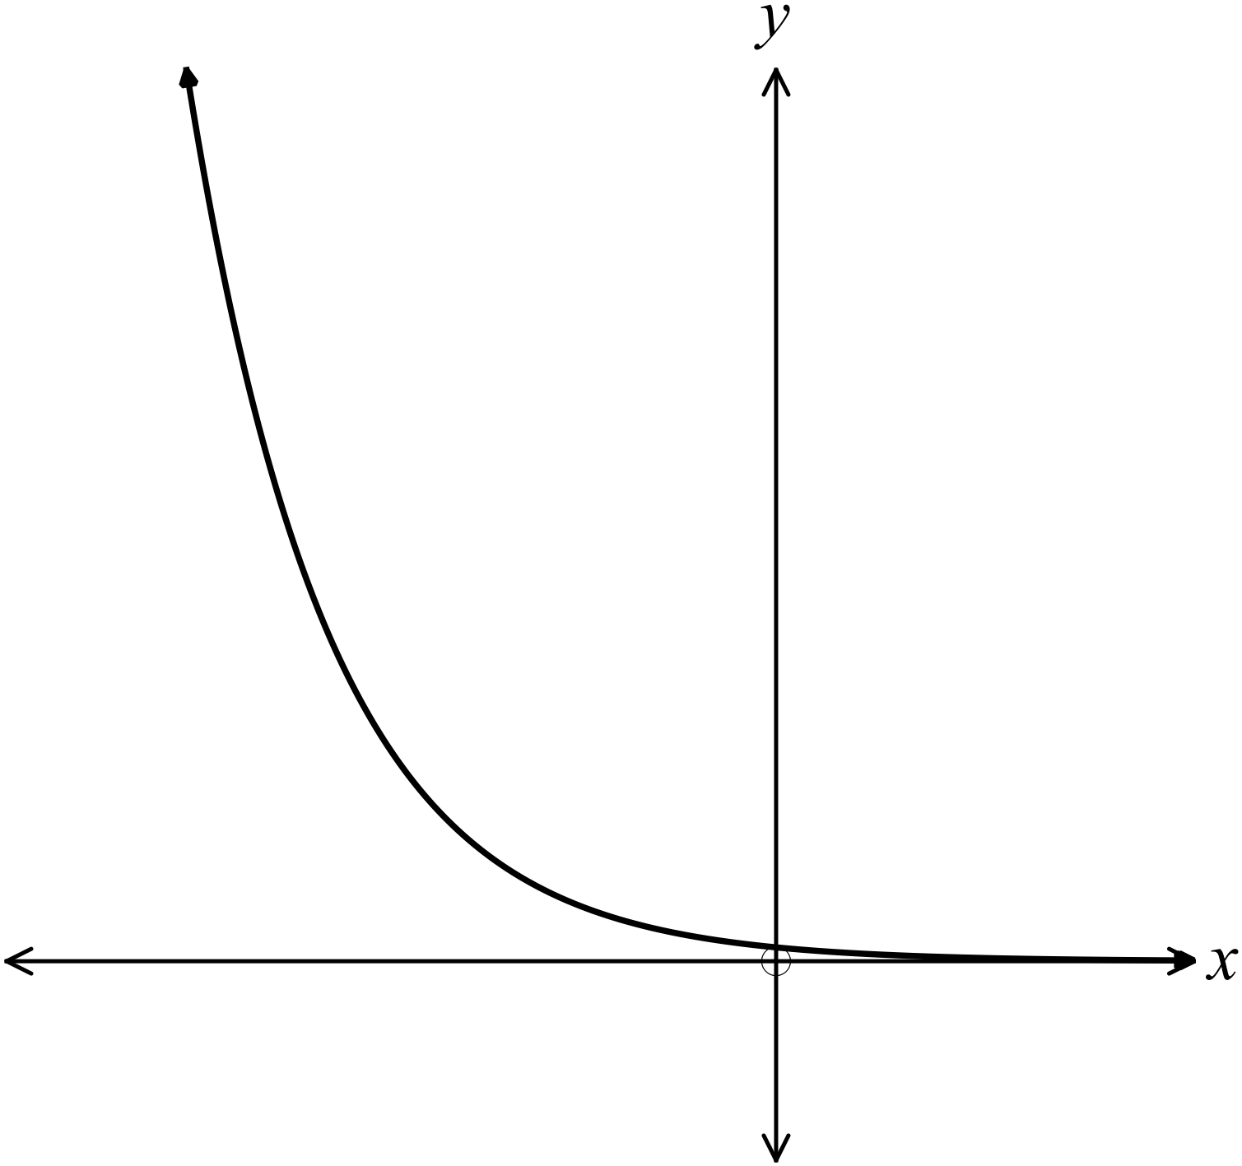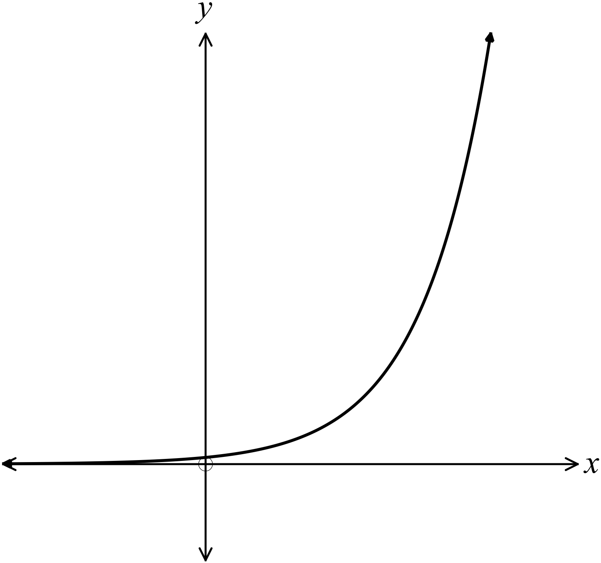A. B.

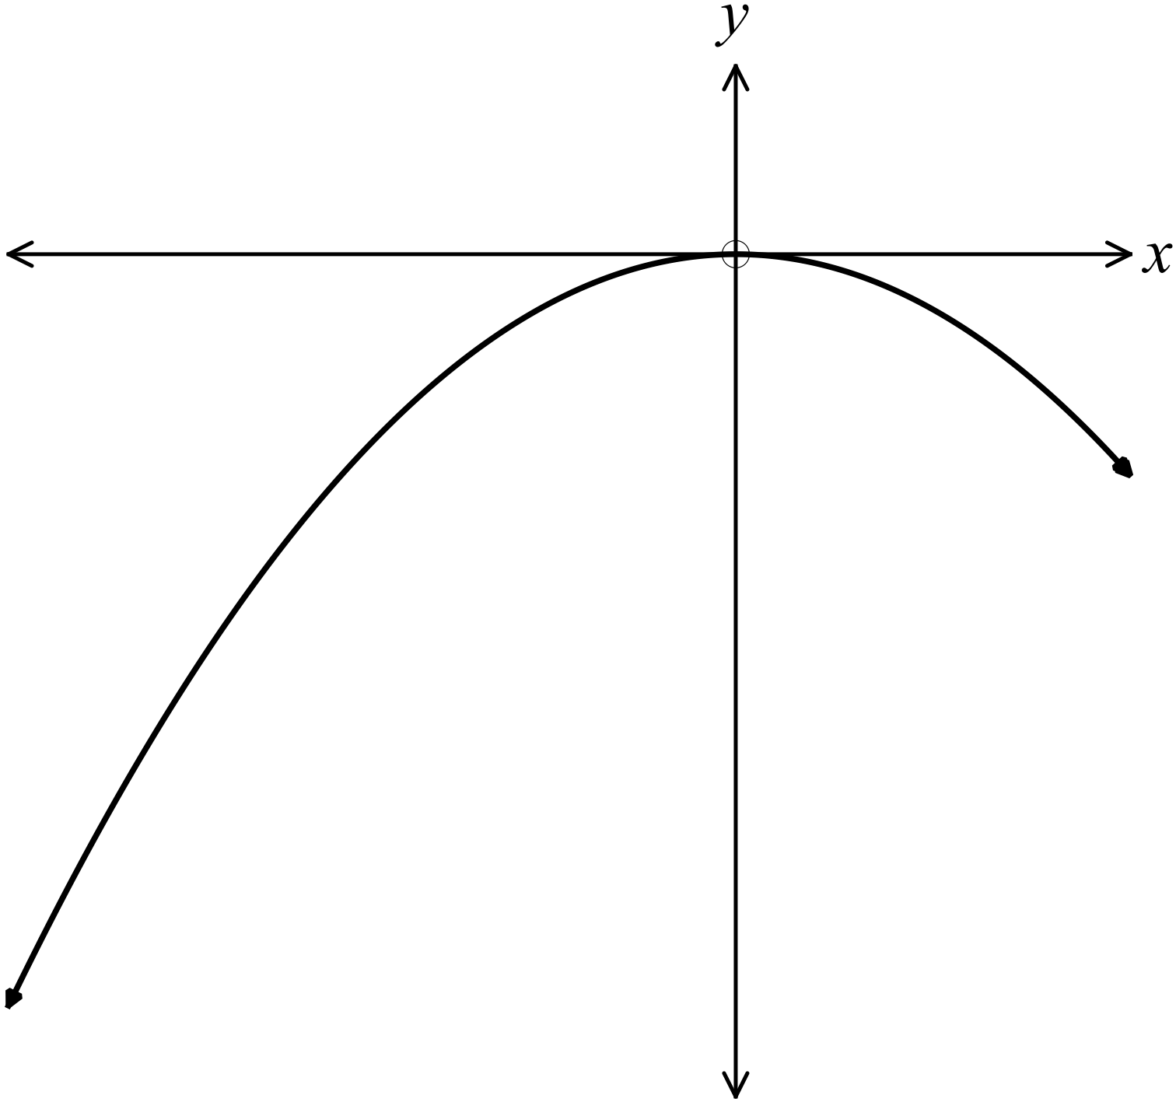C . D.
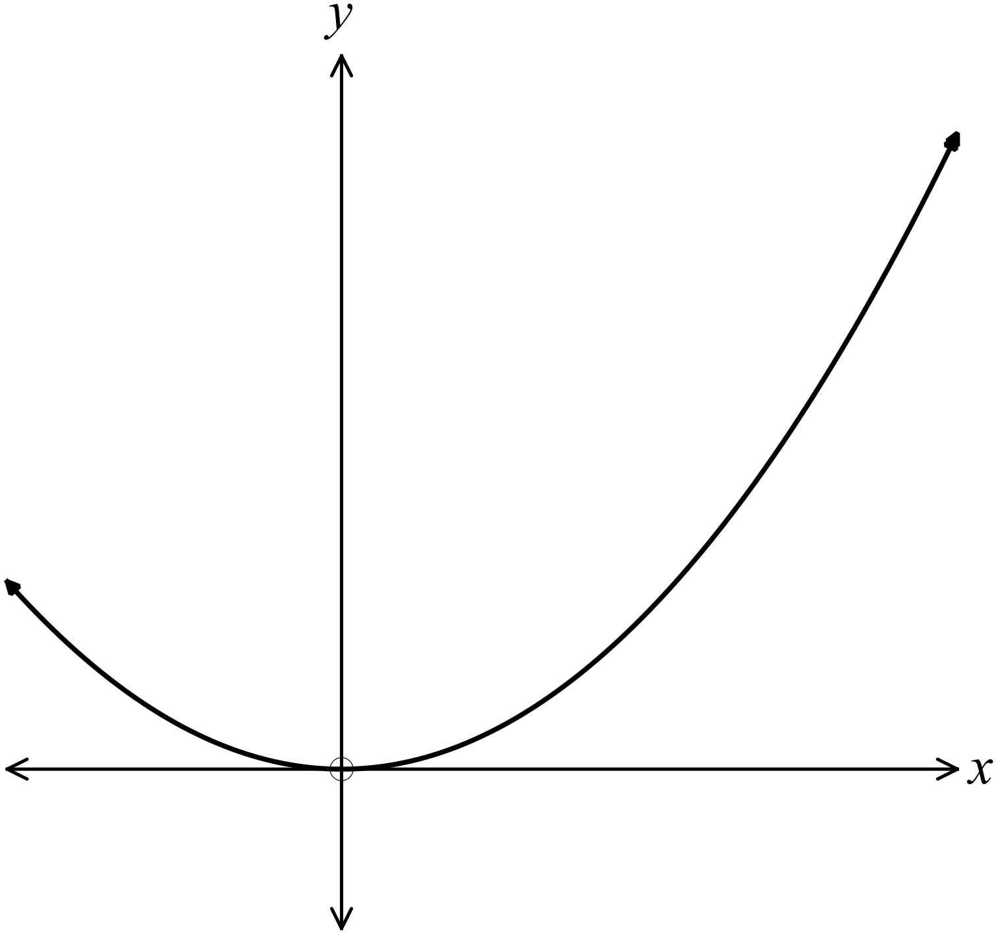

What is the equation of the curve shown?

A. 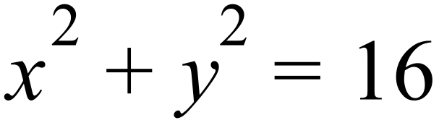
B. 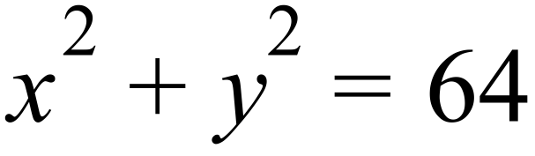
C. 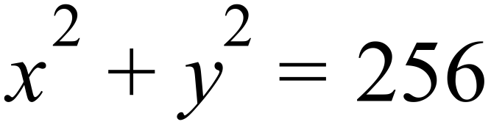
D. 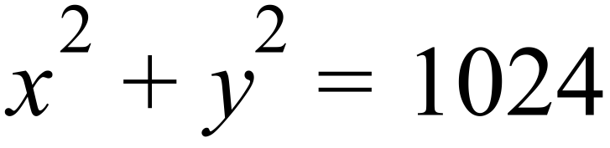

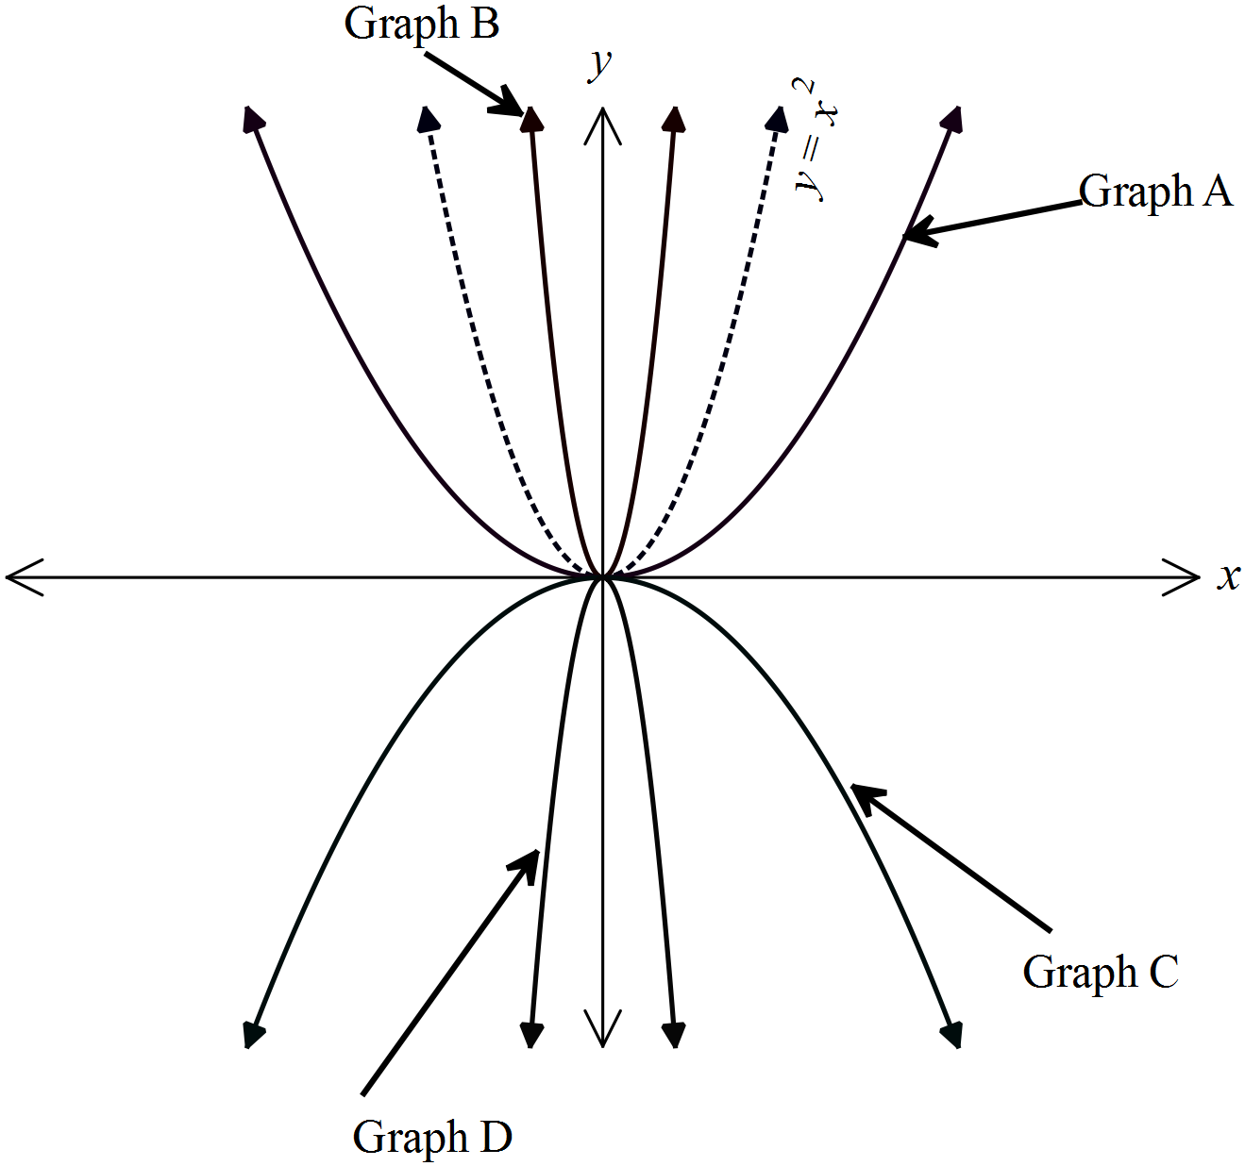The graph 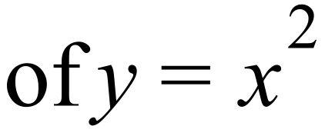 is shown as the dotted curve.
The graphs of four other equations are also shown, labelled Graphs A, B, C and D. Which graph could have an equation of 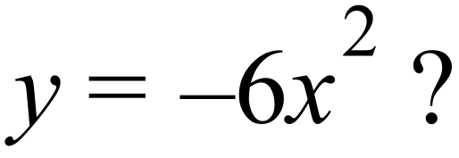

A. Graph A
B. Graph B
C. Graph C
D. Graph D

Which diagram shows the graph of 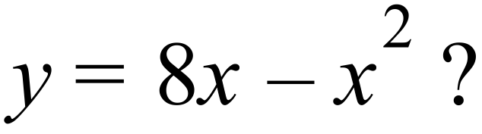
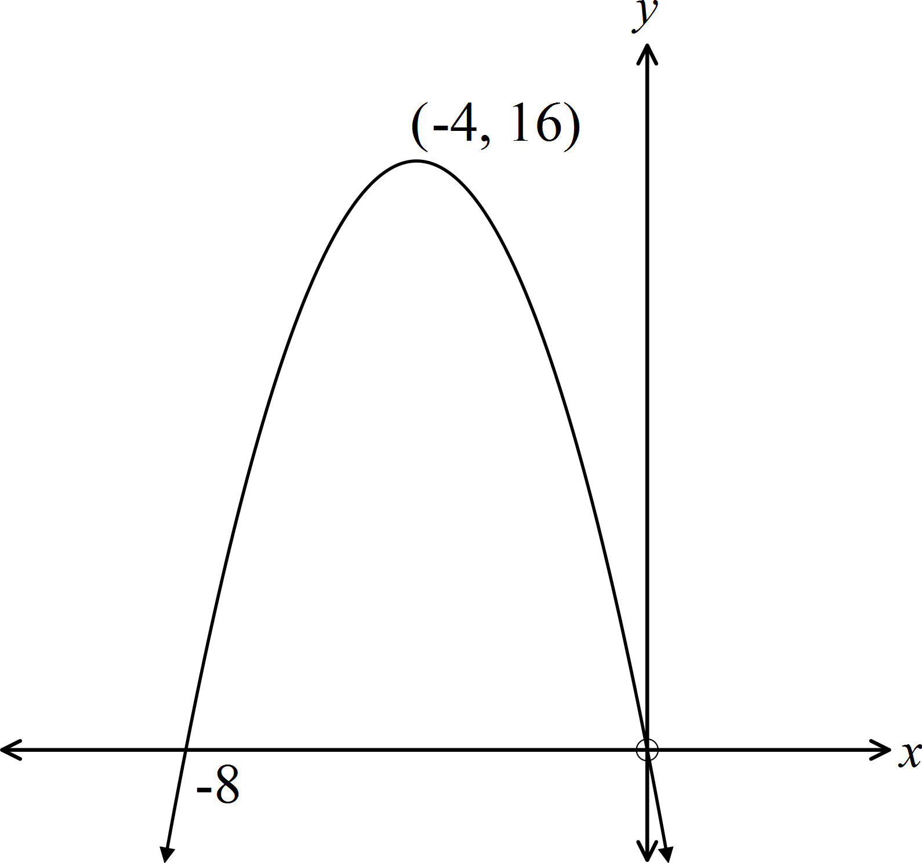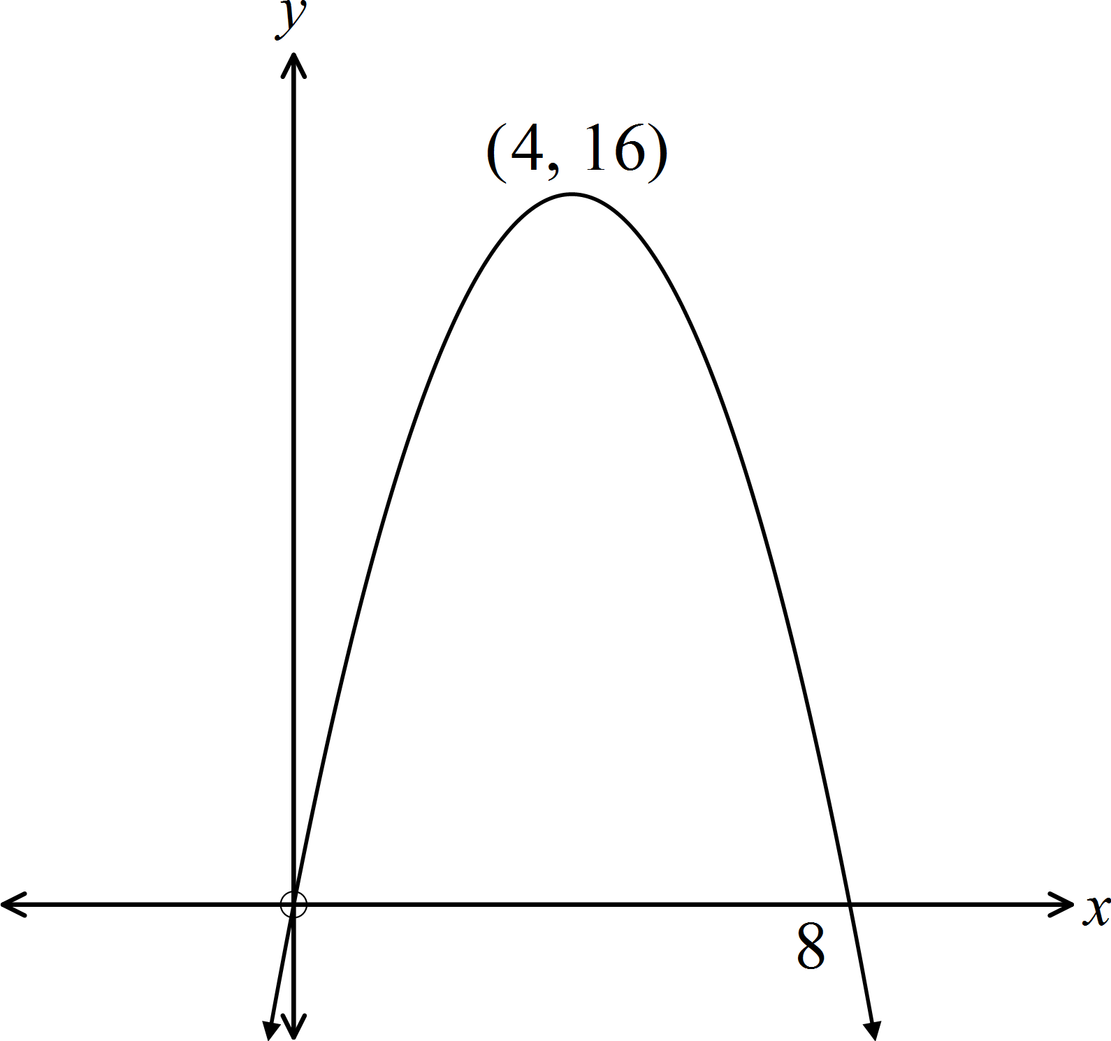
A. B.

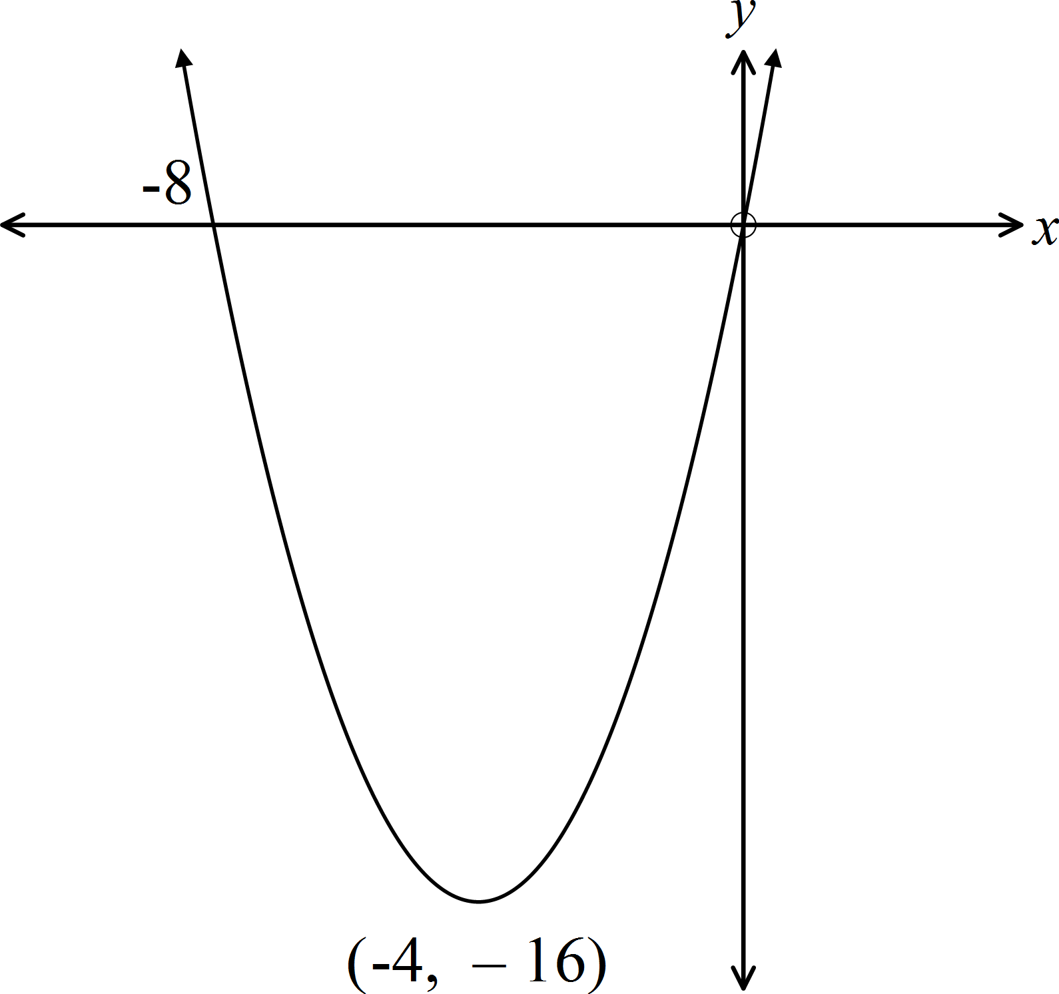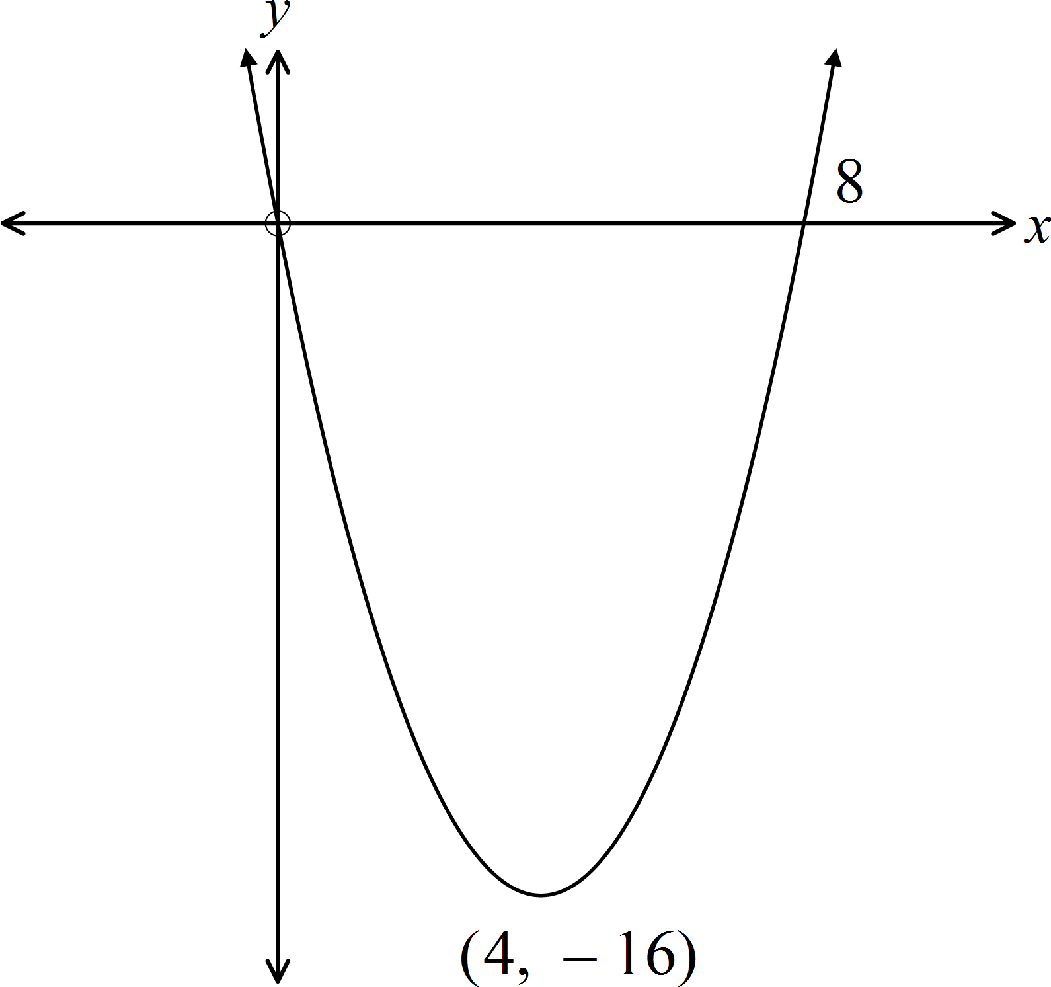 C. D.

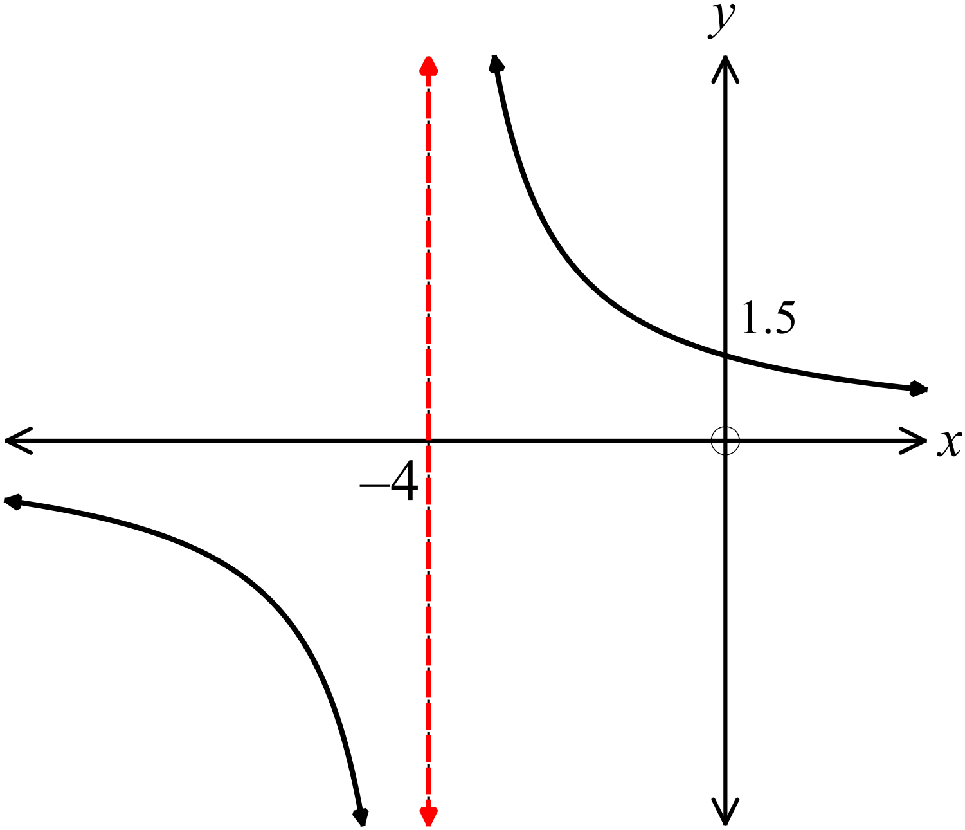Which equation could describe the graph shown?

A. 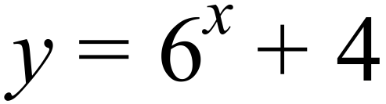

B. 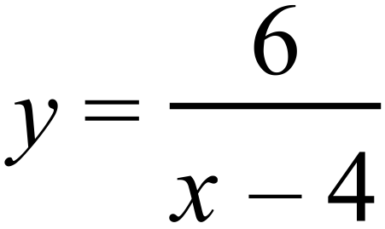

C. 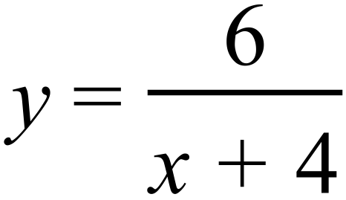

D. 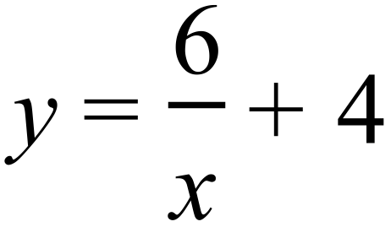

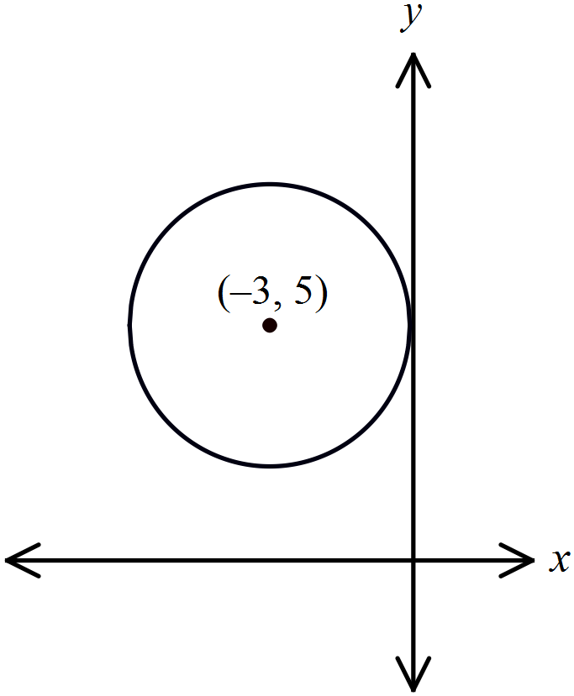What is the equation of the circle shown on the number plane?

A. 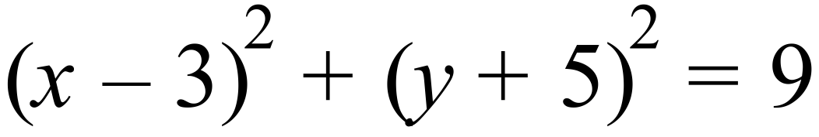
B. 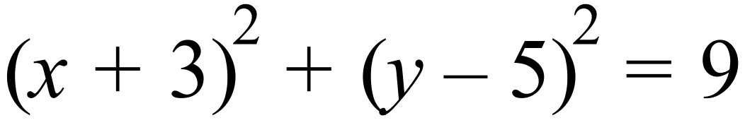
C. 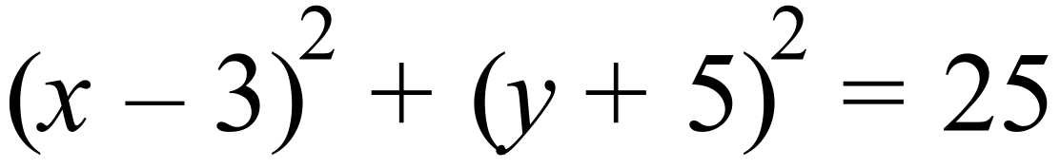
D. 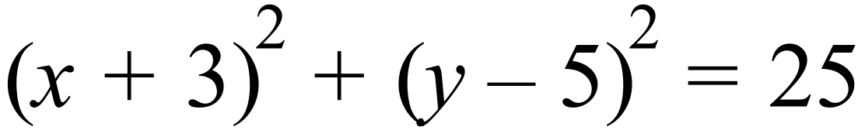

Which is the graph of 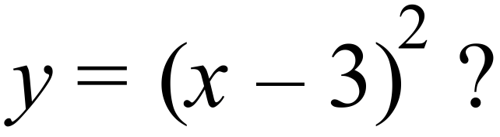

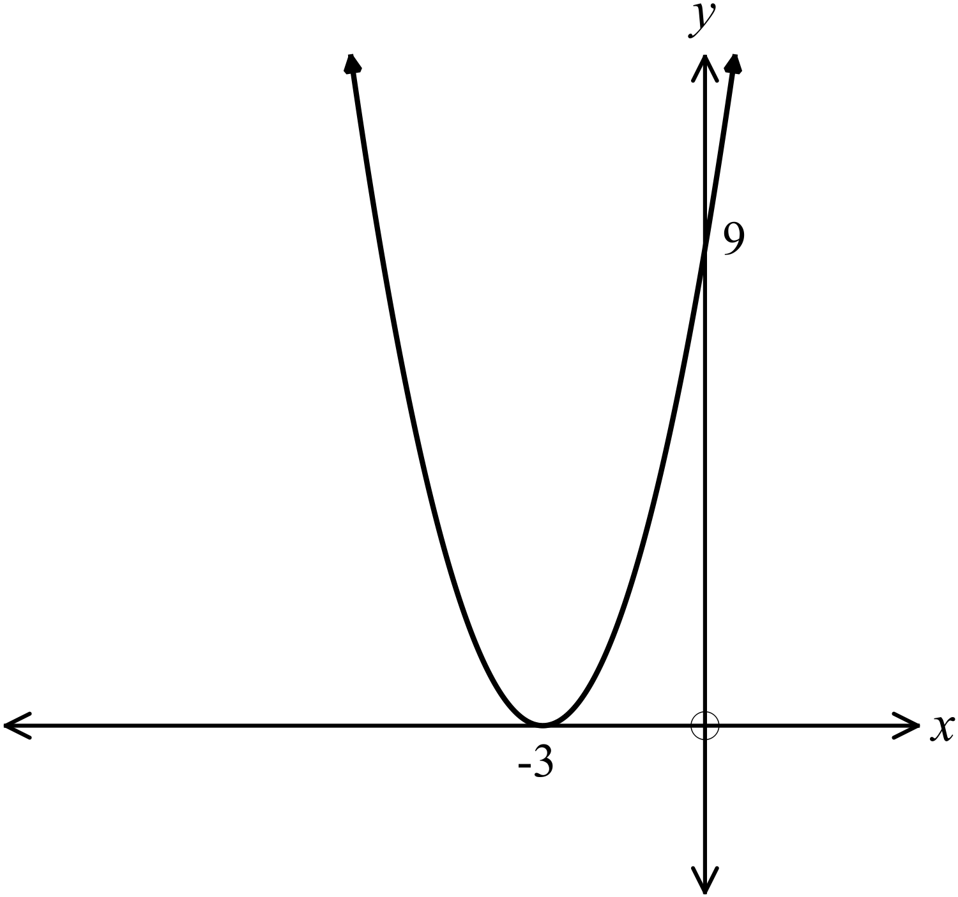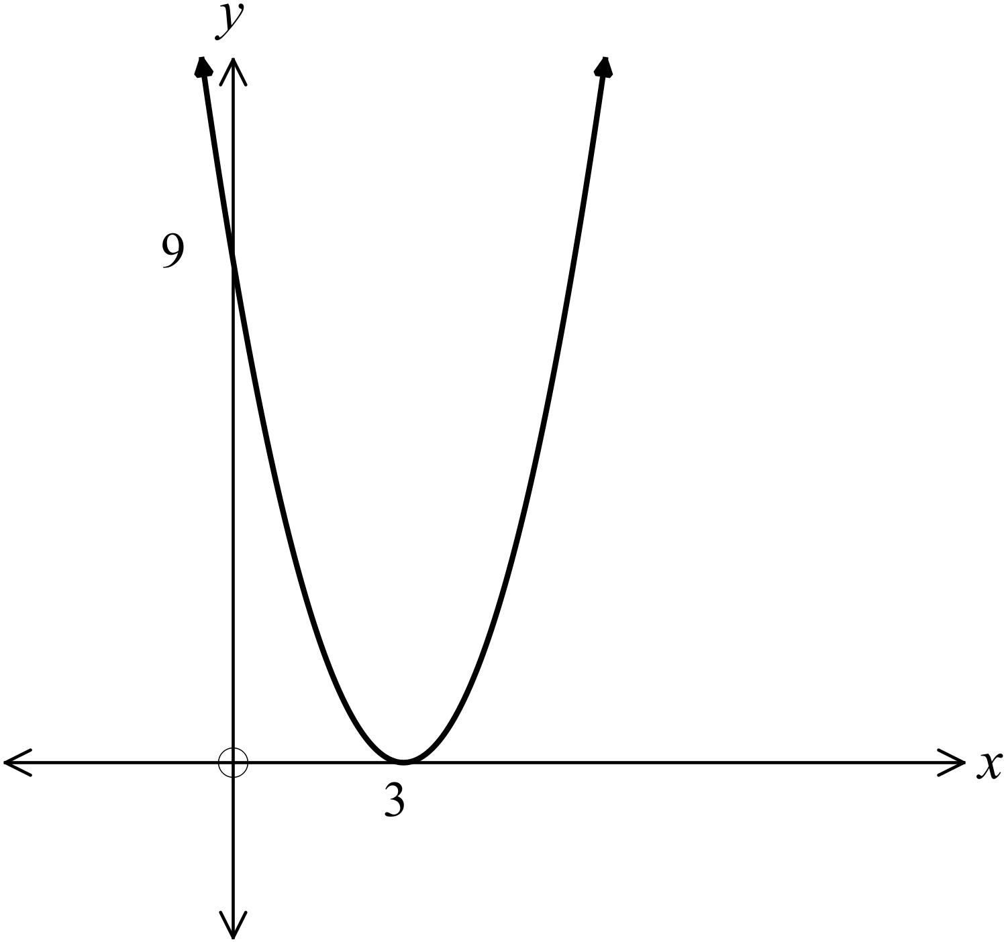A. B.

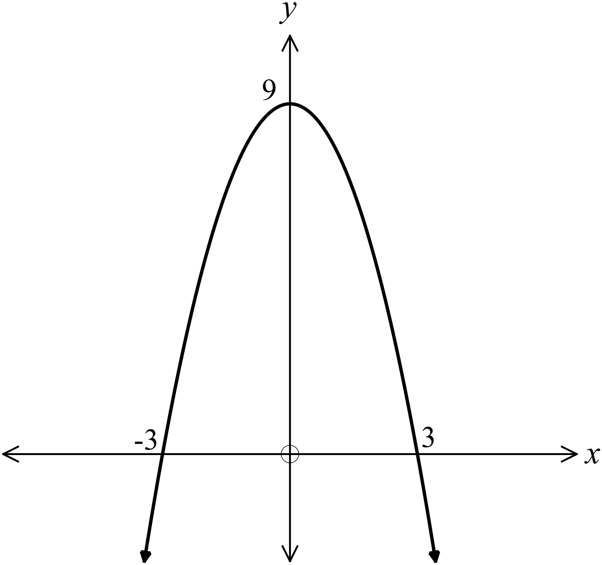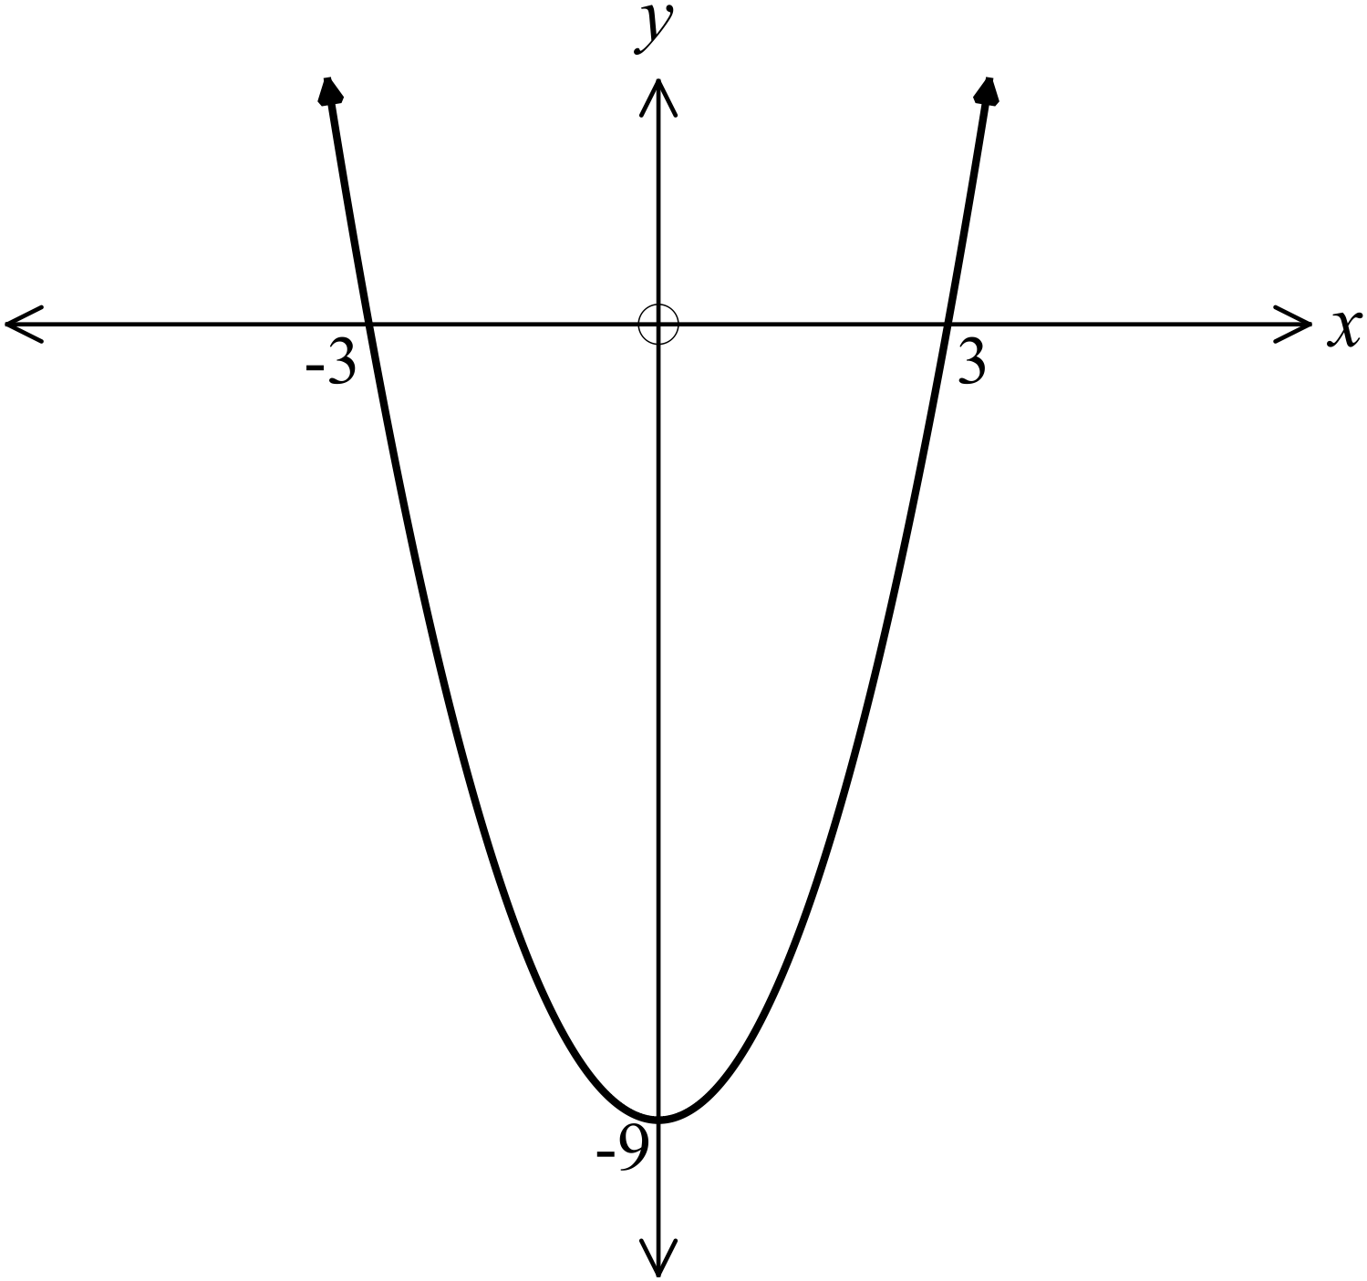C . D.

Which equation describes a circle with centre at 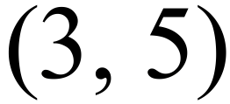 and radius 5 units?

A. 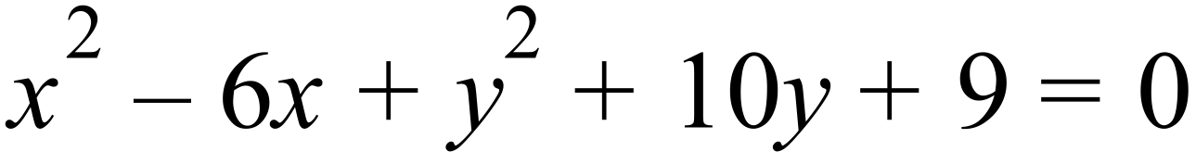 B. 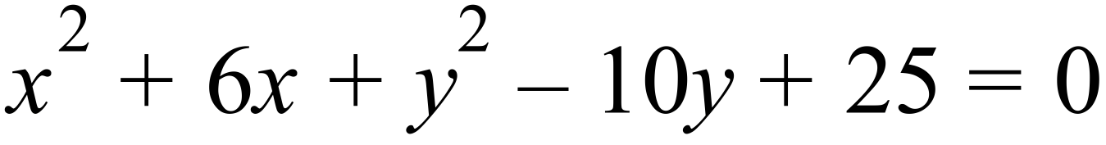

C. 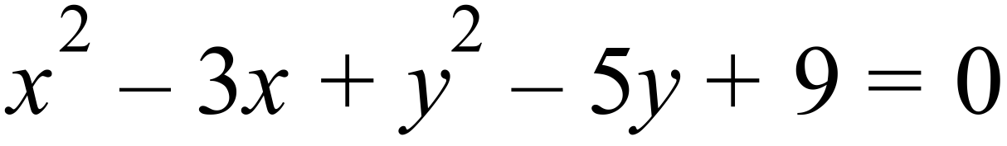 D. 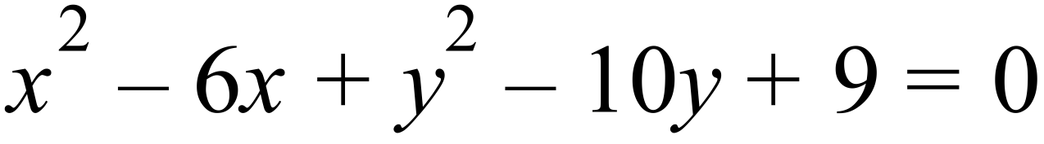

Which curve has an intercept at 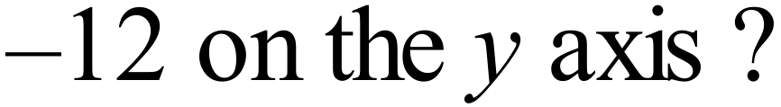

A. 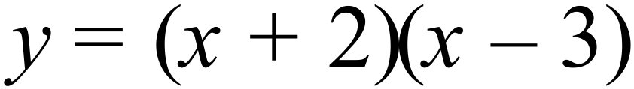 B. 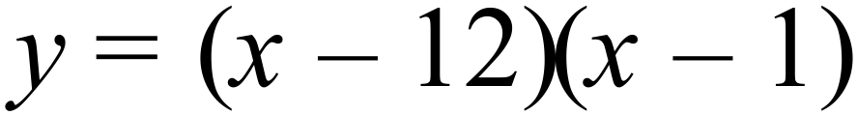
C. 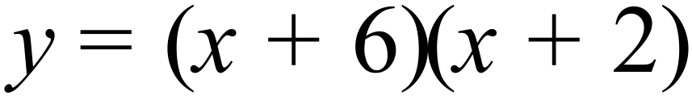 D. 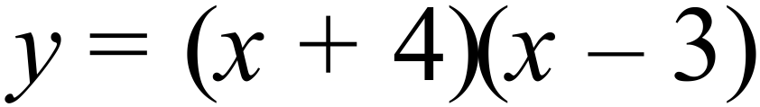
Which is the graph of 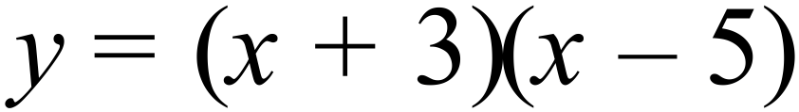 ?

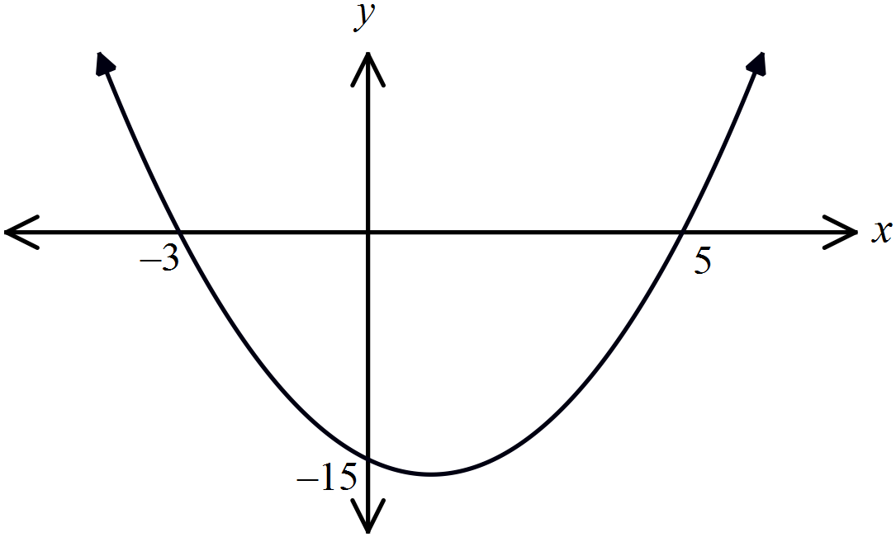 A. B.
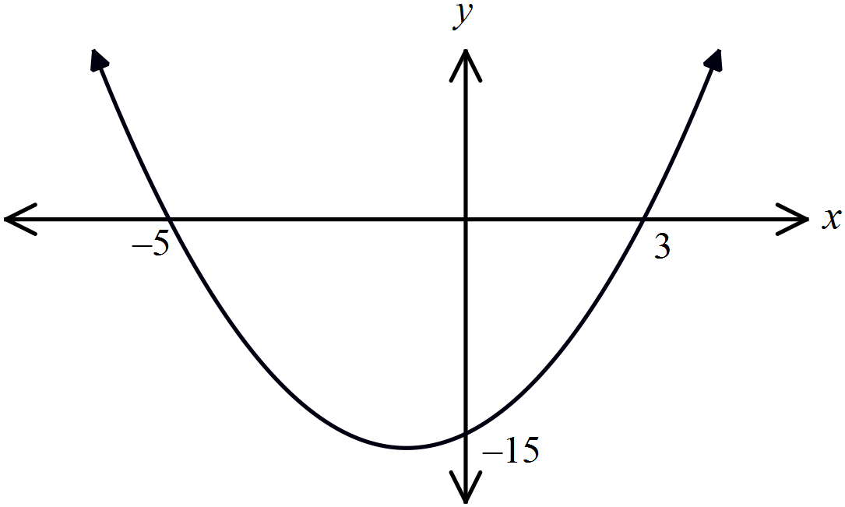

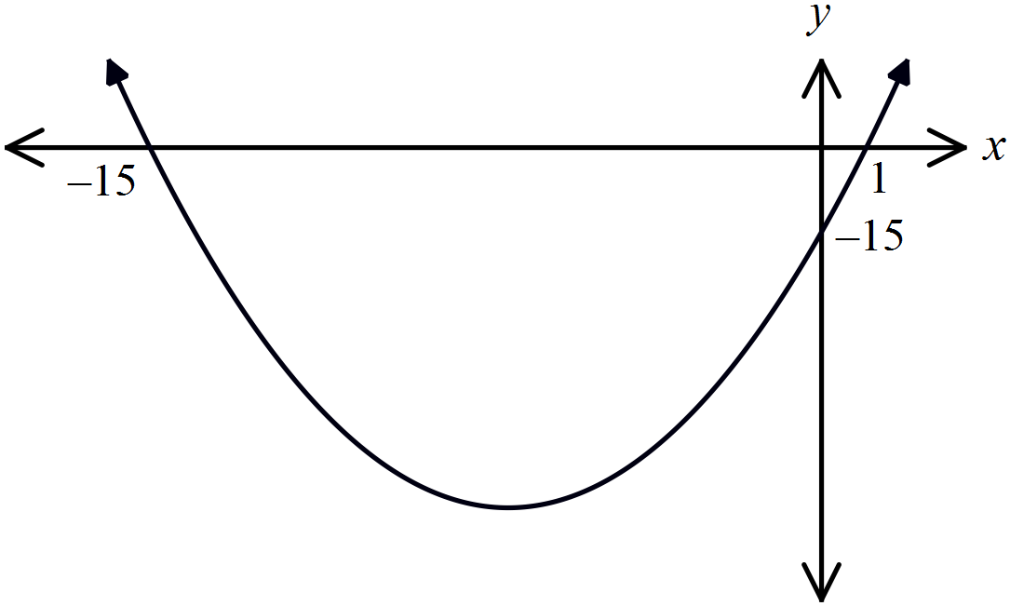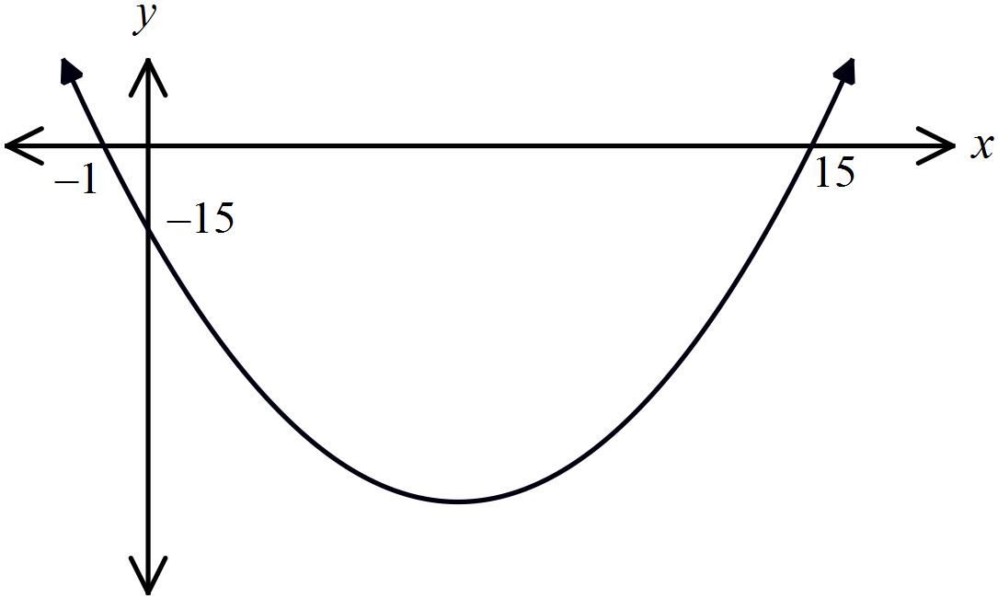 C. D.

Which curve has its vertex at 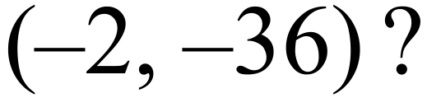

A. 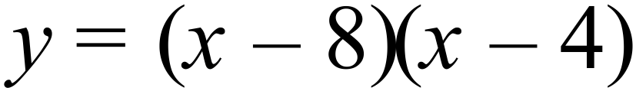 B. 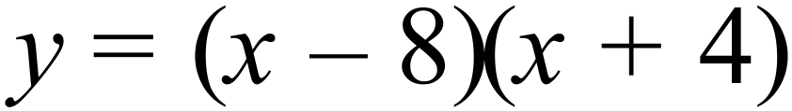
C. 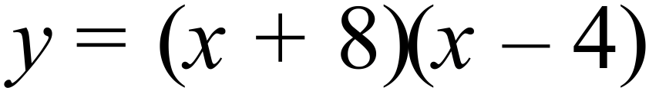 D. 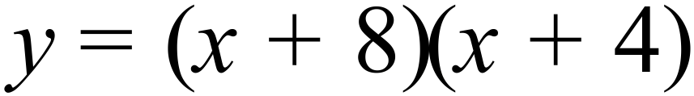
What are the intercepts on the x axis for the curve 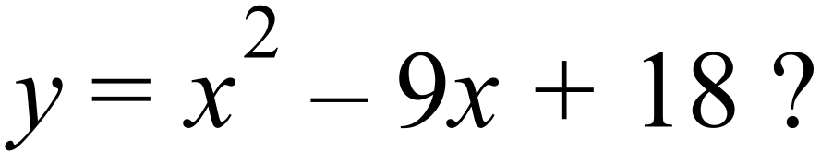

A. 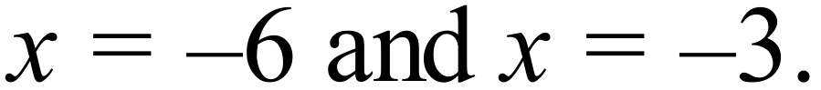 B. 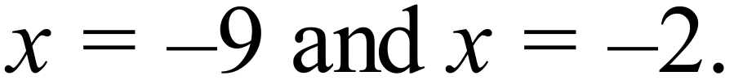
C. 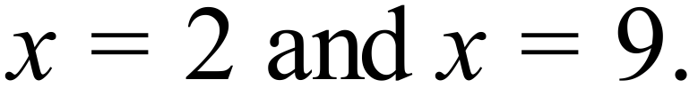 D. 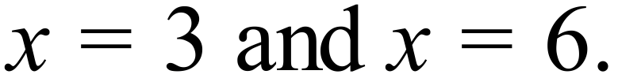

Year 10 | Non Linear Relations | Calculator Allowed
Year 10 | Non Linear Relations | Name___________________
Section 3 Longer Answer Section
Write all working and answers in the spaces provided on this test paper.

 |  | Marks
1. | On the axes provided draw neat sketches of 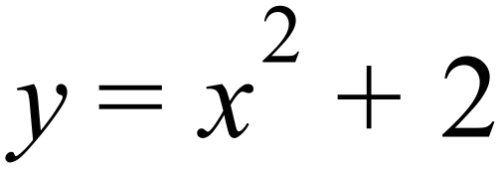 and 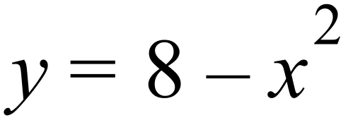.  Clearly mark the x and y intercepts and the vertex of each graph.  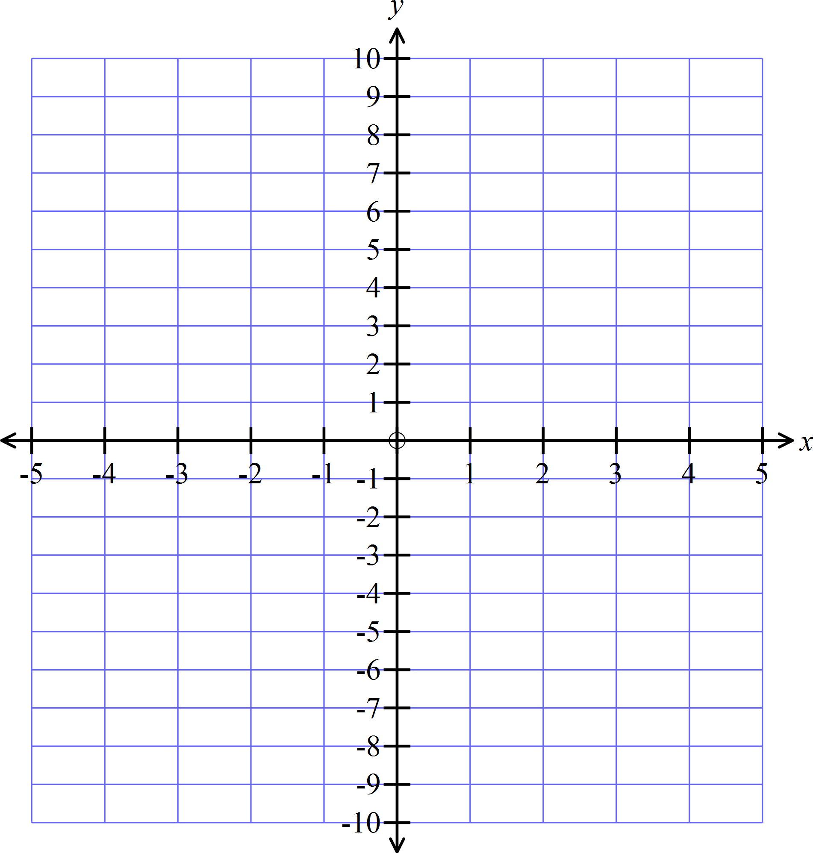 | 4
2. | On the axes provided draw neat sketches of 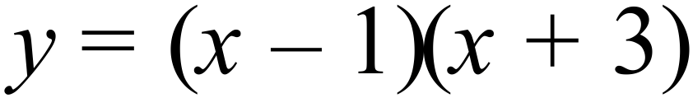 and 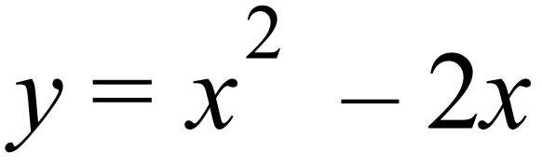.  Clearly mark the vertex of each graph. | 4
3. | On the axes provided draw neat sketches of 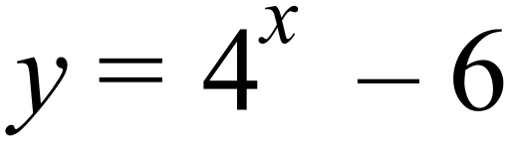 and 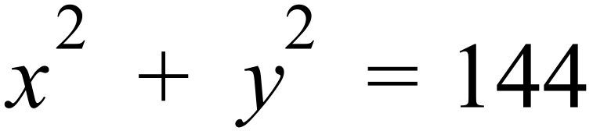.  Clearly mark the x and y intercepts of each graph.  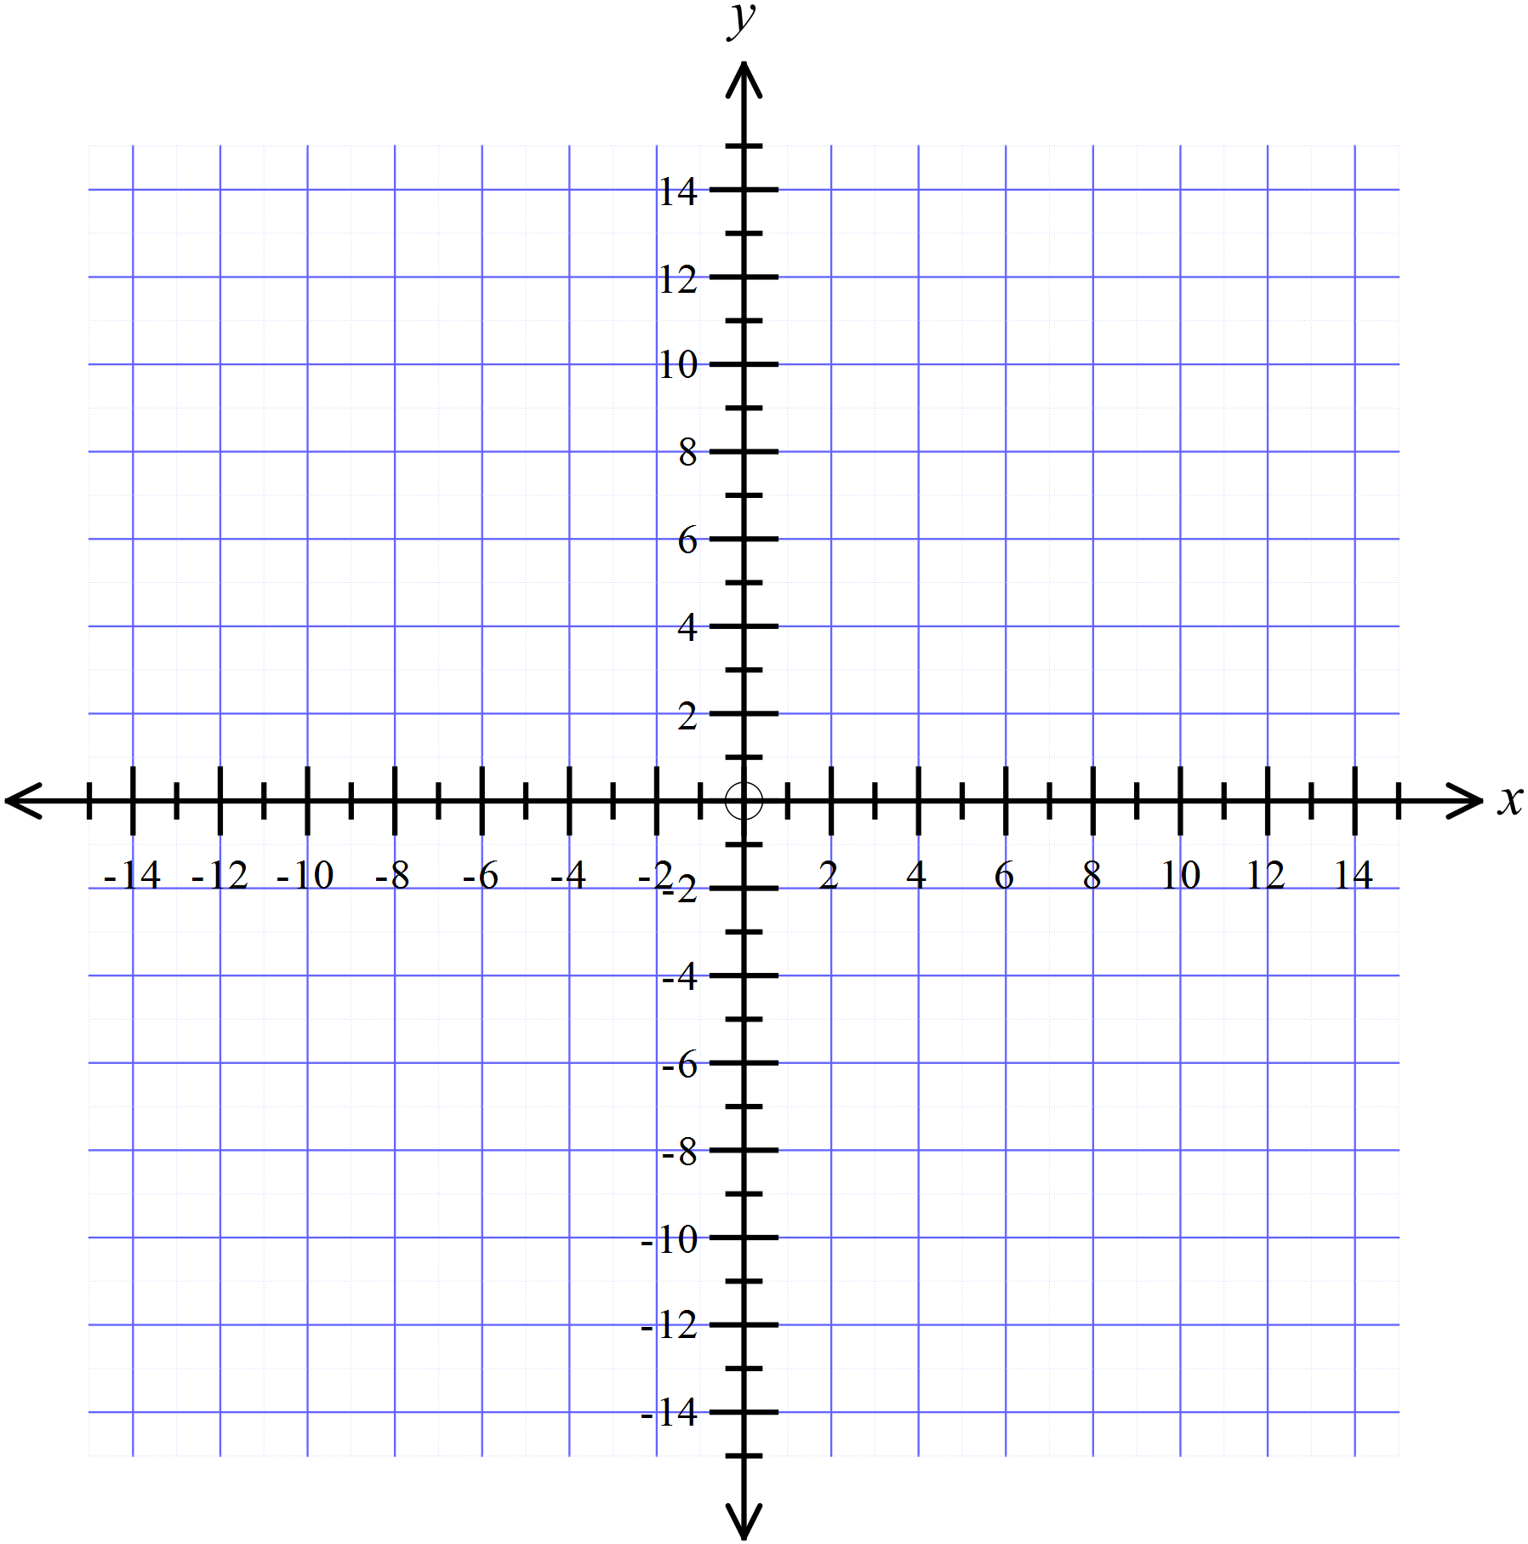 | 4
4. | On the axes provided draw neat sketches of 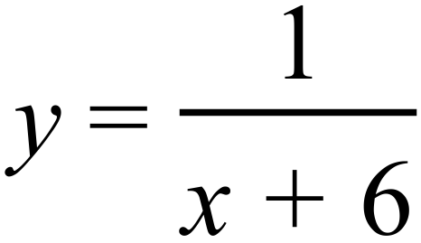 and 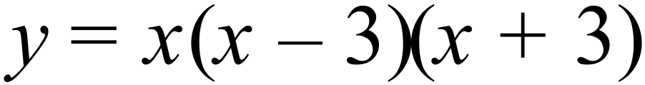.  Clearly mark the x and y intercepts and the vertex of each graph.  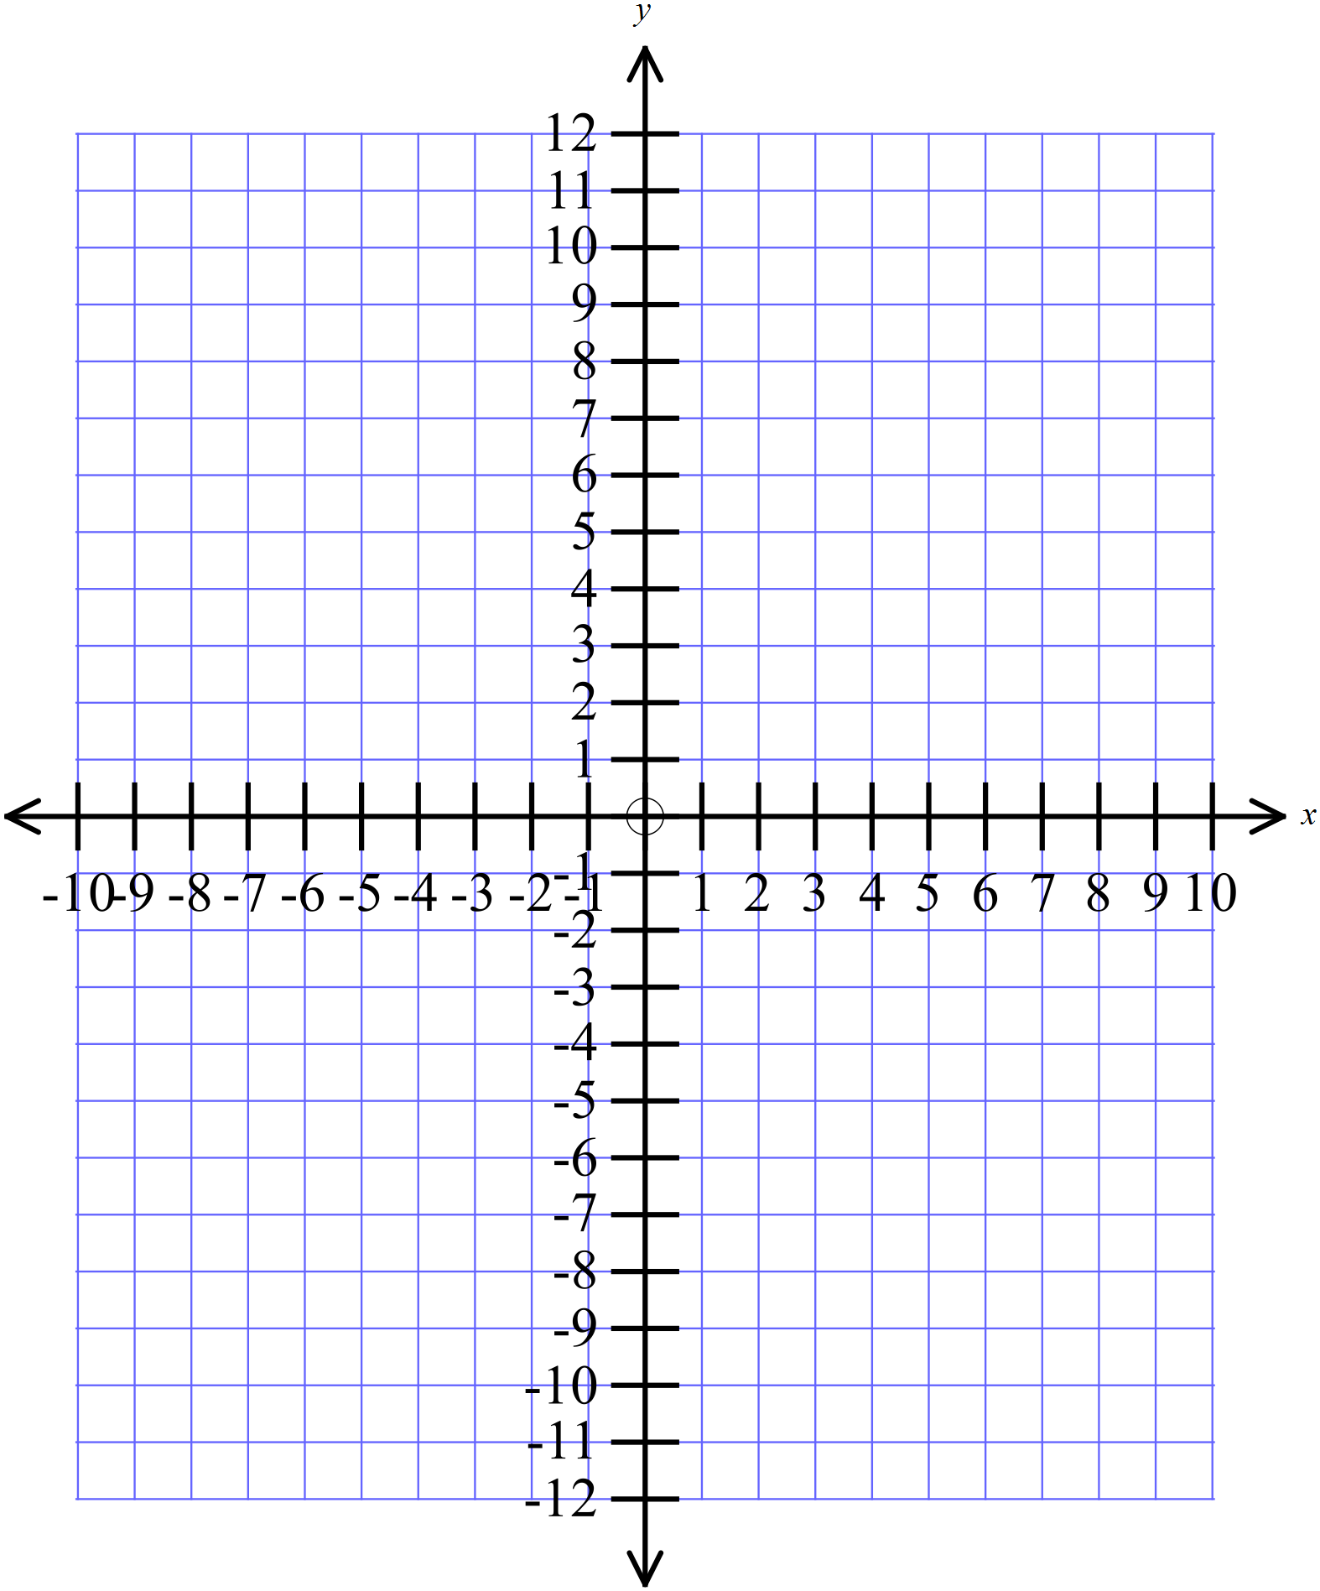 | 4
5. | What is the centre and radius of the circle which has an equation of :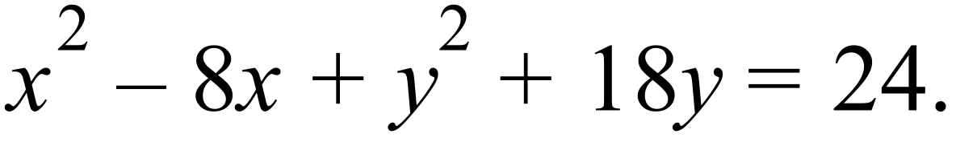  ……………………………………………………………………………………………….  ……………………………………………………………………………………………….  ……………………………………………………………………………………………….  ………………………………………………………………………………………………. | 2

Multiple Choice Answer Sheet
Non Linear Relations
Name _____________________________________________
Completely fill the response oval representing the most correct answer.

1. A B C D
2. A B C D
3. A B C D
4. A B C D
5. A B C D
6. A B C D
7. A B C D
8. A B C D
9. A B C D
10. A B C D
11. A B C D
12. A B C D
13. A B C D
14. A B C D
15. A B C D
16. A B C D
17. A B C D
18. A B C D
Year 10 |  | Non Linear Relations | Non Calculator
Section 1 Short Answer Section
ANSWERS
No. | WORKING |  | ANSWER
 | b is the y intercept, so b = 2. |  | 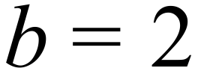
 | a is the x intercept, so y = 0.  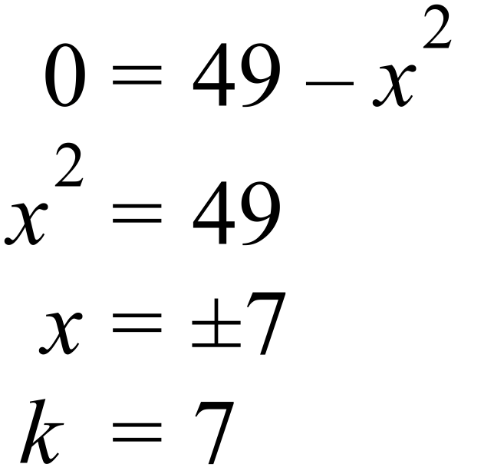 |  | 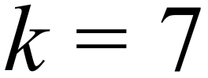
 | 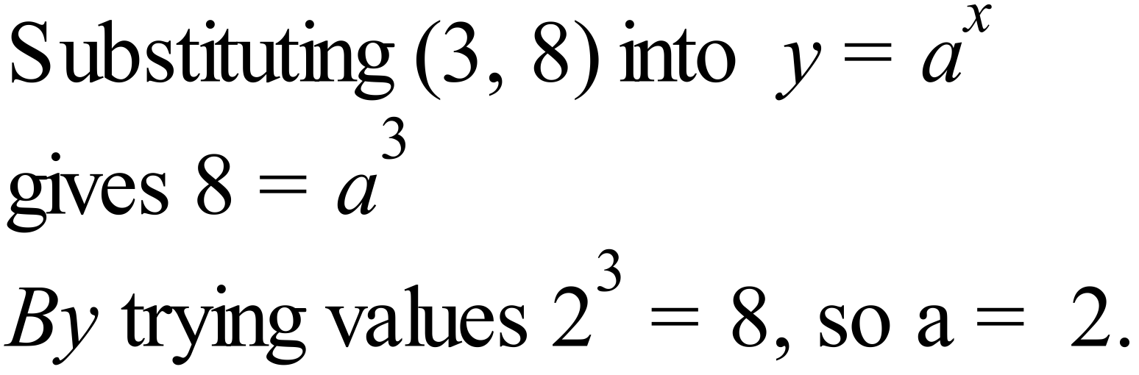 |  | 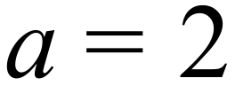
Circle has equation 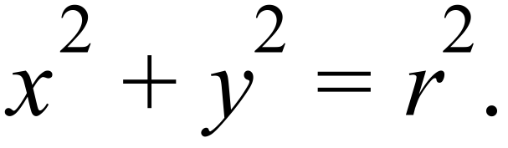
Radius is 9, so equation is 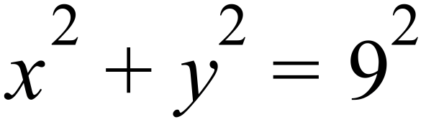
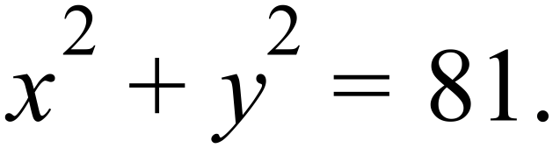
 | Both have a y intercept of y = -6, so only difference is coefficient of x². The larger coefficient gives the steeper curve, so the unbroken curve is 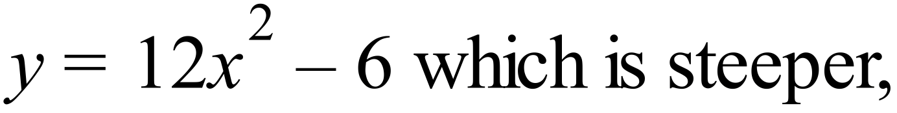 |  | See explanation
 | The y intercept occurs where x = 0.  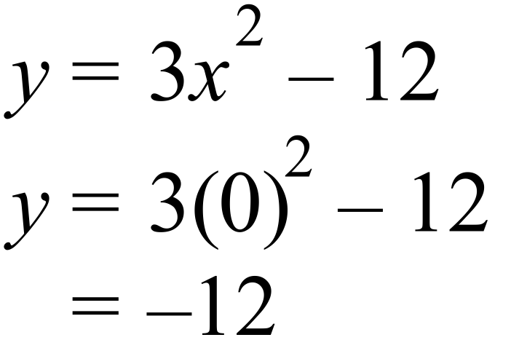 |  | 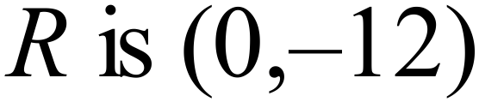
 | The x intercept occurs where y = 0.  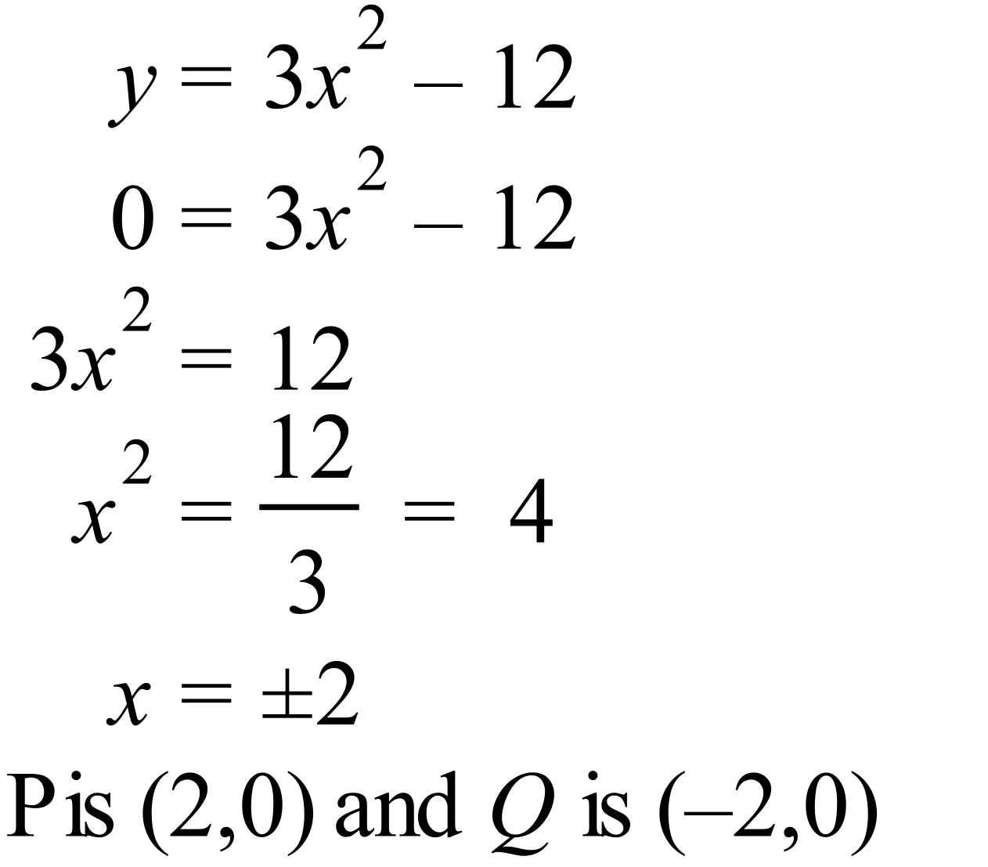 |  | 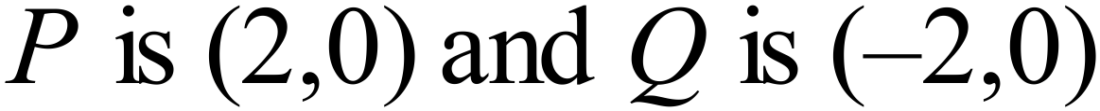
 | 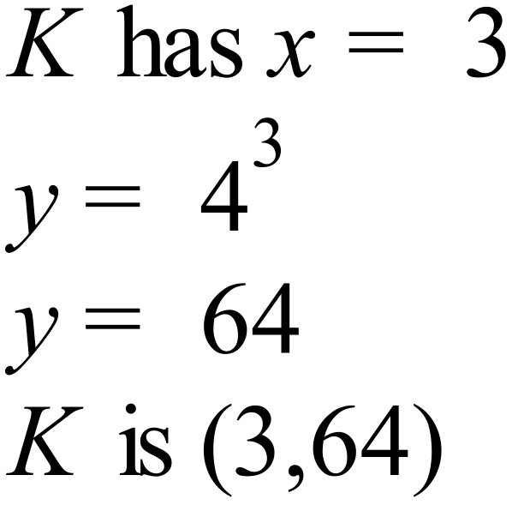 |  | 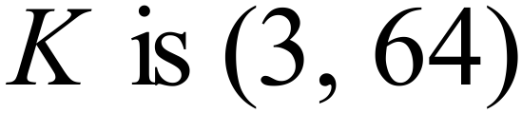
 | 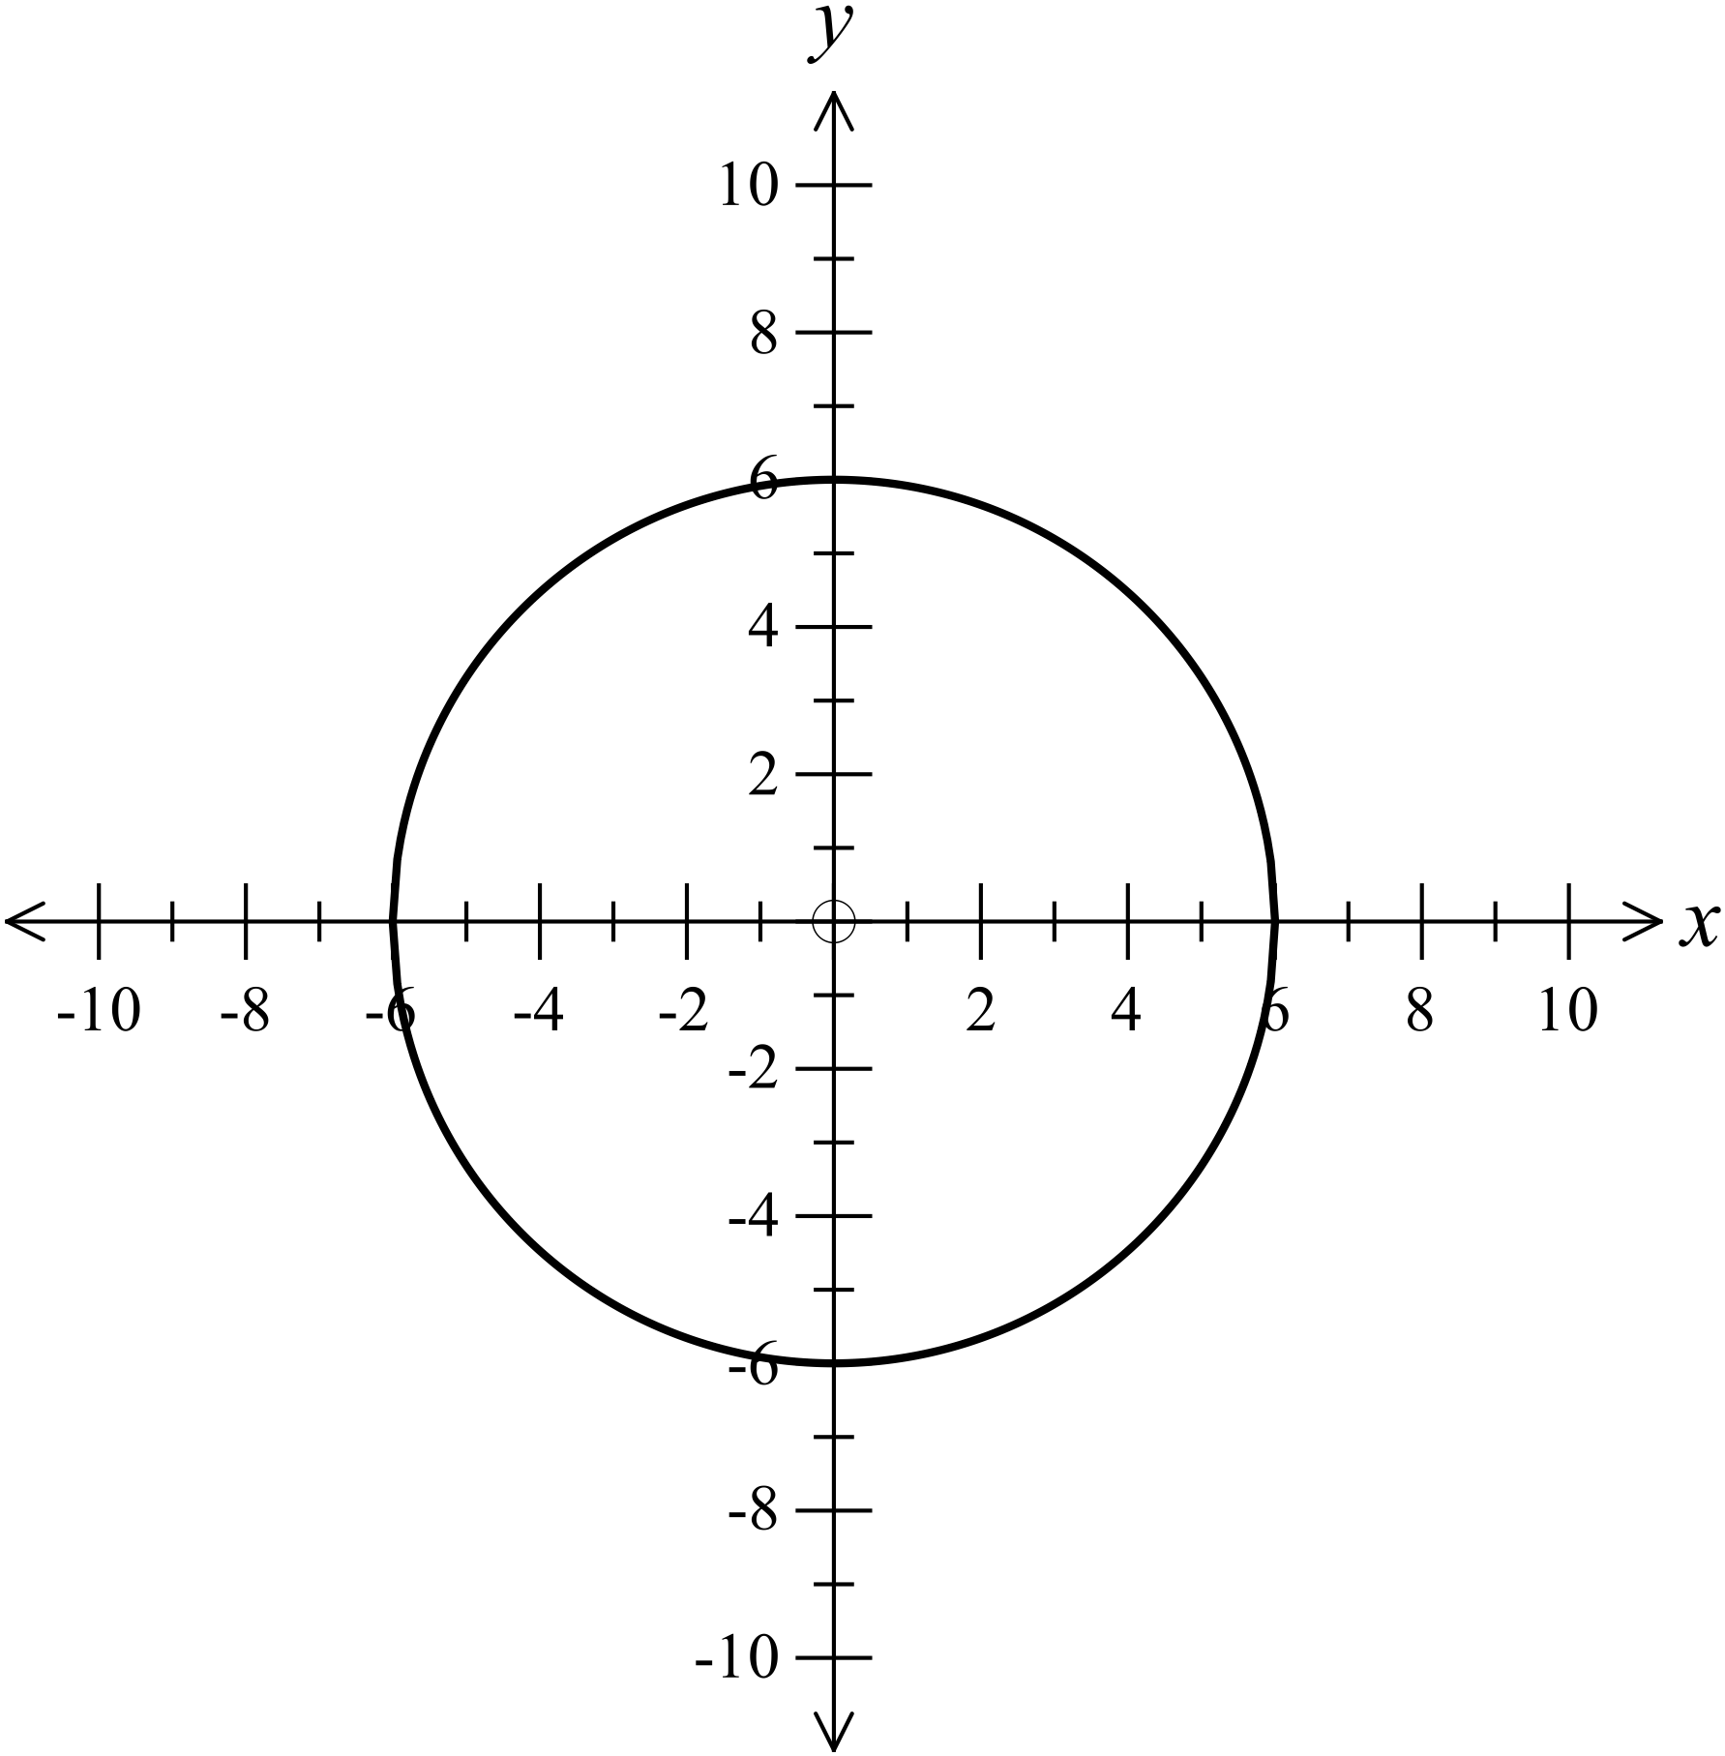 |  | See Graph
 | 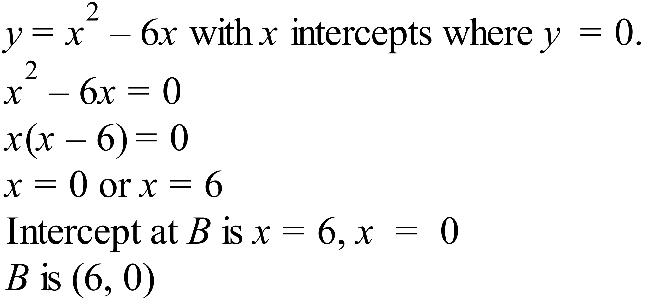 |  | 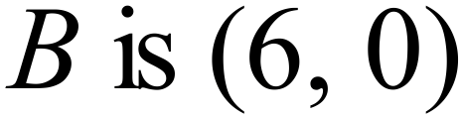
 | Vertex is midway between x intercepts, so x = 3.  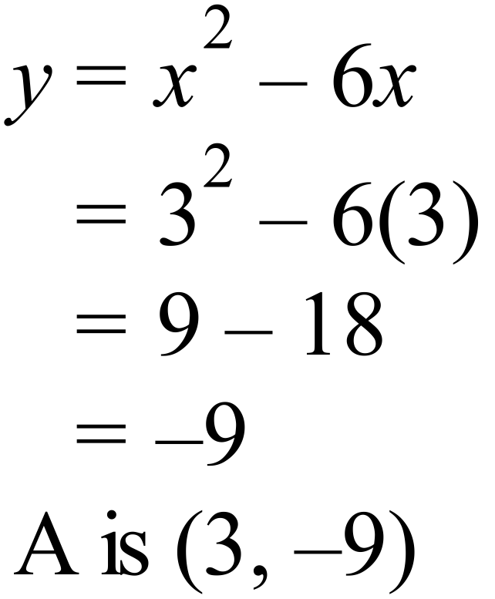 |  | 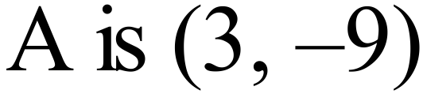
C and D are the x intercepts, so y = 0.
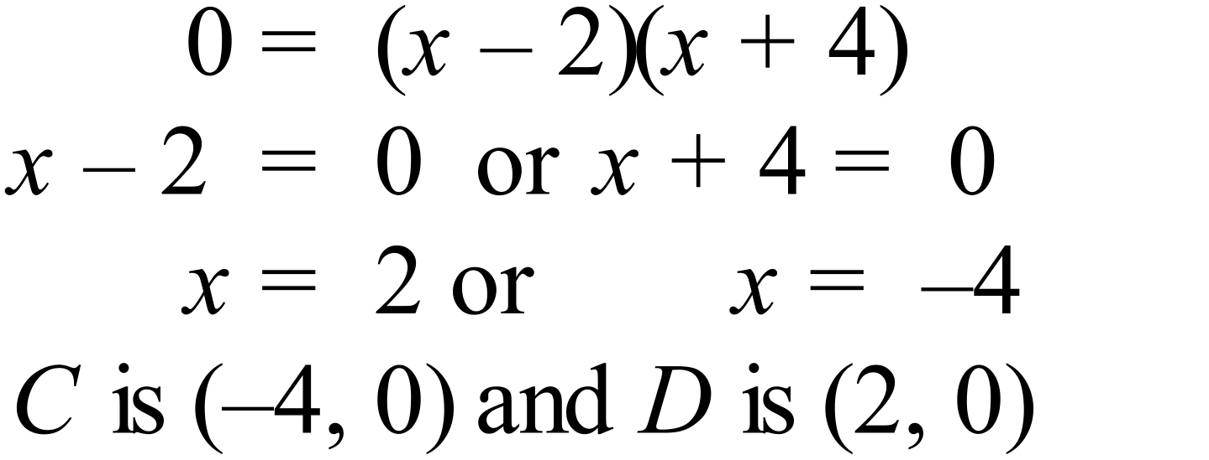
 | Vertex is midway between x intercepts, so 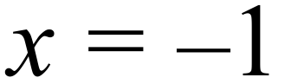 .  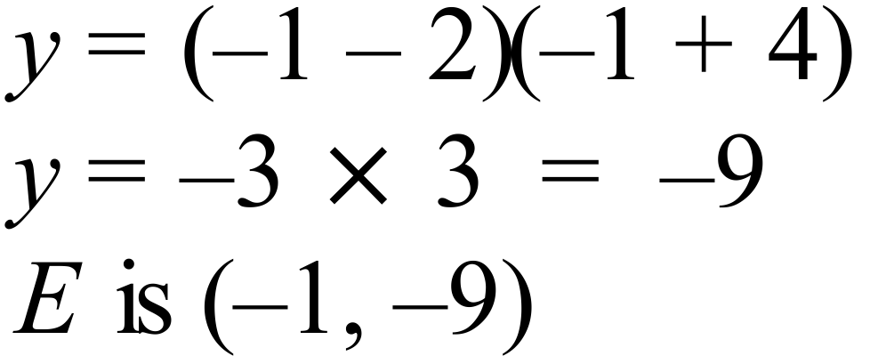 |  | 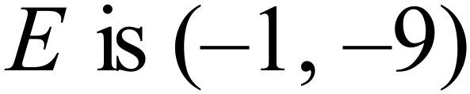
 | 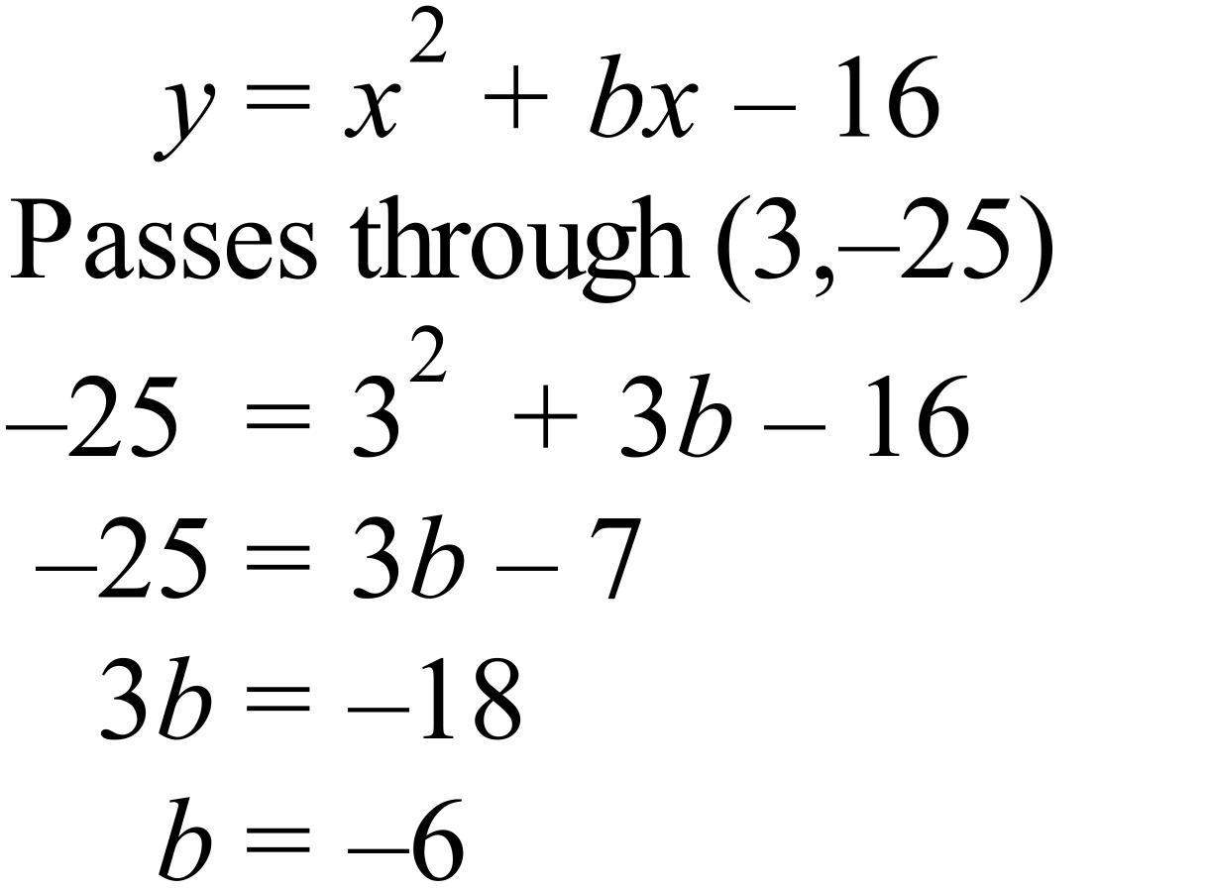 |  | 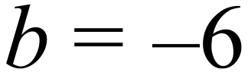
 | 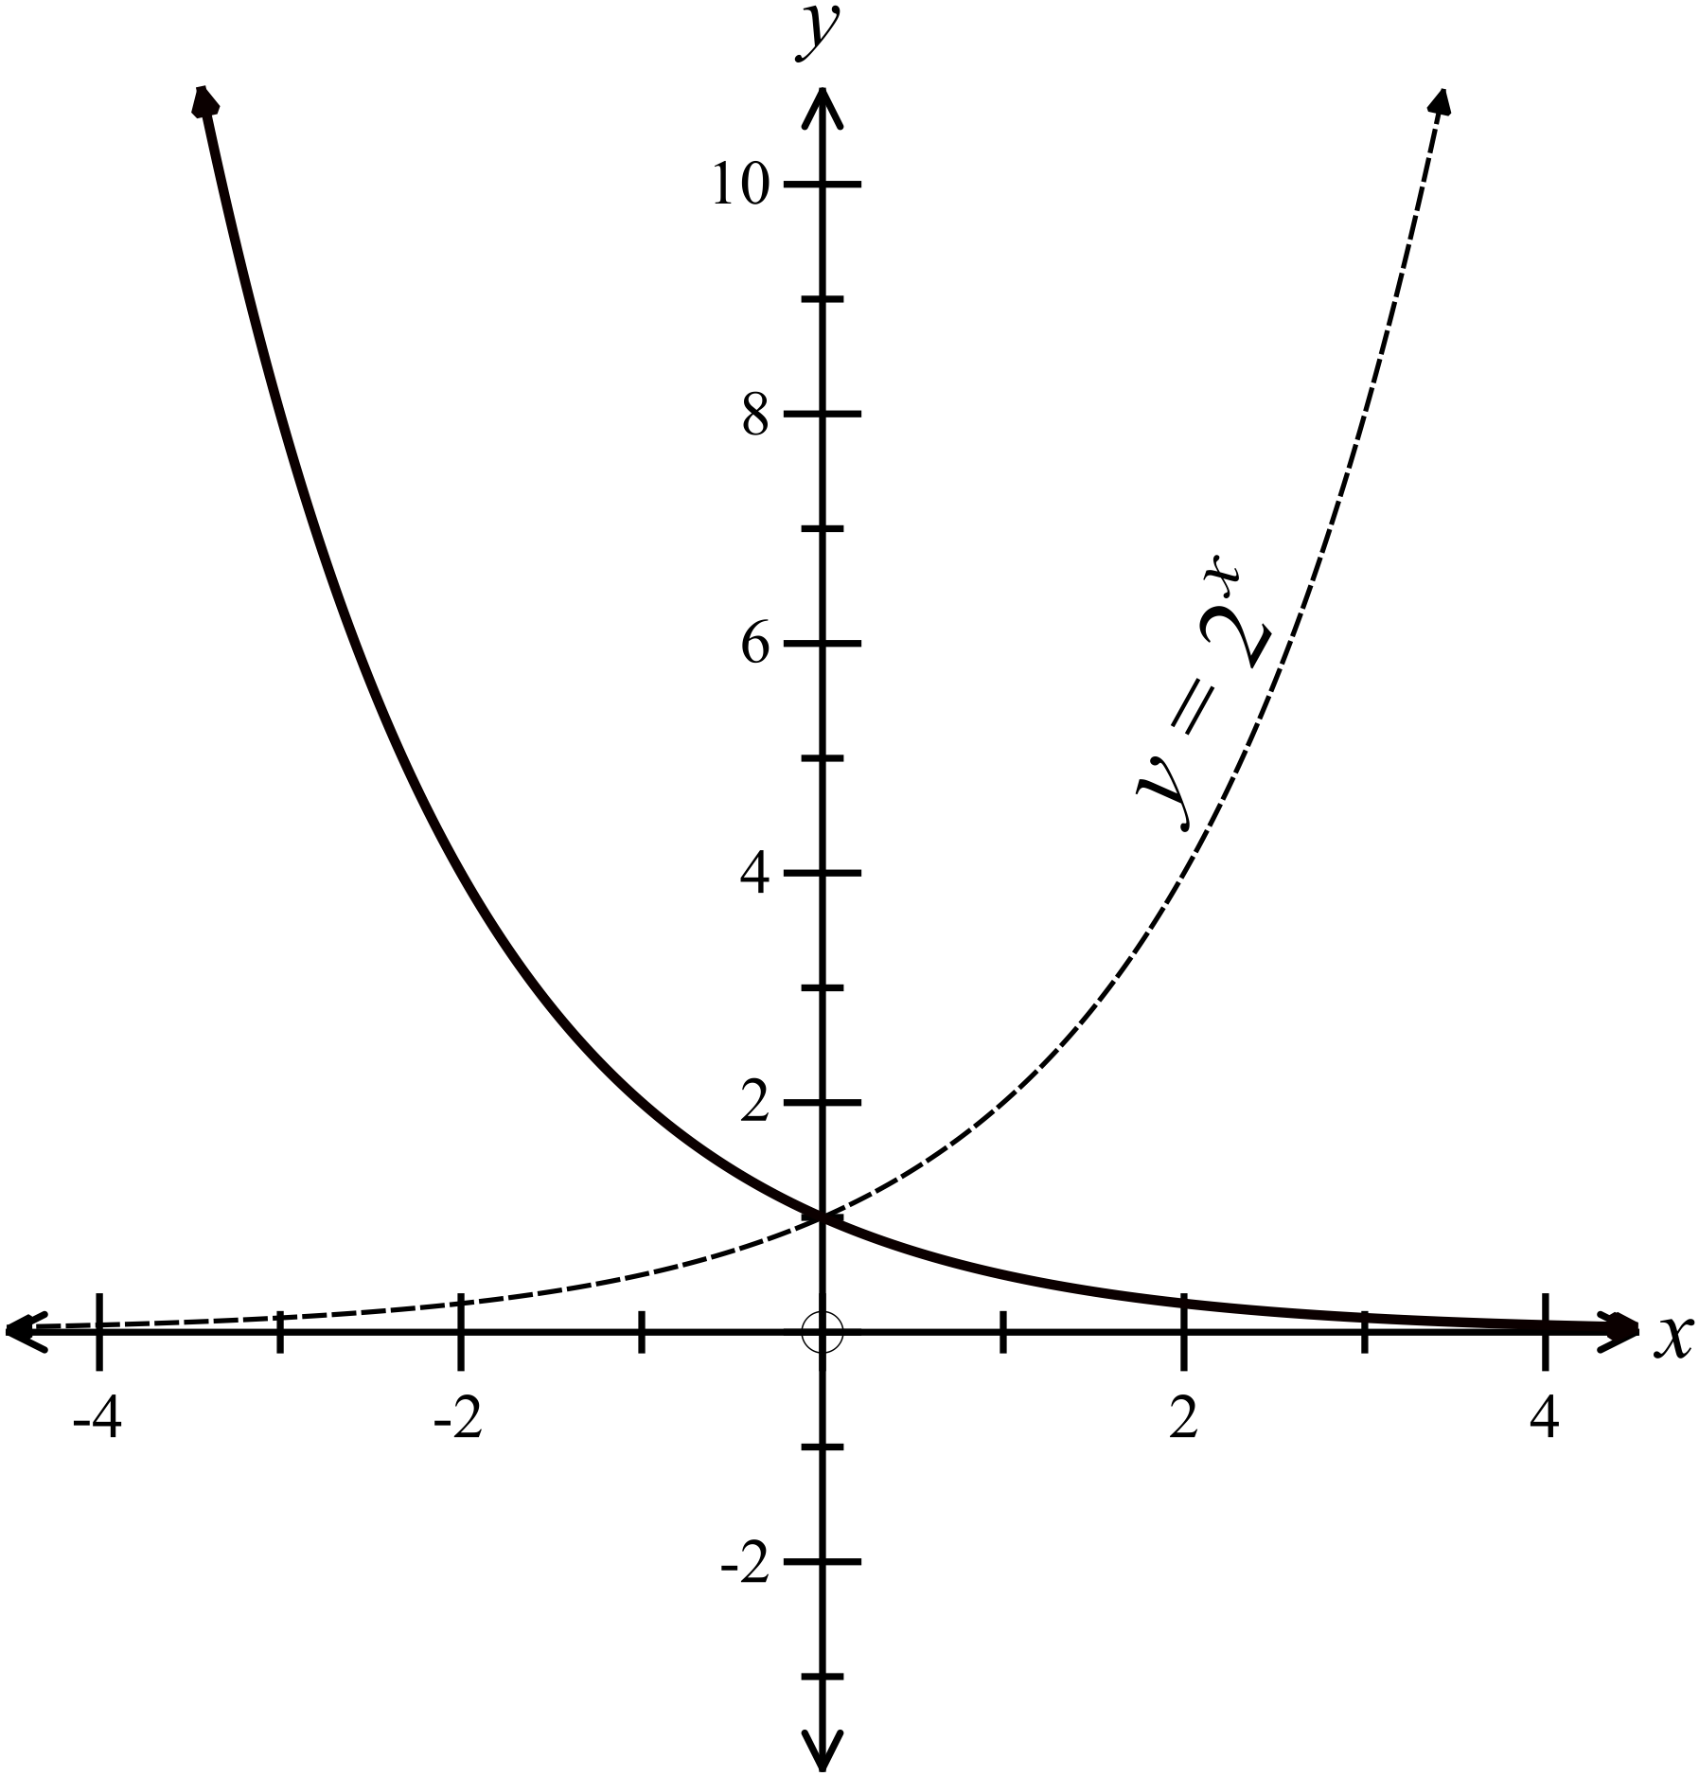 |  | The curve drawn with an unbroken line on the graph.
 | 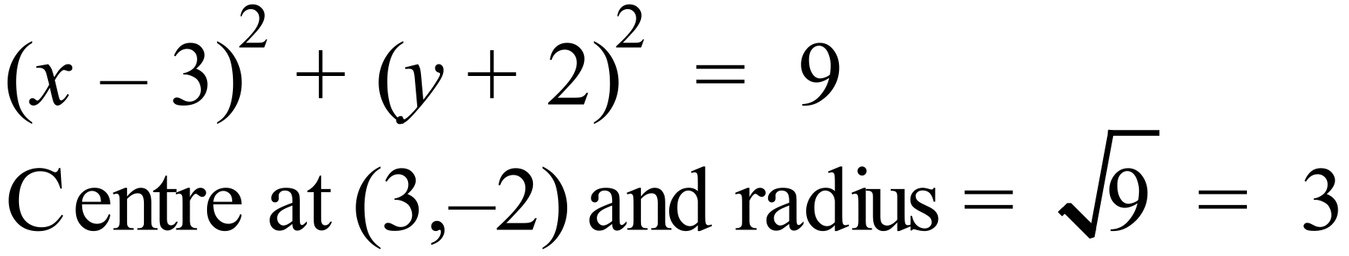 |  | 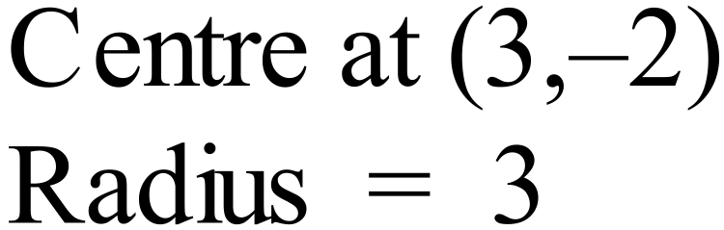

Year 10 |  | Non Linear Relations | Calculator Allowed
Section 2 Multiple Choice Section
ANSWERS
No. | WORKING |  |  | ANSWER
 |  |  |  | A
 | 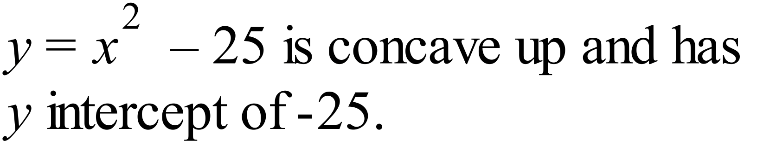 |  |  | C
 |  |  |  | B
 |  |  |  | B
 | 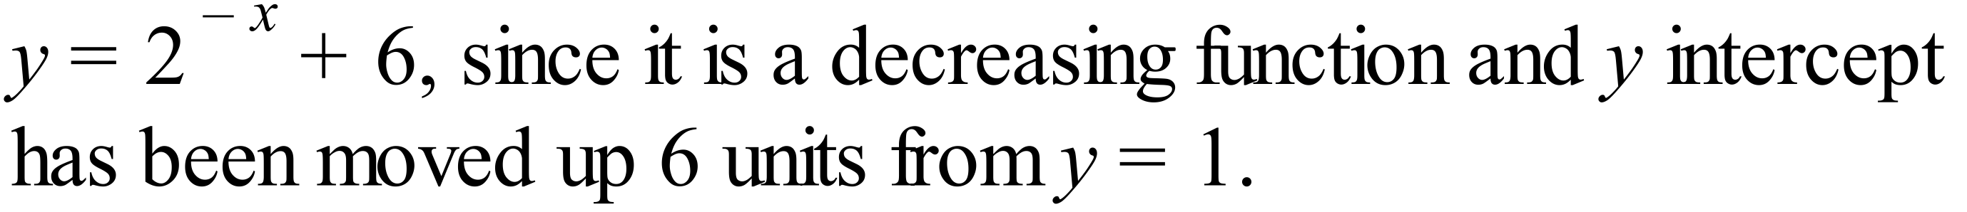 |  |  | A
 | 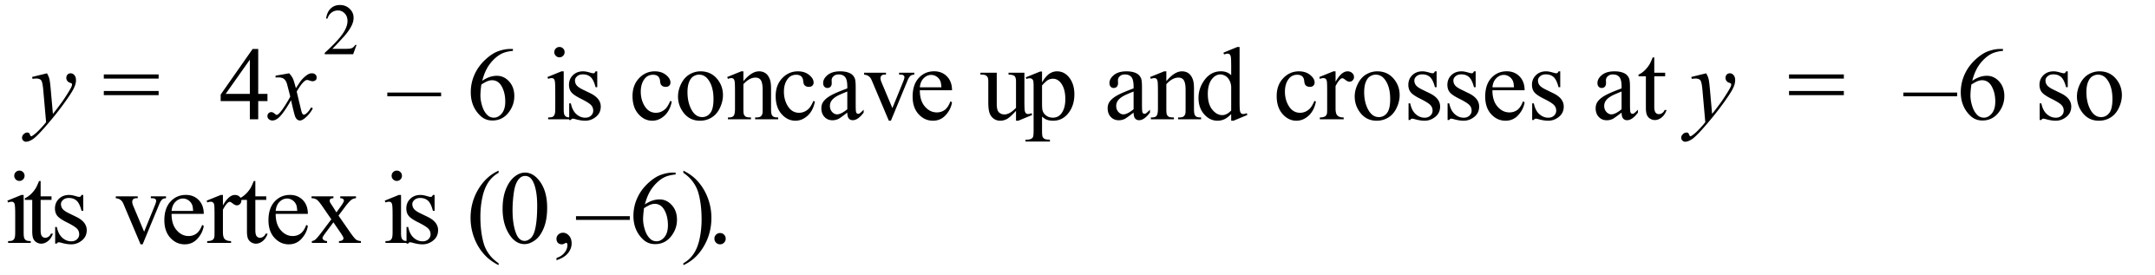 |  |  | D
 | Needs to be a parabola which is concave down and through the origin. |  |  | C
 | 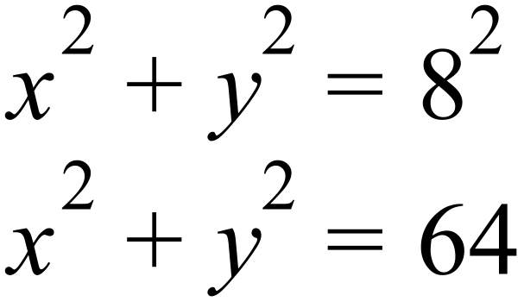 |  |  | B
 | 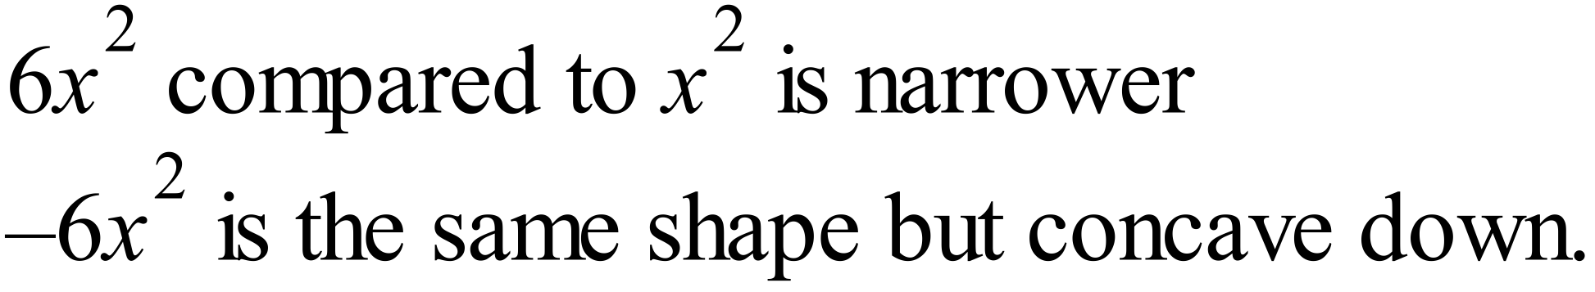  So Graph D |  |  | D
 | 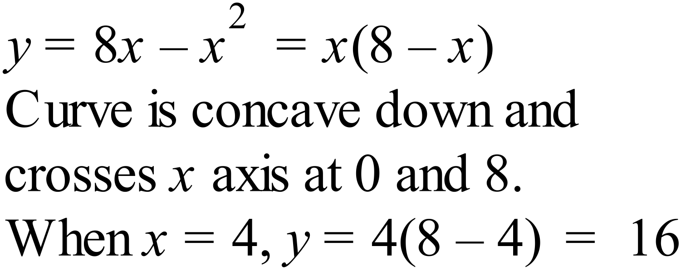 |  |  | A
 | Since two branches it is a hyperbola.  Because asymptote is at 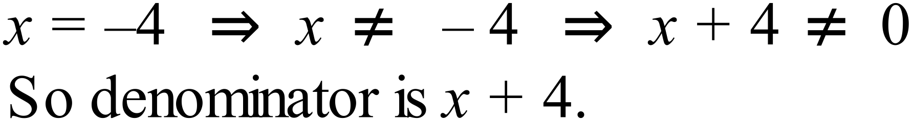  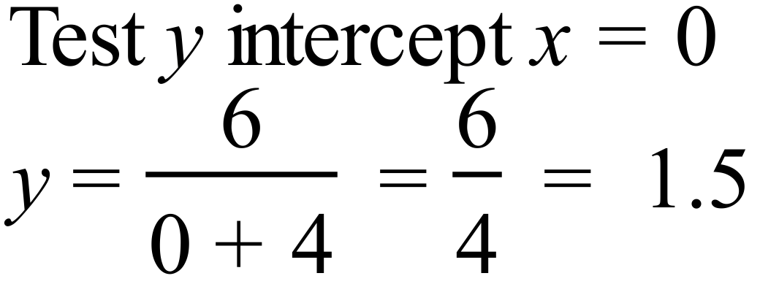 |  |  | C
 | 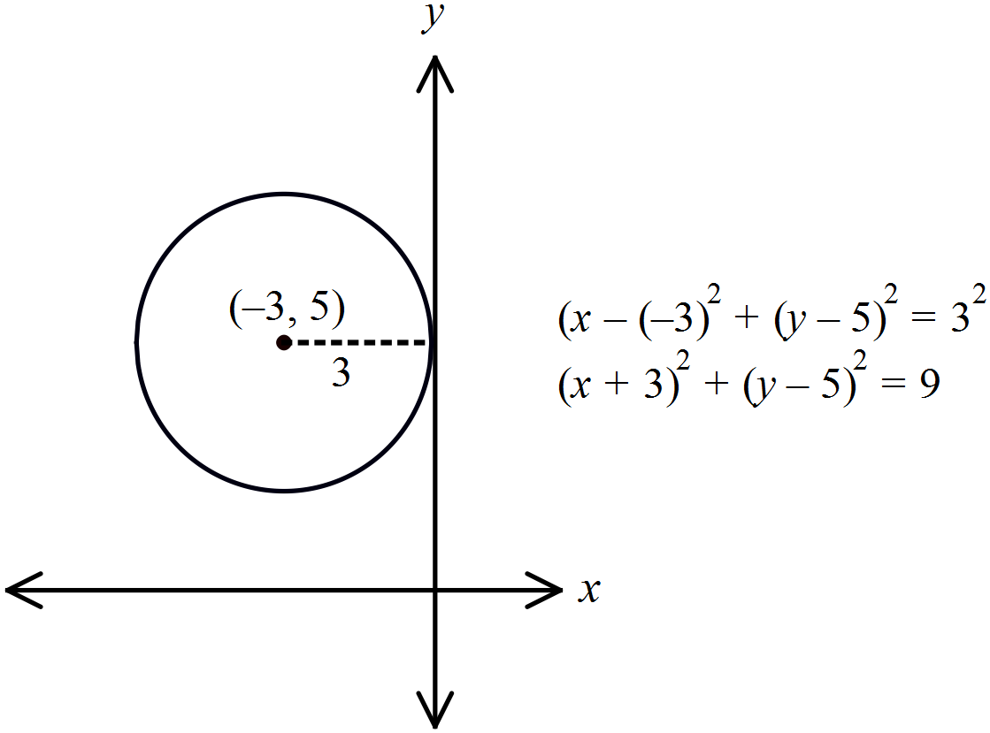 |  |  | B
 | 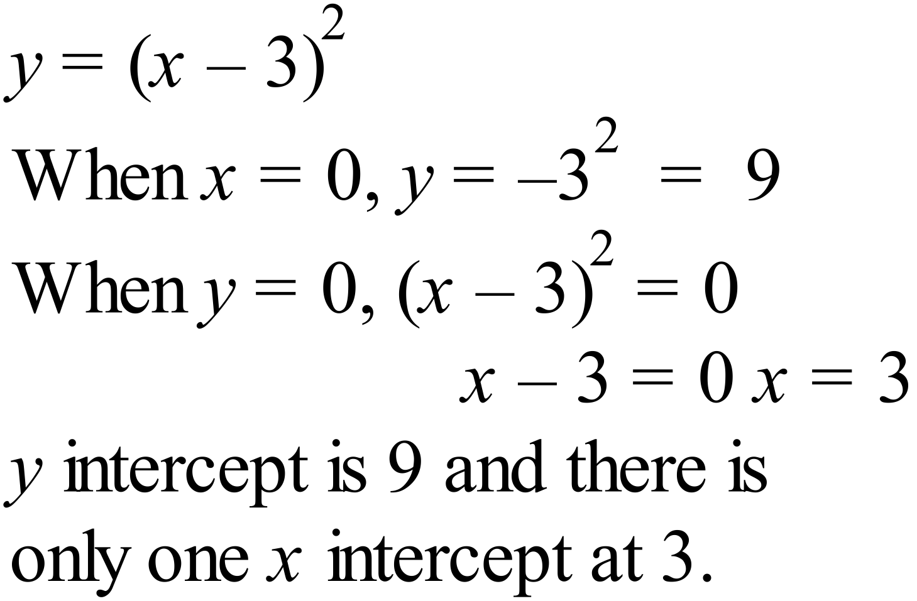 |  |  | A
 | Centre at and radius 5 units gives equation  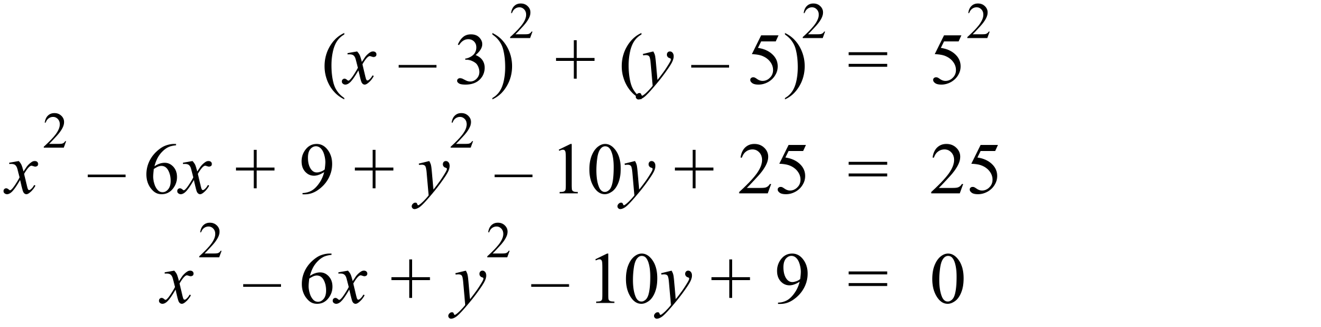 |  |  | D
 | Intercept comes from the constant term, which is the product of the two constants in the factors.  The only two with a product of -12 is +4 and -3. |  |  | D
 | 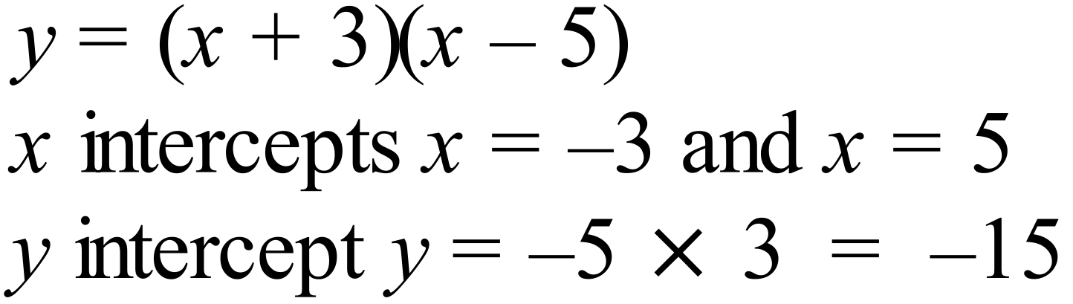 |  |  | B
 | Axis is at x = -2, so intercepts are equally spaced either side of this. Testing x = -8 and x = 4 meet this requirement.  Equation is 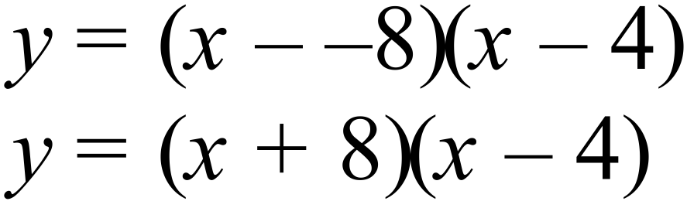 . |  |  | C
 | 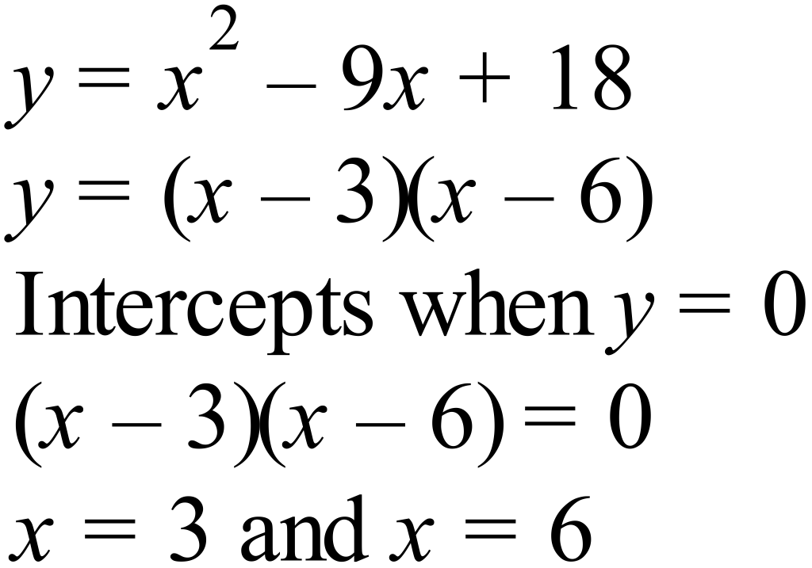 |  |  | D

Multiple Choice Answer Sheet
Non Linear Relations
Name _______ANSWERS_______________________________
Completely fill the response oval representing the most correct answer.

1. A B C D
2. A B C D
3. A B C D
4. A B C D
5. A B C D
6. A B C D
7. A B C D
8. A B C D
9. A B C D
10. A B C D
11. A B C D
12. A B C D
13. A B C D
14. A B C D
15. A B C D
16. A B C D
17. A B C D
18. A B C D
Year 10 |  | Non Linear Relations | Calculator Allowed
Section 3 Longer Answer Section
ANSWERS
 |  |  |  | Marks
1. | On the axes provided draw neat sketches of and .  Clearly mark the vertex of each graph.  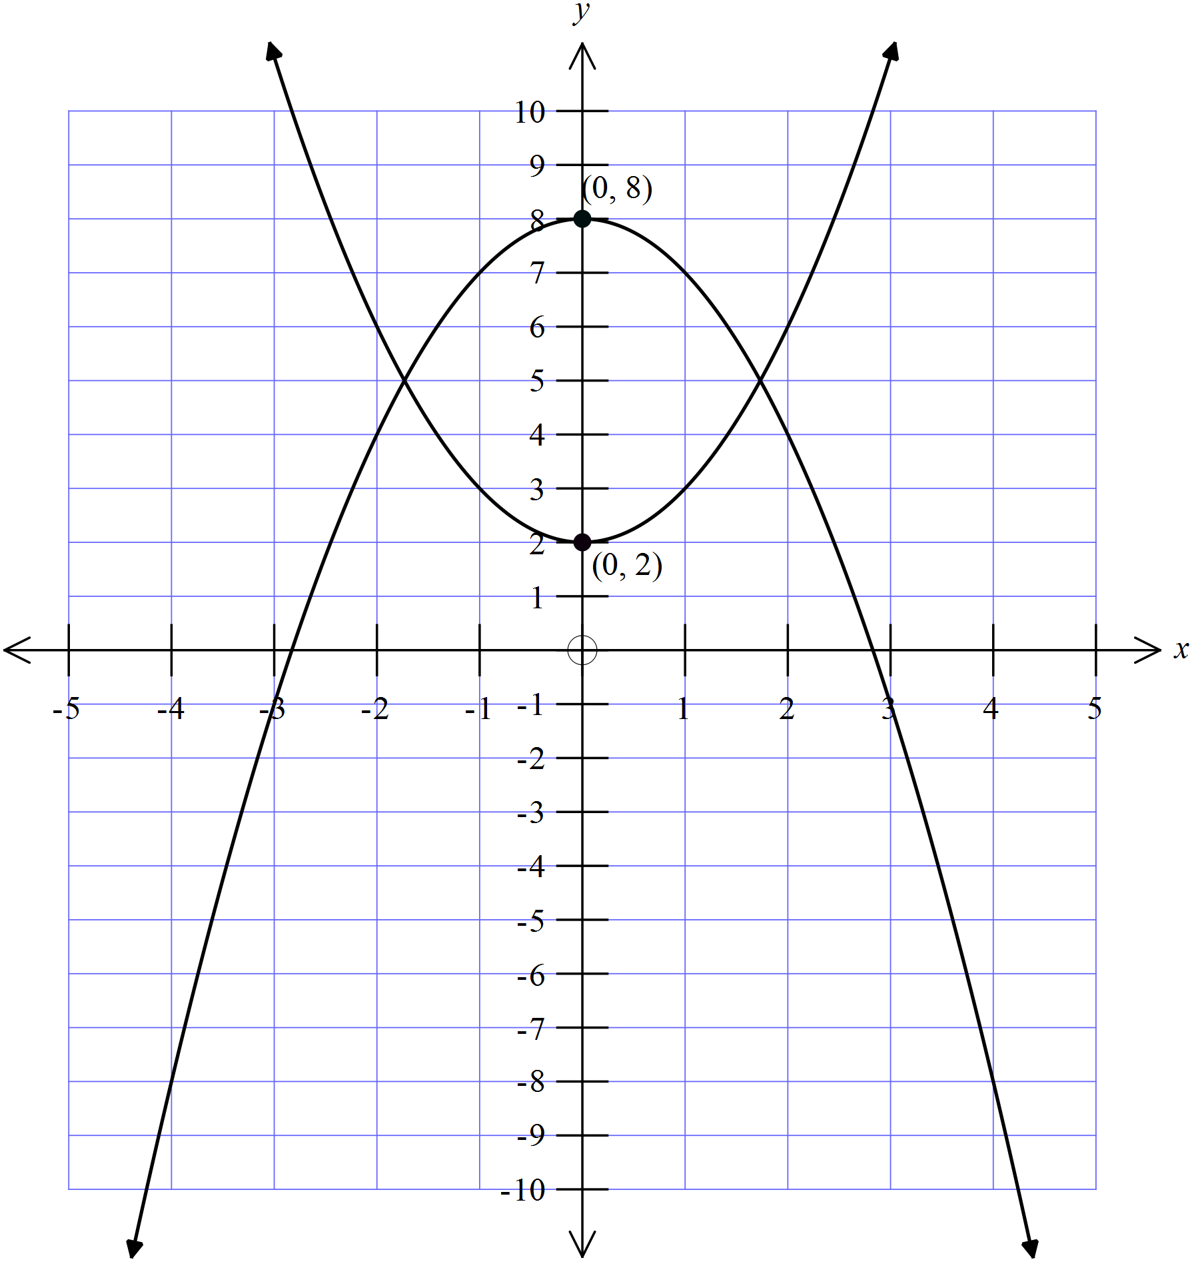 |  |  | 4 marks in total for the two curves.  2 marks for each correct graph of a curve.  For an incorrect graph, if it is a parabola with correct orientation and it shows some correct features give 1 mark.
2. | On the axes provided draw neat sketches of and .  Clearly mark the vertex of each graph.  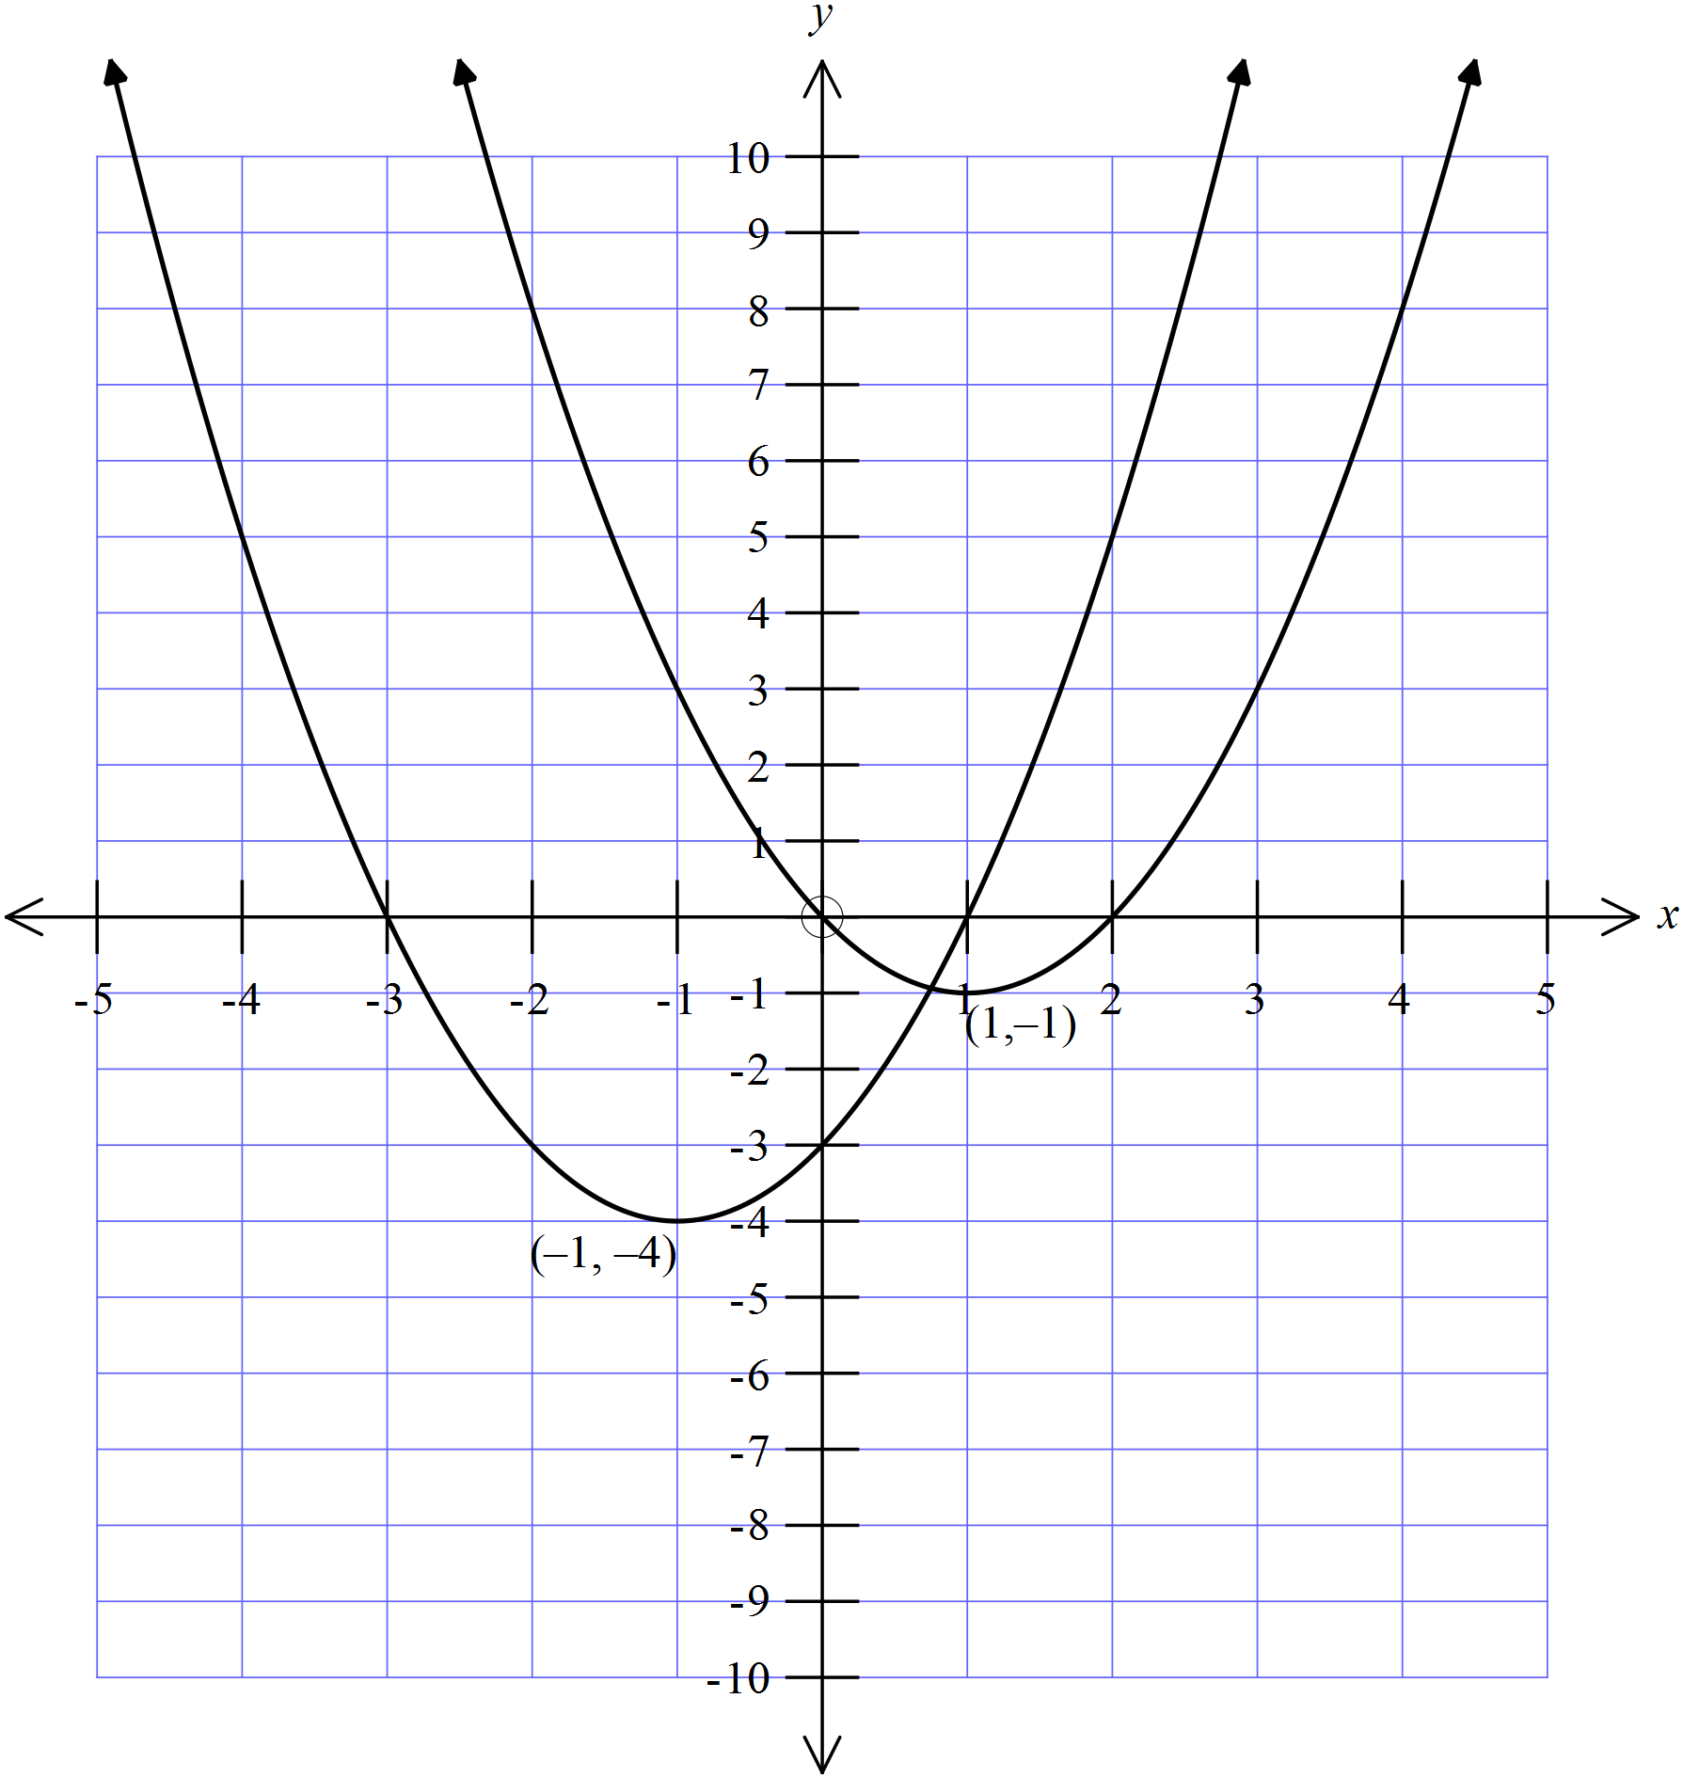 |  |  | 4 marks in total for the two curves.  2 marks for each correct graph of a curve.  For an incorrect graph, if it is a parabola with correct orientation and it shows some correct features give 1 mark
3. | On the axes provided draw neat sketches of and .  Clearly mark the x and y intercepts of each graph.  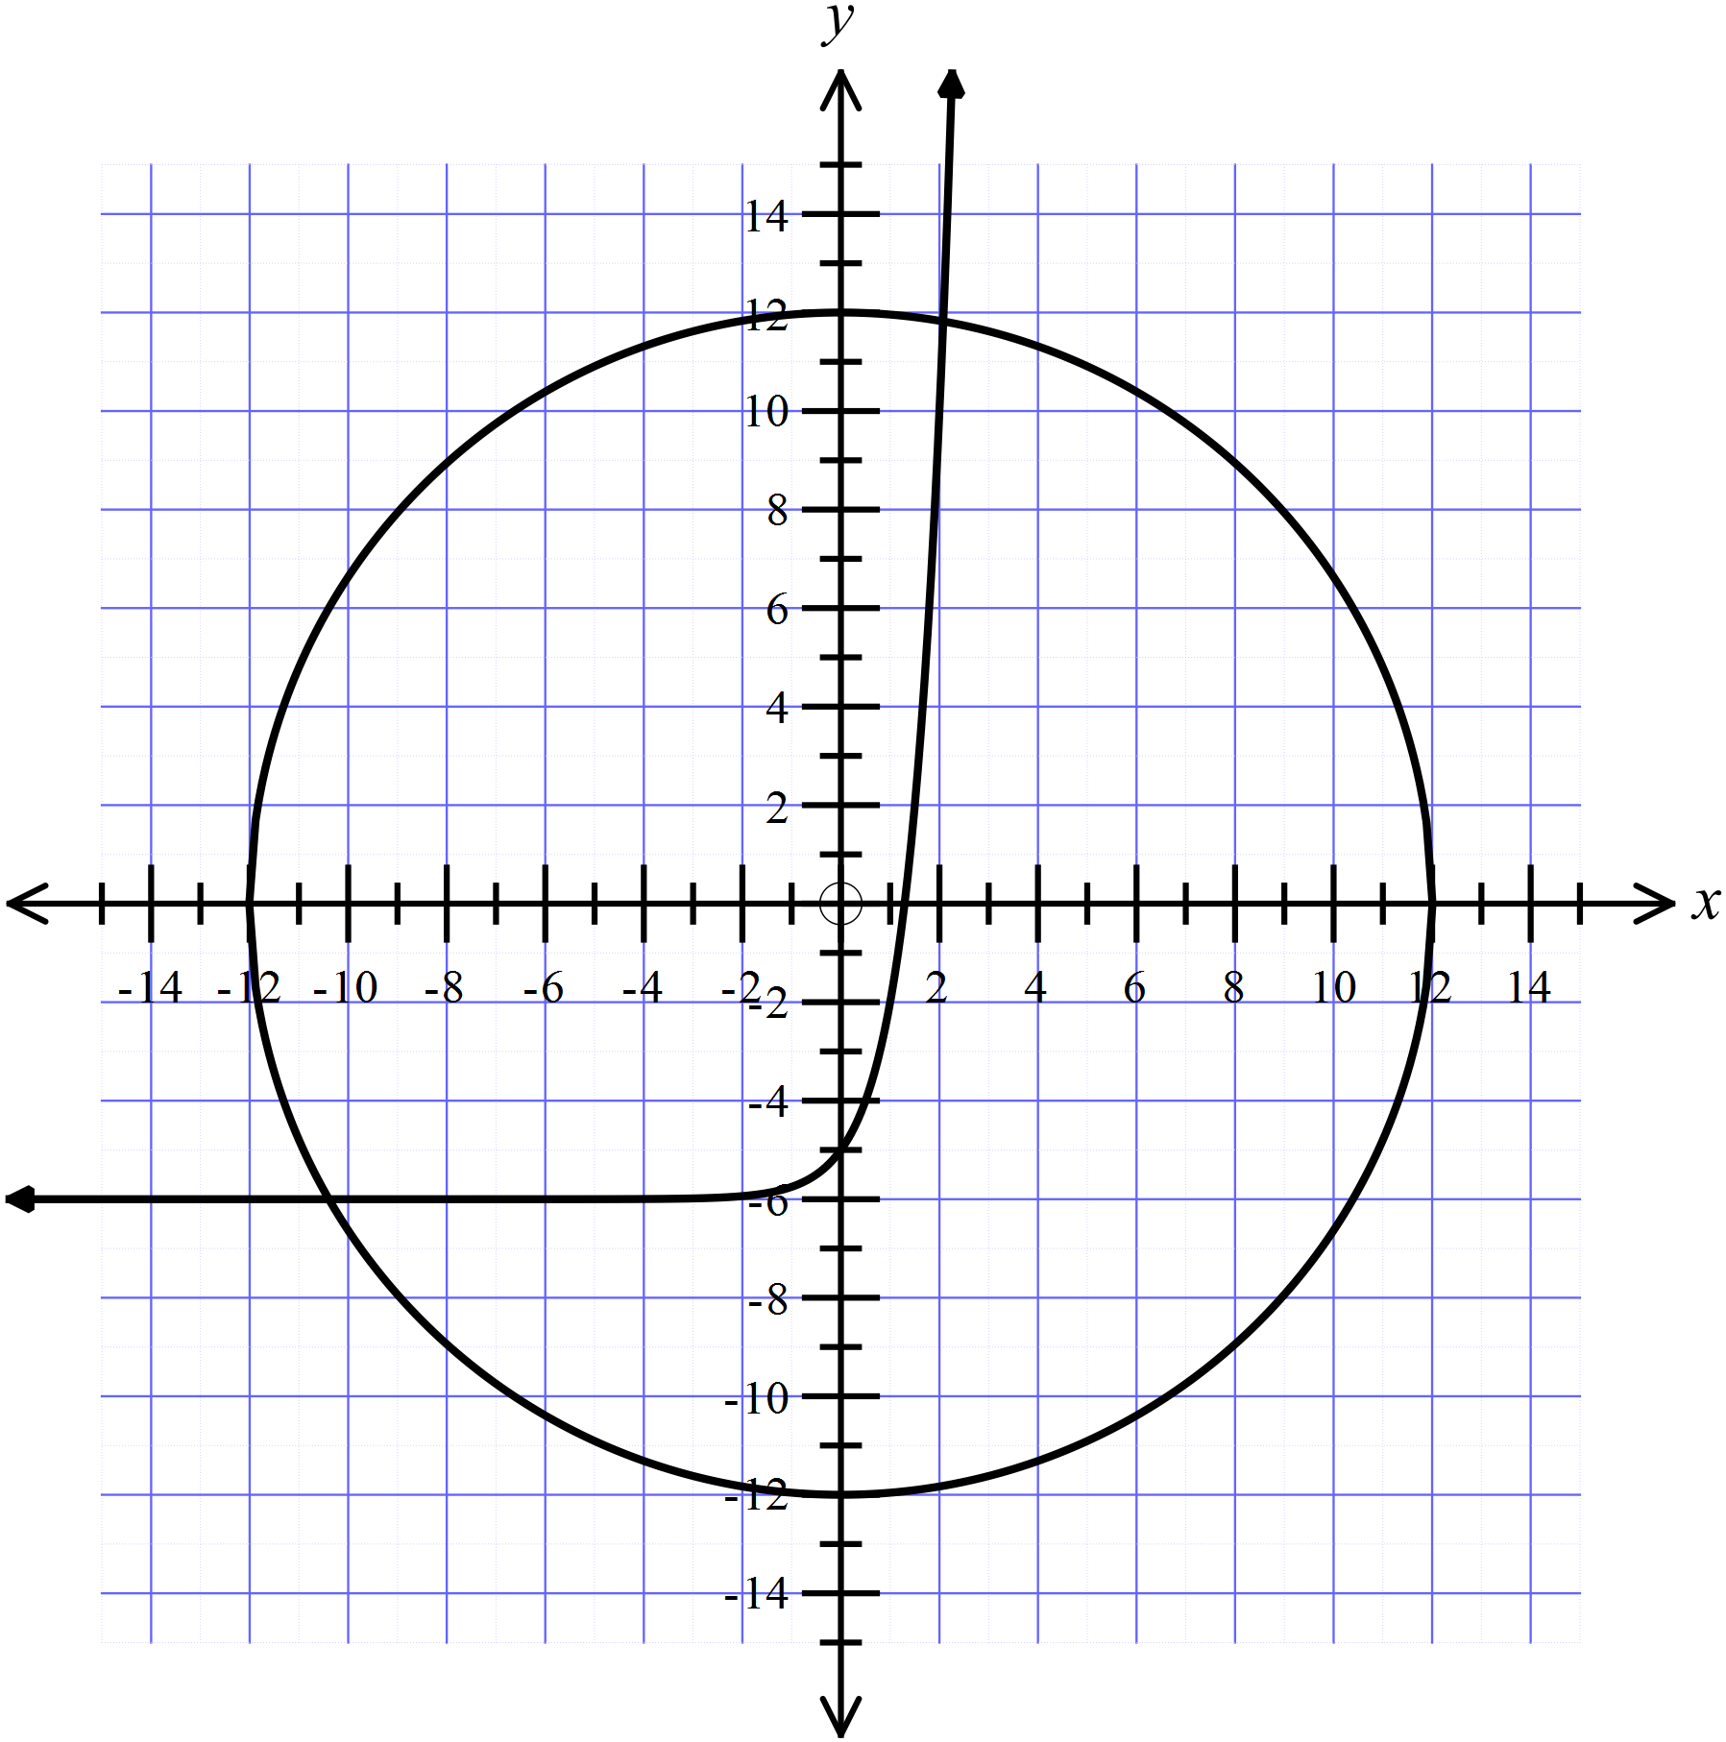 |  |  | 4 marks in total for the two curves.  2 marks for each correct graph of a curve.  For an incorrect graph, if it is the correct type of curve with correct orientation and it shows some correct features give 1 mark
4. | On the axes provided draw neat sketches of and .  Clearly mark the main features of each graph.  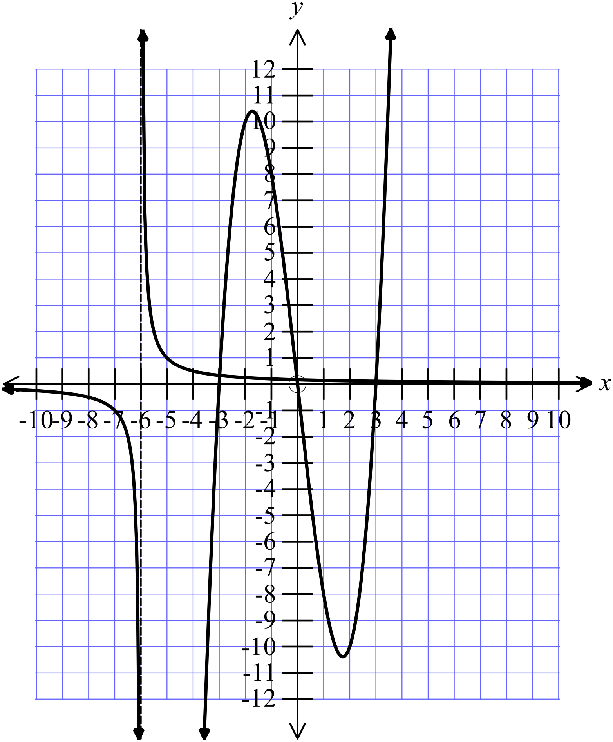 |  |  | 4 marks in total for the two curves.  2 marks for each correct graph of a curve.  For an incorrect graph, if it is the correct type of curve with correct orientation and it shows some correct features give 1 mark
5. | 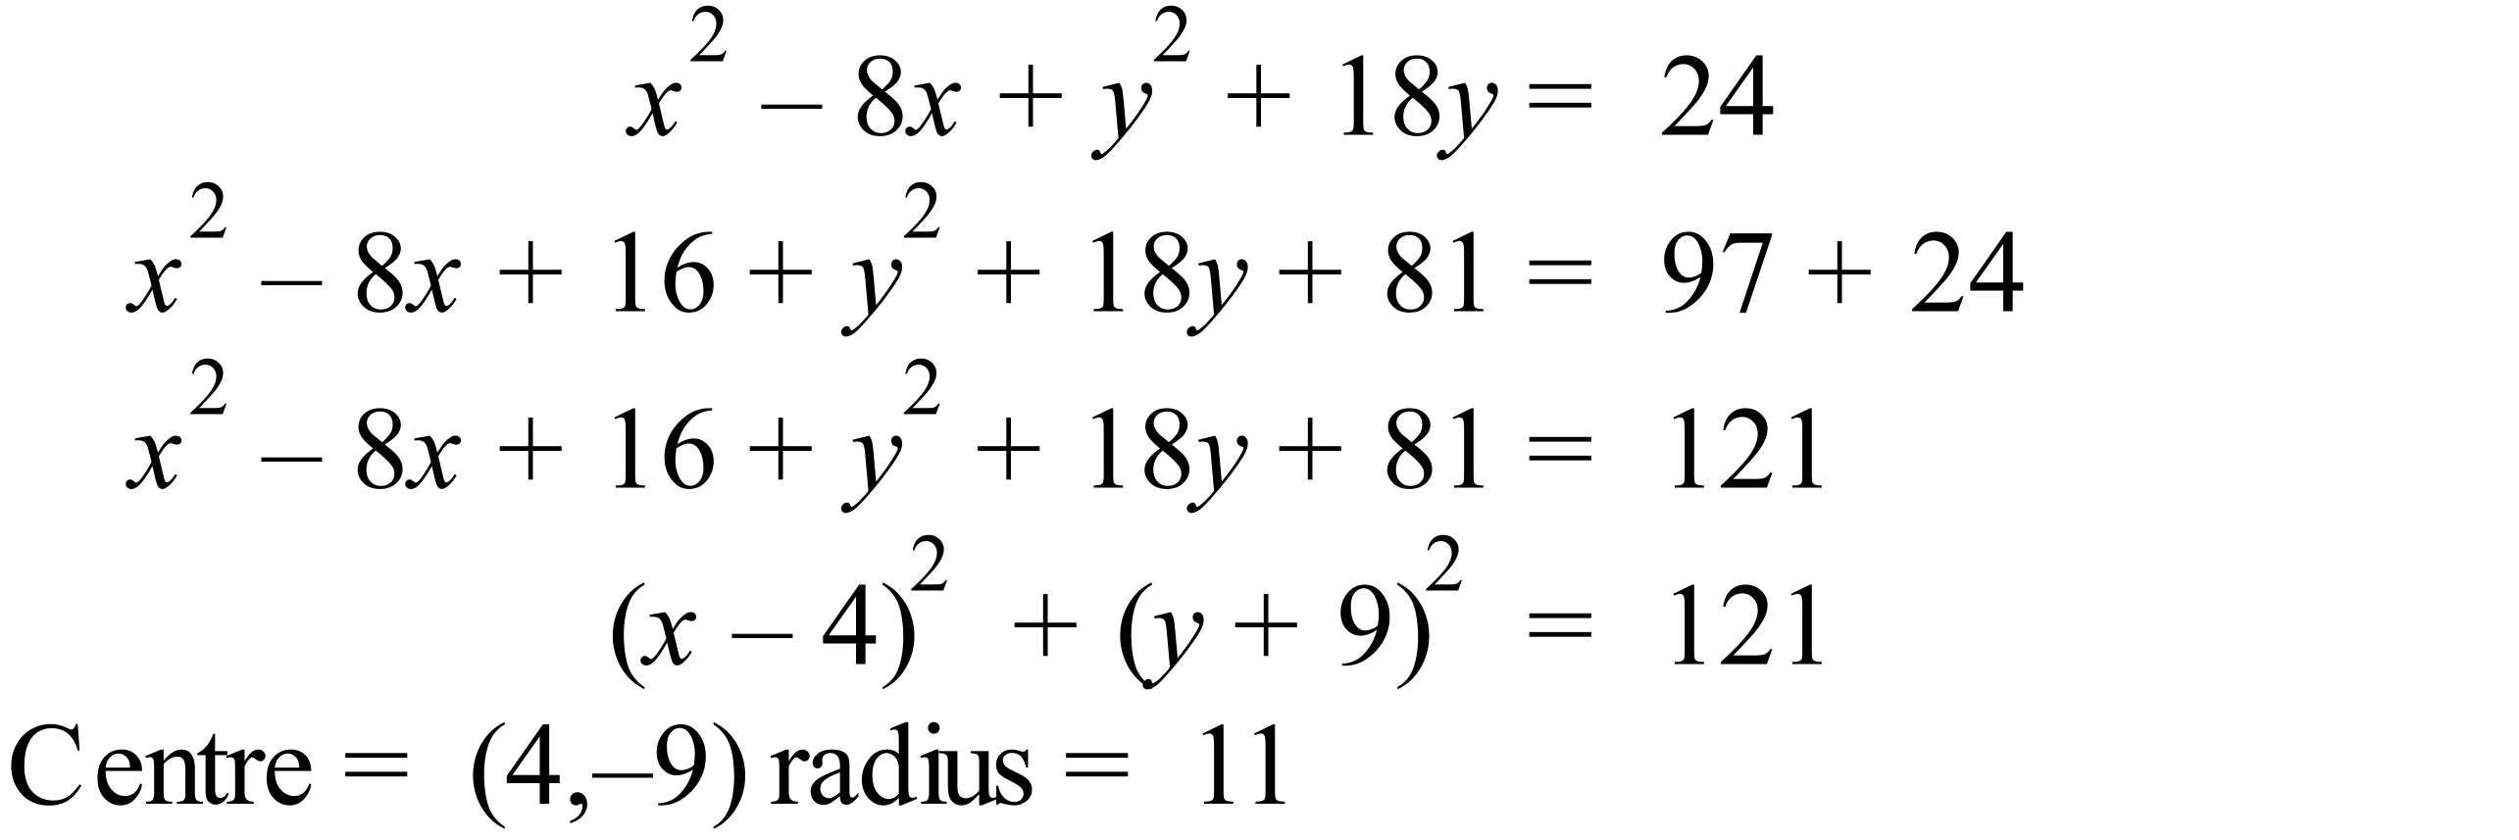 |  |  | 2 marks for both correct.  1 mark if either is correct, or some correct working toward getting both.

